De Aston
English Department

Year 7: Poetry Please
Academic Excellence Booklet

Name:

The role of the Academic Excellence Booklet is for you to complete these tasks over the next six weeks. These activities are purposely designed to challenge you, so don’t worry if you find them difficult. You’re meant to! Learning happens when people have to think hard. That being said, your English teacher is a specialist, so ask any of us for help, anytime!

- Find the lyrics to a favourite song.
Annotate it – Remember to look for anaphora, enjambment, hyperbole and pathos!

- Play poem roulette! https://www.poetryinvoice.com/roulette/ Pick a theme, or mood, or poet and read one of their poems.
What do you think the message is? What features can you spot?
Write your own poem in response. It can be about a similar theme or mood or use similar language features or even borrow some of their phrasing!

- Create a list of key terms to do with poetry.
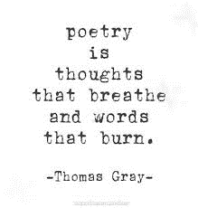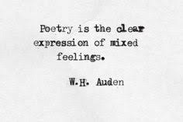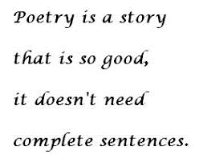

Look at these three statements. Pick one and answer the question. To what extent do you agree that poetry is …..
Use your key words list in your response. You might want to find a poem that supports your argument. Talk to other people. See if their view is similar to yours – it doesn’t have to be!

For more resources, including literacy support, visit www.deastonenglish.com

