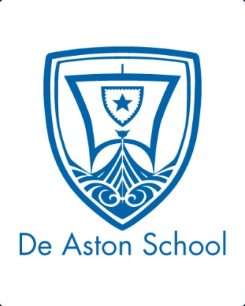
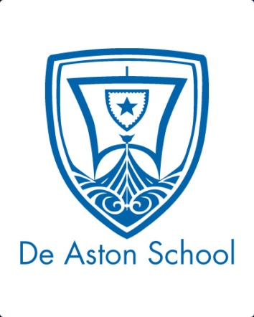
De Aston
English Department

Year 7: Big Imagination
Challenge Tasks

Name:

Week One:
At the start of this unit you will be focusing on Greek myths. Go to https://www.greekmythology.com/Myths/myths.html and spend some time exploring the site. Find a myth you like, and then rewrite it as a modern short story.

Week Two:
Greek mythology involves a range of myths and legends, often dominated by tales of heroes, gods and monsters. This week, choose a challenge task:
Hard – create your own monster and write one paragraph about its life and behaviour;
Harder – create your own monster and write one paragraph about its backstory;
Hardest – create your own monster and write one paragraph about its backstory and the moral lesson the story teaches us.

Week Six:
Now that you have looked at a range of genres, choose the one that appeals to you most and create a resource that shows your understanding of the genre. You could create:
- a poster
- a leaflet
- an artistic representation (collage/drawing/model)
Week Five:
This week you’ve been looking at the fantasy genre. Think of your own fantasy world – what would it look like? You could present your ideas as:
- A detailed description
- A collage of aspects you would include
- A labelled drawing

Week Four:
Yee ha! This week you have been looking at the Western genre and going out West rubbing shoulders with cowboys. Choose a challenge!
Hard – you’ve been digging for gold – describe the scene and what you find…perhaps it’s something surprising;
Harder – there’s been an outbreak of Smallpox on the ranch! Describe your thoughts in a diary entry.
Hardest – you’ve seen a shoot out! Write a court report telling the story as to what you saw.

Week Three:
This week you will have been exploring viewpoint. Choose one of the myths you have studied this term, or the myth you chose for your week 1 homework, and write a series of diary entries as if you were one of the main characters in the story.
Additional challenge tasks:
Make sure you understand what each of these words means and show your understanding by trying to use them in your classwork. Then learn how to spell them – be ready for a spelling test in the last week of term.
Hard:
- Genre 2. Character 3. Narrator 4. Viewpoint 5. Tension
Harder:
- Protagonist 2. Convention 3. Allusion 4. Antagonist 5. Eponymous
Hardest:
- Enigmatic 2. Melancholic 3. Amiable 4. Cynical 5. Demure

Final challenge:
Finally, challenge yourself to read some persuasive articles* and choose one that you find particularly interesting. Print it out and share it with your classmates.
*The Guardian newspaper website has a page dedicated to opinion pieces here: https://www.theguardian.com/uk/commentisfree
Bonus week:
Read the extract below and complete the ‘all’ question and one more of the questions below:
All: list four things you learn about the man on the horse in this extract.
Hard: what genre is the text and how do you know?
Harder: how does the writer use language to interest the reader?
Hardest: to what extent does the text meet the expectations of the horror genre?
When Kosar saw the horseman, the world began to end again.
The horse walked towards the village, the rider shifting in fluid time to his mount’s steps. The man’s body was wrapped in a deep red cloak, pulled up so that it formed a hood over his head, shadowing his face. His hands rested on his thighs. The horse made its own way along the road. Loose reins hung either side of its head, its mane was clotted with dirt, its unshod hooves clacked and clicked puffs of dust from the dry trail. Only one man on a horse, and he did not appear to be armed.
How, then, could Kosar know that death followed him in?
With a grimace he stopped work and squatted. A warm breeze kissed the raw flesh of his fingertips – the marks of a thief – and took away the pain for a few precious moments. Blood had dripped and dried into a dust-caked mess across his hands and between his fingers, and they crackled when he flexed them. The unhealing wounds were a permanent reminder of the mistakes of his past.

For more resources, including literacy support, visit www.deastonenglish.com

