De Aston
English Department
Year 13: Brighton Rock
Academic Excellence Booklet

Activity 1 – Brighton Rock: Evaluating Ida’s role as detective
- Make a bullet-pointed list of all the features we expect of a detective: how we expect them to behave, what we expect them to do in the process of investigating the crime, the reader’s attitude toward them, etc.
- Add to this by doing some research into well-known fictional detectives, such as Sherlock Holmes, Hercule Poirot and Auguste Dupin.
- In what ways does Ida fulfil the traditional role of detective in crime fiction? In what ways does she subvert this?
- Now read the article ‘Ida Arnold and the detective story’ by Brian Diemart. Can you add any further points on how Ida fulfils/subverts our expectations of a detective?

Activity 2 – Brighton Rock: Focusing on the metaphysical
Although there are various shifts in point of view, the main perspective is that of Pinkie Brown. He is a religious gang-leader, who fights against secular enemies. His behaviour is shaped by his Roman Catholic concepts of good and evil, of damnation and salvation.
- How significant is Pinkie’s religion in understanding the novel as a crime text? Do you need to understand a little about the central concepts of the religion, or can it be viewed simply as good vs. evil, or right vs. wrong?
- Read the article “Brighton Rock: what is it about?” What does this add to your understanding of Greene’s intentions? Is he evaluating/criticising the Roman Catholic church and their beliefs, or is this a more general exploration of the concept of beliefs and morality?

Activity 3 – Brighton Rock: Nietzsche and the übermensch
Philosopher Nietzsche, in his 1883 work ‘Thus Spoke Zarathustra’, hypothesised the eventual evolution of man as resulting in an übermensch, translated as ‘overman’, whom would possess the capability to craft his own morality to replace the one dictated by morally omnipotent institutions such as the Church.
- Apply Nietzsche’s concept to Brighton Rock, looking particularly at Pinkie and Ida.

Activity 4 – Brighton Rock: ‘opiate of the masses’
As you may remember, Marx described religion as the ‘opiate of the masses’ in his seminal writings. To what extent is this view present in Brighton Rock? Conversely, do your opinions agree with Orwell’s reading of this text as ‘papist propaganda’?

Activity 5 – Brighton Rock: antimodernism?

Read the article Paper Thin Modernity: Graham Greene’s Brighton Rock. Firstly, summarise the article and then write your response to the ideas presented in it.

Week 1: Ida as detective
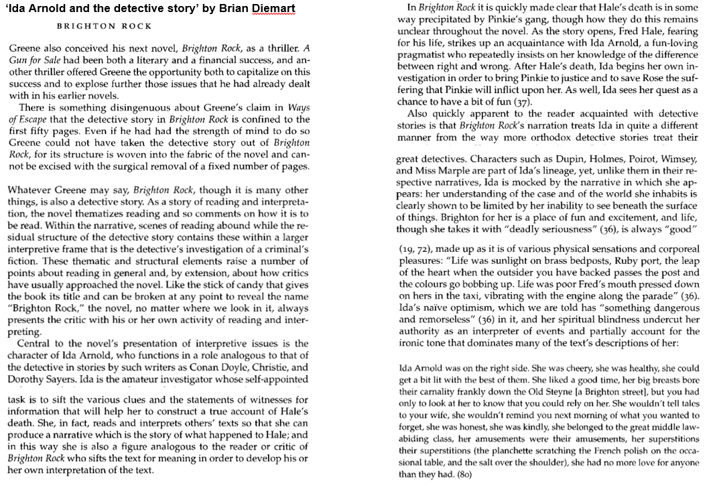
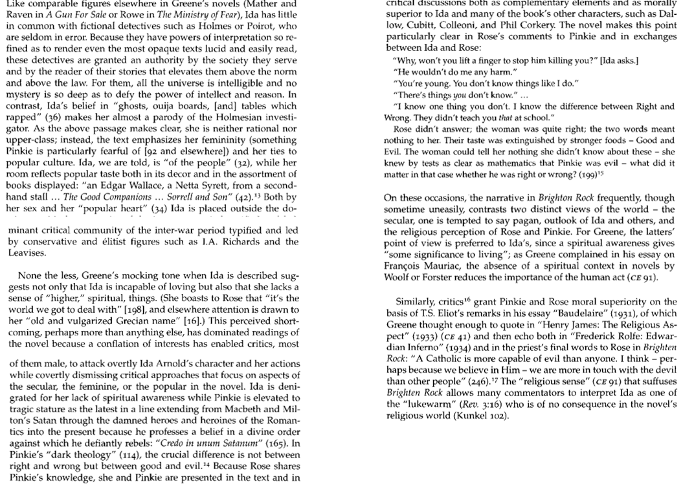

Week 2: Brighton Rock: what is it about?
At one level, this novel is a simple, if elegant, thriller: Ida Arnold, an unlikely heroine, pursues the evil but failed gangster Pinkie Brown; she seeks his punishment, while trying to save from his influence the young woman, Rose, whom Pinkie has married to buy her silence. In these terms, with vivid but usually straightforward characters and well-drawn locations, and the shocking conclusion (the reader is aware of Rose's imminent discovery of Pinkie's hatred) the novel shows why it achieved great popularity, and why it was successfully adapted for the cinema. Unlike some classic works, it obeys the convention of popular fiction, that there should be a well-paced and exciting story; "suspense" is also provided by the reader's concern for the perhaps doomed Rose. But why is the novel also considered to be serious fiction, or a "modern classic"? This is a little less obvious, but we can find reasons for this opinion, if we look.
Like many writers from earlier times, Greene is deeply interested in what could be called metaphysical questions: about the real nature and purpose of this world, about the nature or existence, even, of God; about man's freedom, by his own efforts, to alter his circumstances - or lack of this freedom. In order to address these arguments, Greene depicts characters who are not at all complex, but who hold, profoundly in the case of Pinkie, radically differing views on these matters.
Dallow, like Ida, sees only the immediate material world before him, as do the punters who see Brighton's jolly facade and gaiety, but not the squalor behind this. Pinkie, though, believes also in a world of unseen but eternal spiritual realities. Initially, he believes these to await him after death, and he aspires to better his status in this world; but he comes, gradually, to see what Prewitt, his bent lawyer, articulates for him, that "this (this world, generally; for Pinkie, Brighton) is hell, nor are we out of it". Brighton in its two aspects (the Palace Pier or Paradise Piece) becomes a metaphor for heaven and hell, while the novel begs the question: does Pinkie have a morbid and deluded imagination, or is he right in his view of the world? Ida is a likeable heroine, but Greene does not at all endorse her matter-of-fact view of the world.
In Brighton Rock, Greene shows the continuing importance of religious belief. In Hale's funeral service and Ida's superstitious dabblings in the "spirit world" he ridicules the then fashionable compromise between religious faith and so-called "rationalism". Pinkie's rebuke to Dallow's "I don't believe in what my eyes don't see" ("They don't see much then"; p. 212 ) could reasonably be read as the author's gibe against the blindness, to eternal realities, of the modern materialist outlook. These ideas will be discussed more fully later.
Pinkie accepts the Roman Catholic teaching about heaven and hell, but in a rather perverted way. There may be heaven though he can form no idea of it; but he has a vivid idea of hell: "Of course there's Hell. Flames and damnation." (p. 52) Initially, Pinkie believes that hell awaits him after death, and there is no point in troubling about it beforehand: "Hell - it's just there. You don't need to think of it - not before you die" (p. 91) But his remark to Rose immediately prior to this ("I don't take any stock in religion") is not convincing. It is probably true, however, at this point, that Pinkie believes he can use his position as Kite's successor to gain status and influence, though it is not clear to the reader how he can achieve these, as Pinkie lacks imagination; his refusal to meet Colleoni's terms seems foolish. What Pinkie wants immediately is to obliterate his past in Paradise Piece, with the knowledge of his parents' sexual habits, and to escape from the room at Frank's, where strategic planning is made impossible by the interruptions of the other gang members and Judy. An idea of controlling the race track, resisting Colleoni and doing what he needs to, in order to silence Rose is Pinkie's vision of worldly success. The reader notes, first that the celibate, ascetic Pinkie is unfitted to enjoy the fruits of this success, other than the prestige it might bring; second, that Ida, effortlessly, achieves what is denied Pinkie: he is refused a room at the hotel on his wedding-night, while Ida uses the "unlucky" Hale's tip to pay her way in Brighton, and her charm to hitch a lift to the races in a luxury sports car.
What Pinkie comes to realize about his original view of things is that it is mistaken, and that hell is all around us. In trying to silence Rose, he finds himself committing a sin more serious than murder (the corruption of an immortal soul). He also sees how the squalid domestic routines and the sexual relations he has hitherto sought to escape have now trapped him; the only way out is to arrange Rose's death. Pinkie sees this most vividly when he takes his bride back to Frank's place:
Now it was as if he was damned already and there was nothing more to fear ever again. The ugly bell chattered, the long wire humming in the hall, and the bare globe burnt above the bed - the girl, the washstand, the sooty window, the blank shape of a chimney, a voice whispered, " I love you, Pinkie". This was hell then; it wasn't anything to worry about; it was just his own familiar room. (p. 182)
Later, when he visits Prewitt (Part Seven, Ch. 3), this is articulated most clearly. Pinkie's fear of settled domesticity is alarmingly embodied in Prewitt's household. Prewitt is successful enough (or has been) to own a house and to employ a servant. But his house is near the railway line, "shaken by shunting engines" while soot settles "continuously on the glass and brass plate". The party wall is so thin, there is non-stop noise from the neighbour's radio. The wife in the basement and the girl with "grey underground skin" suggest the hell just beneath this world. Prewitt tells Pinkie that the Boy's danger of conviction is to be preferred to his own living death: "The worst that can happen to you is you'll hang. But I can rot". Finally, Prewitt tells Pinkie of Mephistopheles' words to Faustus: "Why, this is Hell, nor are we out of it" repeating the phrase soon afterwards. Pinkie would not be familiar with Marlowe's play, but the quotation expresses an idea to which his own thoughts have been tending.
The reader sees that Pinkie is like Faustus: he has tried to make a deal, accepting his own damnation, in return for some advantage in this world. Like Faustus, he finds that the worldly gain is illusory and unsatisfying. We see further how Pinkie becomes aware more and more of a loss of control. When he confronts Hale, he is utterly confident he can kill him with impunity. Early in the novel (p. 7) Greene likens Pinkie to a hunter "before the kill". As he is drawn into closer relations with Rose, Pinkie sees how his scope for action is lessened. This becomes explicit when he visits Prewitt: "More than ever yet he had the sense that he was being driven further and deeper than he'd ever meant to go": he is now the hunted.
This idea is central to the novel's conclusion: although Pinkie is fairly sure of his own damnation, he believes (in theory) that a Catholic can be saved if he repents before death, an idea he thinks of repeatedly in terms of the rhyme about the "stirrup" and the "ground". When he fears he may be about to die, after the attack on the race-course, he finds that this does not work, that his whole attention is given to trying to stay alive. But Greene is careful not to exclude the possibility of forgiveness for Pinkie. Driving with Rose to the country, to arrange her "suicide", Pinkie thinks of himself as pre-destined, unfairly, for damnation, because of the experiences of which "his cells were formed". He is stirred by "an awful resentment", and wonders why he should not "have had his chance, like all the rest, seen his glimpse of heaven, if it was only a crack between the Brighton walls". (p. 228) But as he looks back on his brief courtship of Rose, Pinkie has his chance. He discovers, to his surprise, that he remembers it "without repulsion" and the (slight) possibility of affection for Rose occurs to him; "somewhere, like a beggar outside a shuttered house, tenderness stirred, but he was bound in a habit of hate".
The image is repeated (p. 237) as Pinkie feels almost protective of Rose in response to the boasting of the upper-class men in the bar: "Tenderness came up to the very window and looked in". The chance of repentance, twice refused, comes most vividly, the third and final time; as he drives away from the bar, Pinkie is aware of "an enormous emotion", likened to "something trying to get in; the pressure of gigantic wings against the glass. Dona nobis pacem...If the glass broke, if the beast - whatever it was - got in, God knows what it would do." (p. 239) The colloquial "God knows" here clearly has a serious literal meaning. Pinkie is aware of what is happening, this is the "crack" opening in Brighton's walls, but when it comes, he resists it.
Having declined the threefold offer of mercy, Pinkie cannot escape the divine judgement. His death is presented very much as the action of supernatural punishment: "it was as if the flames had literally got him" (the burning of the vitriol anticipating and becoming a metaphor for the hell-fire which Pinkie is about to meet). When he goes over the cliff no sound is heard: "it was as if he'd been withdrawn suddenly by a hand out of any existence - past or present, whipped away into zero - nothing". (p. 243) The "hand" is a conventional anthropomorphism for the action of God, while the reference to time indicates how Pinkie's hell, as Prewitt correctly divines, begins before his death.
In the depiction of Pinkie, Greene addresses many of the paradoxes of Roman Catholic doctrine. Pinkie seems to be doomed - both by his environment and by his temperament - to hell, and yet he is held accountable for his actions. His lack of imagination (of others' sufferings) and inability to value those for whom he has no affection (and he has affection for nobody) explain, but in Greene's eyes neither justify nor excuse, his crimes. He has the possibility of mercy but declines it. The reader is satisfied (with Ida) that justice has been done (though we understand it, as Ida does not, in the context of eternal damnation).
Ida, like Dallow, believes in what she sees. She is superstitious, being quite ready to believe in a spirit world, but not seeing, as Pinkie does, the vivid reality of hell-fire. "She believed in ghosts, but you couldn't call that thin transparent existence life eternal". (p. 36) This is contrasted with Ida's hedonistic ideas about life, as a series of tangible material pleasures to be enjoyed without self-reproach: "She took life with a deadly seriousness". (p. 36) Ida has no belief in heaven or hell: "That's just religion...Believe me, it's the world we got to deal with". (p. 198) "Fred" has been deprived of life and Rose's life may be in danger; Ida, with her overwhelming sense of "right and wrong", of fair play, casts herself in the rôle of avenger.
Greene explains Ida's popularity in terms of her understanding of ordinary people; her physical presence, her joie de vivre and her sentimentality all make her attractive; she is generous in every respect, and mixes common sense with commonplace superstition. In this, she is a kind of representative of the people, and of the popular world view. Many readers will see things as Ida does; most will admire the courage with which she responds to what she sees as her duty to "Fred". Whether we agree with Ida's belief that "it's the world we got to deal with" is another matter. It is possible to see Pinkie's theology as the morbid fantasy of a moral imbecile. But the conclusion of the novel appears more to endorse the supernatural than the worldly outlook. The "hand" which seems to withdraw Pinkie from existence, for example, is not in his mind (we have no insight into the dying man's thought) but in the narrative.
Just as Ida sets out to save Rose's (mortal) life, so Rose hopes to save Pinkie's (immortal) soul. If this is impossible, she thinks, she would rather be damned with him. Though familiar with the Catholic doctrine in which she has been brought up, her understanding is very different from Pinkie's. She is quite ready to defer to his authority, even when he pretends not to believe the orthodox teaching on marriage, in order to persuade Rose that he and she are "to be married properly". Although Rose is conventionally "good" she has a sense of inhabiting a country where "good or evil" live together, speaking "the same language", coming together "like old friends"; Pinkie and she live in a common world, from which the non-Catholics are excluded. She sees Ida (in relation to Catholicism) as resembling "an Englishwoman abroad", as if "in a strange country" without a "phrase book".
Rose rightly suspects that Pinkie's background is the same as hers; he denies this (p. 91) not least because his home is the thing of which he most wants to be free. Rose fails, at the last, to commit suicide; though she thinks of the voice prompting her to stay alive so she can plead for Pinkie "at the throne of grace" as speaking like a "devil", yet her hand is stayed long enough for her to be overtaken by events. When Ida and the policeman arrive, Rose throws away the revolver she is holding. Rose tells the priest (p. 246) that Pinkie was damned and knew it. The priest encourages her to believe it might be otherwise "if he (Pinkie) loved" her, and tells her to make her child a saint "to pray for his father". The novel's concluding sentence intimates that Rose will soon discover (from Pinkie's recorded message) that he hated her, thus giving the lie to the priest's suggestion.

For more resources, including literacy support, visit www.deastonenglish.com

