English Literature GCSE
De Aston School
Name:
Year Group: Year 10
English Teacher:
Literature paragraph structure
Point
Clearly / evidently…
We observe that…
We see that…
[author] reveals that…
Quotation
Meaning
… he/she means…
In other words…
Literally…
Here, he/she is saying…
Choose 2-5 of these per paragraph | Analysis  Here, [author] shows / demonstrates / emphasises / highlights / implies…  We notice that…  More specifically,…  In particular,…  Perhaps / this could be / maybe…  It is as though…  It is almost as if…  It seems that…  It could be…  This could represent…  +because… +or maybe even… +and… and… +or… or…
Bigger picture
More broadly, we may consider…
Thus we see…
Therefore we conclude…
We are encouraged to…
A contemporary audience / reader may / could / might… because…
A modern audience may / could / might… because…
[author] might be suggesting…

Versatile Vocabulary
Solid, real | Concrete | Abstract | Not physical, an idea
Tidy, controlled, clear | Order | Chaos | Confusion, disorder
Difficult to harm | Secure | Vulnerable | Easy to harm, fragile
Stubborn, unchangeable | Dogmatic | Malleable | Able to be changed, flexible
Stable, the same | Constant | Volatile | Unpredictable, uncertain
Every so often | Intermittent | Perpetual | Cyclical, repetitive, incessant
Can be touched, real | Tangible | Intangible | Cannot be touched
Can be touched, real | Physical | Metaphysical | Not physical, not real
Expected, logical, usual | Natural | Supernatural | Beyond laws of nature, magical
Expected, logical, usual | Normal | Abnormal | Beyond what is expected
Original, basic, true | Literal | Metaphorical | Symbolic, not literal
Logical, using reason | Rational | Emotional | Using mood or feelings
Lasting forever | Permanent | Ephemeral | Lasting for a short time, temporary
Make stronger, support | Reinforce | Transgress | Go against
Right, good | Moral | Immoral | Wrong, bad
Kind, good | Benevolent | Malevolent | Unkind, evil
Gullible | Credulous | Duplicitous | Two-faced
Inside | Interior | Exterior | Outside
Inside | Internal | External | Outside
Less than | Inferior to | Superior to | Better than
The worst imaginable world | Dystopia | Utopia | The best imaginable world
Staying still | Static | Active | Moving
Hunted | Prey | Predator | Hunter
Sufferer | Victim | Villain | Creator of suffering
Free | Liberated | Imprisoned | Trapped
Generous, loves people | Philanthropic | Misanthropic | Mean, hates people

A brief guide to writing: the basics
Remember the 4 Is in each paragraph, after your quotation:
- In other words…
- In particular…
- It is almost as if…
- [writer] intends…

You can add:
- …not only… but also…
- …and, by proxy,…
- Triples of analysis
- Literally…
- Metaphorically…
- Symbolically…
- A Freudian reading would suggest…
- Might / could / may
- ...or maybe even…

Macbeth:
- Written in 1606.
- Gunpowder Plot in 1605.
- Great Chain of Being.
- Divine Right of Kings.
- Daemonologie (by King James) – witches are “detestable slaves of the devil”.
- Deeply patriarchal and misogynistic Jacobean audience
- Dichotomous (opposite) gender roles.
- Adam and Eve and biblical allusions (hints).

Activity 1 – Write an introduction to Macbeth using the information learnt so far:
Introduction (can be changed, added to, and then learnt)
At its heart, Macbeth, written in approximately 1606, is a … play that aims to…
by….

A. Context |  |  |  |  | B. Vocabulary/Concepts |  | C. Key Scenes
1597 | Daemonologie written by James, the future king. |  |  |  | Protagonist | Main character. | Act 1 Scene III | Macbeth and Banquo meet witches and prophecies are made.
 |  |  |  |  | Antagonist | Oppositional character.
1599 | Basilikon Doron (meaning royal gift) written by James, the future king. |  |  |  | Phallic | Alluding to the penis. | Act 1 Scene V | Lady Macbeth reads Macbeth’s letter and decides on a course of action.
 |  |  |  |  | Sycophantic | Flattering for personal gain.
1603 | Death of Elizabeth I and the accession of James I. Beginning of Jacobean era. |  |  |  | Tragic Hero | Inherently good character who falls. | Act 1 Scene VII | Macbeth ponders and worries yet is vigorously persuaded by Lady Macbeth.
 |  |  |  |  | Duplicitous | Two-faced.
1605 | The Gunpowder Plot. |  |  |  | Hamartia | A fatal flaw. | Act 2 Scene II | The aftermath of the “deed”.
1606 | Macbeth first performed. |  |  |  | Equivocation | Purposely false statement. | Act 3 Scenes I/II | Banquo is suspicious. Macbeth and Lady Macbeth discuss the best course of action.
 |  |  |  |  | Transgress | Go against.
1616 | Shakespeare dies aged 52 |  |  |  | Misogyny | Hatred of women. | Act 3 Scene IV | Macbeth sees shocking images via hallucination.
The Great Chain of Being |  |  |  |  | Patriarchy | Male dominated society. | Act 4 Scene I | Macbeth visits the Witches and receives more prophecies.
The Divine Right of Kings |  |  |  |  | Emasculation | The removal of ‘maleness’. | Act 4 Scene II | Lady Macduff’s castle is surprised.
D. Thematic Content |  |  |  |  | Dichotomy | Relationship between opposites. | Act 5 Scene I | Lady Macbeth sleepwalks and hallucinates.
Unchecked Ambition |  |  | The corrupting nature of immoral “desire”. |  | Regicide | Killing of a king. | Act 5 Scene V | Macbeth’s nihilistic soliloquy regarding time.
Religion |  |  | The schema of existence in Jacobean England. |  | Id | Unconscious, instinctive desire. | F. Quotations
Biblical Imagery |  |  | Multiple allusions to the Bible throughout the play. |  | Ego | Realistic, rational mind. | “Fair is foul, and foul is fair.”
The Supernatural |  |  | The power of mysterious, unnatural forces. |  | Super Ego | Idealistic “correct” behaviour. | “Stars, hide your fires. Let not light see my deep and black desires.”
Cruelty vs Masculinity |  |  | Was/Is viciousness a key aspect of being male? |  | Paradox | Self-contradictory statement. | “Look like the innocent flower but be the serpent under it.”
Betrayal |  |  | Macbeth’s levels of extreme disloyalty/treachery. |  | E. Key Characters |  | “Yet I do fear thy nature; It is too full o’ the milk of human kindness…”
Time |  |  | Nihilistic approach to the pointlessness of existence. |  | Macbeth | Thane of Glamis. | “Unsex me here, fill me from the crown to the toe top full of direst cruelty.”
Fate vs Free Will |  |  | Predetermination or choice? |  | Lady Macbeth | Wife of Macbeth. | “I dare do all that may become a man; Who dares do more is none.”
G. Critical Approaches |  |  |  |  | King Duncan | King of Scotland. | “Or art thou but a dagger of the mind, a false creation…”
Binary Opposition |  | The nature of opposites or dualism. |  |  | Banquo | Loyal friend to Macbeth. | “Macbeth doth murder sleep.”
Feminist |  | Equality for women. |  |  | Macduff | Thane of Fife. | “A little water clears us of this deed.”
Psychoanalytic |  | Freudian approach to the (mainly) unconscious mind. |  |  | Three Witches | “Weird” (fate) sisters. | “There’s daggers in men’s smiles.”
Historicism |  | Alternative approaches to history. |  |  | Malcolm | Son of Duncan. | “I fear thou play’dst most foully for it.”
H. Literary Techniques |  |  |  |  |  |  | “O full of scorpions is my mind, dear wife.”
Tragedy |  |  |  | A text dealing with tragic occurrences and the downfall of the protagonist. |  |  | “I am in blood stepped in so far that… returning were as tedious as go o'er.”
Soliloquy |  |  |  | Thoughts spoken aloud to the audience by one character. |  |  | “It will have blood, they say; blood will have blood.”
Foreshadowing |  |  |  | Subtle prediction of later action. |  |  | “Out, damn spot! Out I say!”
Elision |  |  |  | Action taking place offstage. |  |  | “Yet who would have thought the old man to have so much blood in him?”
Symbolism |  |  |  | One thing standing for, or representing, another. |  |  | “Out, out, brief candle!”
Motifs |  |  |  | Recurring images/symbols within a text (blood, hallucinations, sleep, hands). |  |  | “Tomorrow, and tomorrow, and tomorrow, creeps in this petty pace…”
Freytag’s Pyramid |  |  |  | Five stages of a dramatic text. |  |  | “It is a tale, told by an idiot, full of sound and fury, signifying nothing.”
Pathetic Fallacy |  |  |  | Weather reflecting the mood or atmosphere. |  |  | “Despair thy charm…Macduff was from his mother's womb untimely ripp'd.”
Euphemism |  |  |  | A polite word or expression replacing harsh/unpleasant ones. |  |  | “This dead butcher and his fiend-like queen.”

Activity 2 – complete tasks from pages 7-13
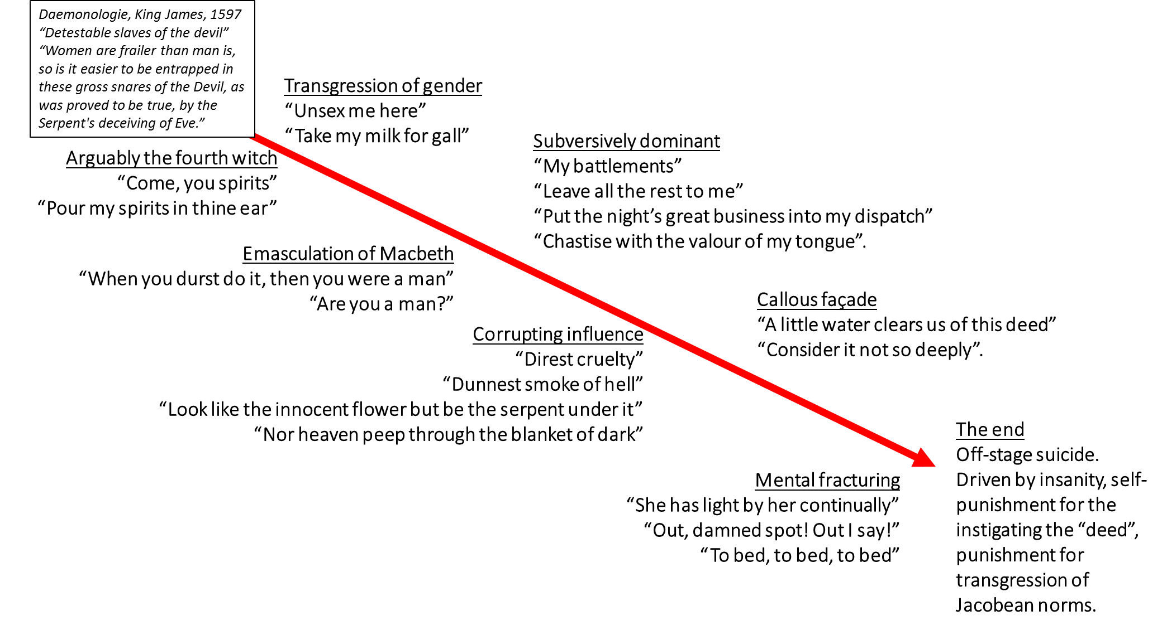
- Lady Macbeth [Task: add annotations]

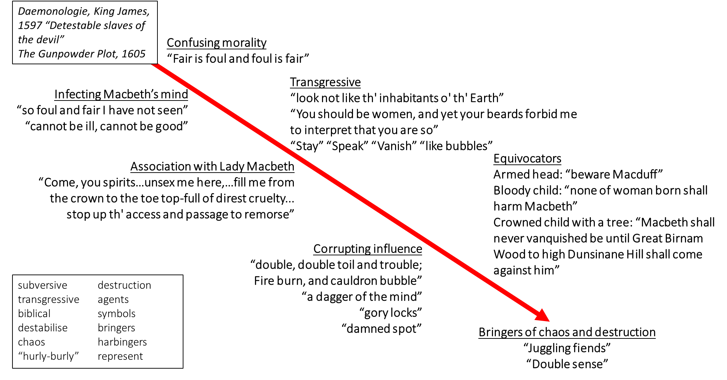
The witches [Task: add annotations]

Macbeth [Task: add annotations]
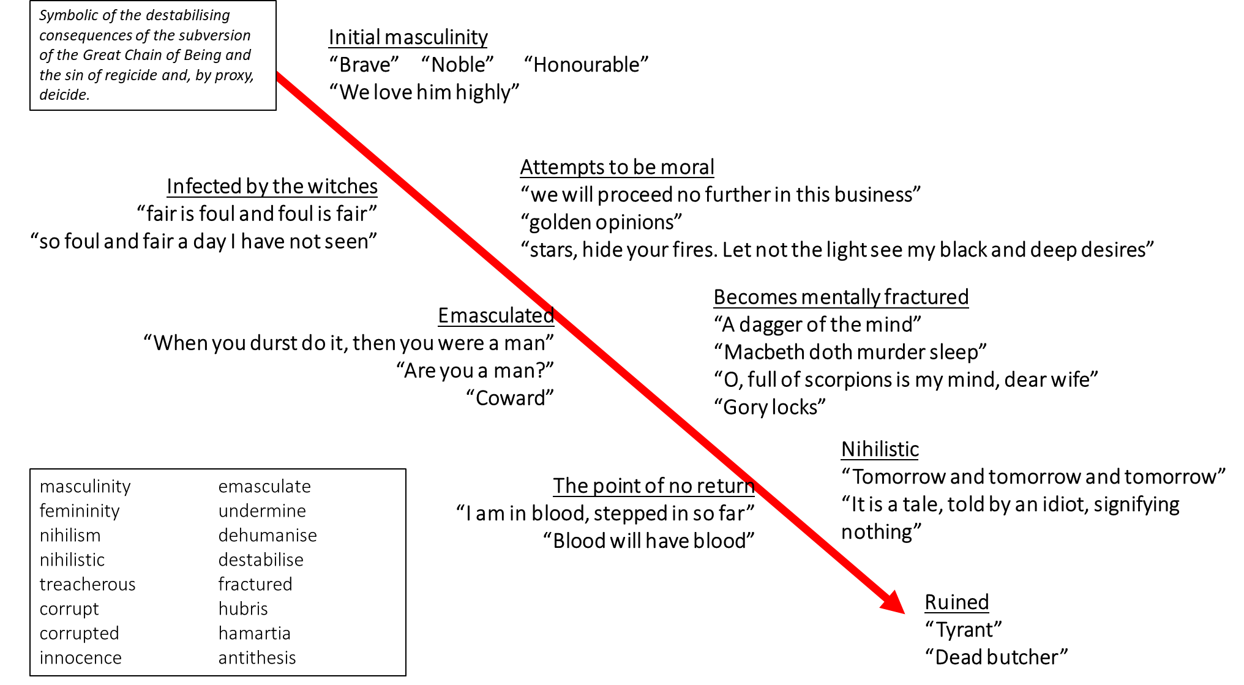

[Task: add annotations to these core quotations]

“fair is foul and foul is fair”

“look like the innocent flower but be the serpent under it”

“a dagger of the mind”

“Out damned spot! Out I say!”
“o full of scorpions is my mind, dear wife”

Life is “a tale, told by an idiot, signifying nothing”

Analysis Practice

- The witches are creators of chaos and turmoil. We see this when they chant “fair is foul and foul is fair.” In other words
In particular, the use of this paradox It is almost as if Perhaps Shakespeare intends to reveal

- Lady Macbeth commands Macbeth to wear a “false” façade and to be a duplicitous fiend. We see this when she tells him to “look like the innocent flower but be the serpent under it”. In other words
In particular, It is almost as if Perhaps Shakespeare intends to reveal

- Macbeth becomes mentally fractured and destabilised by his “bloody”, murderous and regicidal thoughts. We see this when he hallucinates a “dagger of the mind”. In other words
In particular, It is almost as if Perhaps Shakespeare intends to reveal

- Macbeth has almost become infected by the corrupting influence of the witches and Lady Macbeth. We see this when he cries “o, full of scorpions is my mind, dear wife”. In other words
In particular, It is almost as if Perhaps Shakespeare intends to reveal

- At the end of the play, Lady Macbeth has become almost mentally destroyed by the “deed”. We see this when she cries “Out damned spot! Out I say!” In other words
In particular, It is almost as if Perhaps Shakespeare intends to reveal

- After hearing the news of the death of his “dearest partner in greatness”, Macbeth becomes nihilistic and sees life as futile. He says life is “a tale, told by an idiot, signifying nothing.” In other words
In particular, It is almost as if Perhaps Shakespeare intends to reveal

Example Essay: How does Shakespeare present the theme of morality?
At its heart, Macbeth, written in approximately 1606, is a transgressive, didactic and instructive morality play that aims to demonstrate that chaotic, destabilising and “juggling” supernatural forces and “vaulting ambition” can create perpetual, continuous and inescapable “deep damnation” by depicting Macbeth’s drastic moral and psychological downfall.
Clearly the witches, who are seen as “detestable slaves of the devil” by King James in his book Daemonologie, transgress the rules and conventions of morality. This is seen through their paradoxical chant “far is foul and foul is fair”. In other words, they are telling the deeply religious Jacobean audience that they are “weird” creatures who invert or flip the meaning of good and bad. Here, Shakespeare implies that the witches are transgressive and subversive characters who aim to confuse and blur the boundaries between morality and immorality. More specifically, we might consider that they have the power to transform the “fair” “brave” and “noble” Macbeth into a “foul” “butcher”. Perhaps, in their chant, they create an expectation of chaos and destruction, which infects the whole play and its characters, causing mental fracturing and the fragmenting of the social hierarchy and moral rules. It could be that Shakespeare aims to present the witches as malevolent, malicious and misanthropic bringers of instability. More broadly, we may consider that the witches are used as symbols of the horror of challenging the stability of the Great Chain of Being; to break, deconstruct or destabilise this structure is to plunge society into chaos and to act as a “detestable slave of the devil”.

We observe that Lady Macbeth, arguably the fourth witch, is also presented as a disruptive and immoral force because she challenges the rules of morality. We see this when she commands Macbeth to “look like the innocent flower but be the serpent under it”. In other words, she is demanding that he conceal his sinful, “dark” and “black” “desires” beneath a façade or mask of innocence. More specifically, a “flower” has connotations of life, flourishing, nature, beauty, growth and femininity. Perhaps she is, in a sense, emasculating him in her command so that she can achieve dominance and superiority. Maybe she is aiming to force him to construct a veneer of natural benevolence to fool so that he can hide his regicidal and “serpent”-like actions from God, society and maybe even himself. It seems that her instruction for him to “be the serpent” demonstrates that she wants him to be demonic, satanic and malevolent because the Devil, in the Garden of Eden, was disguised as a “serpent”. This could demonstrate that Lady Macbeth is a manipulative, scheming and morally corrupting force, just like Eve (who committed the Original Sin). It may be that Shakespeare wants us to see Lady Macbeth as a character who is associated with the “serpent” because he wants to put forward the misogynistic Jacobean idea that women are morally twisted, vulnerable to influence by the devil and “dark” and therefore should be oppressed.

Shakespeare reveals that Macbeth’s morality has been corrupted by his thoughts about the “deed” and by Lady Macbeth and the “weird” witches. We see this when he hallucinates a “dagger of the mind”. In other words, he sees a “dagger” in front of him that he suspects is constructed by his corrupted “mind”. More specifically, a “dagger” is a weapon that is used to cut, stab or kill and therefore it is almost as if his own “mind” or maybe his mental stability has been cut, stabbed or killed by his “dark” “desires”. Perhaps the cause of his instability is Lady Macbeth, who uses her “gall” to infect his “mind” with the disease of immorality. Maybe his hallucination is caused by the witches, who invert the meaning of “foul” and “fair” and therefore force Macbeth’s world into inescapable chaos. It could be that the “dagger” has been constructed by Macbeth’s own “mind” because of his “vaulting ambition”, which reflects his hubris and foreshadows his descent because of this hamartia. It seems that forces of immorality surround Macbeth, even penetrating his “mind”. Thus we see that Shakespeare aims to show a Jacobean audience how vulnerable we are to “dagger”-like forces that can infect our “mind”.

We observe that, because of the their immoral thoughts and actions, both Lady Macbeth and Macbeth descend into insanity and mental fracturing. We see this when Lady Macbeth hallucinates a “spot” of blood, crying “out damned spot! Out I say!” and Macbeth, nihilistic, exclaims that life is a “tale told by an idiot, signifying nothing”. In other words, both Lady Macbeth and Macbeth are punished in mental “damnation” for their “serpent”-like “desires”. More specifically, Lady Macbeth’s “damned spot” of blood could represent her permanent guilt, regret or even remorse for her regicidal actions. It is almost as if she feels she has been mentally and physically stained by her immoral actions. In particular, the use of exclamation marks and repetition of “out” could demonstrate how desperate, anxious and frantic she is because she now understands that her soul, her mind and her psyche is “damned”. Perhaps Macbeth’s nihilistic response to Lady Macbeth’s death also shows that he knows he is “damned” It is as though, after the death of Lady Macbeth, he feels that he himself has been an immoral and hubristic “idiot”. Maybe he is calling God an “idiot”, demonstrating his blasphemous, “sacrilegious” and damning thoughts. It seems that, for Macbeth, now that he has entered into his world of sin so “deep[ly]”, life is “signifying nothing” because he has lost his sense of morality and therefore religion, hope and order. We are encouraged to see that “damnation”, mental fracturing and nihilism of Lady Macbeth and Macbeth was inevitable. A Jacobean audience may see the descent of Lady Macbeth and Macbeth as a “tale” of the horrifying consequences of immoral actions.

Practice Essays:
Write as many of these as you can. Each essay should be at least 4 paragraphs, like the example given.
- How does Shakespeare present the relationship between Macbeth and Lady Macbeth?
- How does Shakespeare present Macbeth as an evil character?
- How does Shakespeare explore the theme of morality?
- How does Shakespeare explore the theme of the supernatural?
- How does Shakespeare present the witches in the play?
- How does Shakespeare present ambition in the play?
- How far is Lady Macbeth the most powerful character?
- How far is Macbeth the most powerful character?
- How does Shakespeare present King Duncan?
- How does Shakespeare explore the character of Banquo?
- How does Shakespeare present the character of Macduff?
- How does Shakespeare present gender in the play?
- Explain how Shakespeare explores the theme of power.

Revision Cards:
- Make gap-fill quotation questions. For example “look like the innocent but be the under it”
- On the back of the revision card, write the answer. Test yourself.
- Make plot questions. For example: Does Macbeth hallucinate the “dagger” before or after he murders Duncan?
- On the back of the revision card, write the answer. Test yourself.

Complete 5 of these per day. Look up the answers and use them to create revision cards.
- When was Macbeth written?
- Where is Macbeth set?
- What do we call the audience of Macbeth?
- When was the Gunpowder Plot?
- What did the Gunpowder Plot try to destabilise?
- Who is King of Scotland at the start of the play?
- Where are the witches?
- “Fair is… and foul is…”
- Who are the witches expecting to meet?
- Macbeth is introduced as a “….” Man
- Macbeth kills Macdonwald violently. True or false?
- What are the names of Duncan’s sons?
- Ross tells Duncan that the Thane of …. has been treasonous
- Duncan sentences the Thane of … to death
- Who is Macbeth with when he meets the witches?
- When he arrives on the heath, Macbeth says “so … and … a day I have not seen”
- Although the witches look like women, they have …
- Macbeth is currently Thane of …
- The witches say Macbeth will be Thane of …
- The witches say Macbeth will be King of …
- The witches say “all … Macbeth”
- Banquo asks the witches to “look into the seeds of …”
- “Thou shalt get kings, though thou be none.” In other words, Banquo’s … will be king
- Although Macbeth commands the witches to “stay” and “speak”, they …
- After they hear the predictions, Angus and Ross arrive to tell Macbeth that he has been named Thane of …
- Macbeth thinks that the predictions “cannot be … cannot be …”
- Banquo thinks Macbeth is “rapt”. In other words…
- Malcolm is named the Prince of Cumberland, which means he will be King of …
- Macbeth thinks that The Prince of Cumberland is a “step on which I must fall down, or else …”
- “stars, hide your …”
- “let not light see my … and deep desires”
- Macbeth writes a letter to Lady Macbeth to tell her about …
- Macbeth is Lady Macbeth’s “dearest partner in …”
- Lady Macbeth is afraid that Macbeth is “too full of the … of human …”
- Lady Macbeth wants to “pour” her “…” into his ear
- Lady Macbeth says “come, you …”
- “un… he here”
- “fill me from the crown to the toe top-full of direst …”
- “take my … for …”
- “nor … peep through the … of dark”
- “… like the innocent … but be the … under it”
- Duncan trusts Lady Macbeth and Macbeth. True or false?
- Macbeth has “vaulting …”
- Macbeth says to Lady Macbeth “we will proceed no further in this …”
- However, Lady Macbeth emasculates him by calling him a “c...d”
- “when you durst [dared] do it, then you were a …”
- Lady Macbeth says that, if she had promised to do it, she would have “dashed” the “b… out” of her baby.
- Who do Lady Macbeth and Macbeth plan to frame for the murder?
- How will Lady Macbeth and Macbeth make
- Macbeth changes his mind; he agrees to commit the “deed”. He says that “f… face” must hide his “false heart”
- Before he commits the “deed”, Macbeth hallucinates a “dagger”. He thinks it could be a “dagger of the m…”
- Who did Duncan look like as he slept?
- Macbeth hears a voice cry “… no more. Macbeth does murder …”
- Which sound do Lady Macbeth and Macbeth hear repeatedly?
- What colour does Macbeth think his hands will stain the sea?
- How much water does Lady Macbeth think will “clean” their hands?
- What colour does Lady Macbeth call Macbeth’s heart?
- What does it mean to “equivocate”?
- There was a terrible storm the night that Macbeth killed Duncan. “The earth was feverous and did sh…”
- When Macduff sees Duncan’s dead body, he shouts “O horror, …, …”
- Macduff thinks the murder is “sacrilegious”. In other words…
- Macbeth killed the guards because he wanted to seem…
- Malcolm and Donalbain run away because they think “there’s … in men’s smiles”
- Malcolm goes to…
- Donaldbain goes to…
- In the old man and Ross’ conversation, we find out that Duncan’s horses “turned …” and “eat each other”
- Macbeth’s coronation is in Scone. However, who refuses to attend?
- Banquo fears Macbeth “play’dst most … for” the crown.
- Before the feast, Banquo goes out on a horse ride. Who does he go with?
- Macbeth decides to kill Banquo because of his “f…less crown”
- Who does Macbeth hire to kill Banquo?
- Macbeth says that his mind is “full of …”
- Who do the murderers kill?
- Who do the murderers not kill?
- Macbeth calls Fleance a “worm” “that in time will venom breed”. In other words...
- Whose ghost does Macbeth see at the feast?
- Lady Macbeth asks “are you a …?” when Macbeth sees the ghost
- “Blood will have …”
- Macbeth says to the ghost of Banquo “never shake thy gory … at me”
- What does “thy” mean?
- What does “thou” mean?
- What does “thee” mean?
- Macduff and Malcolm form an army against Macbeth in which country?
- Where does Macbeth live?
- Macbeth returns to the witches, who say “double, double toil and trouble; fire burn, and cauldron …”
- The First Apparition Macbeth sees is an “armed head”, which says “Beware …”
- The Second Apparition Macbeth sees is a “bloody child”, which says “none of … born shall … Macbeth”
- The Third Apparition Macbeth sees is a “child crowned, with a tree in his hand”, which says “Macbeth shall never vanquish’d be until Great B… wood to high D… hill shall come against him”
- Finally, Macbeth sees eight kings, which look like the Ghost of B…
- Macbeth finds out that Macduff has fled to E…
- Macduff is Thane of F…
- Macbeth plans to seize upon Fife to kill …
- When the murderers come to kills Macduff’s family, Macduff survives because…
- Malcolm says that Macbeth is a “t…” [cruel ruler]
- Macduff also says that Macbeth is a “t…” [cruel ruler]
- Macduff, after hearing his family have been killed, says “all my … ones? Did you say …?”
- Malcolm tells Macduff to “dispute it like a …”
- We see a Doctor, who has come to see Lady Macbeth because she is …walking
- Lady Macbeth has a “… by her continually”
- Lady Macbeth “… her hands”
- Lady Macbeth cries “Out, … spot! Out, I …!”
- “Who would have thought the old man to have so much … in him?”
- “What, will these hands ne’er be …?”
- “Here’s the smell of … still”
- “all the perfumes of Arabia will not sweeten this … hand”
- “to …, to …, to …!”
- Malcolm and Macduff’s gather near B… wood to fight against Macbeth
- Angus says that Macbeth’s title hangs “loose about him, like a g…’s robe upon a dwarfish thief”
- Macbeth says “I will not be afraid of death and bane till B… wood come to D…”
- Malcom tells his soldiers to cut down a bough [branch] from the trees in B… wood to conceal themselves
- We hear the cry of women and then we hear that “the …, my lord, is dead”
- “Tom… and tom… and tom… creeps in this petty pace”
- “Out, out, brief …”
- “It is a tale, told by an …, signifying …”
- Macbeth’s speech is nihilistic. This means that he believes that his life is …
- The messenger comes to tell Macbeth that it looks as though B… wood is moving
- Siward, like Malcolm and Macduff, calls Macbeth a “t…” [cruel ruler]
- Macbeth does not fear Macduff because Macduff is “born of …”
- Macduff tells Macbeth, at the end of the play that he was “from his mother’s womb un… ripped”
- Macbeth calls the witches “juggling f…”
- Macduff, like Lady Macbeth, calls Macbeth a “c…d”
- Macduff arrives with “Macbeth’s head” and they “Hail, King of Scotland!” The new King of Scotland is M….
- At the end of the play, Malcolm calls Macbeth a “dead b…” and calls Lady Macbeth his “f…-like queen”
- What is the name of Banquo’s son?
- What is the name of Malcolm’s brother?
- What is the name of Malcolm’s father?
- What is the opposite of malevolent?
- What does transgress mean?
- What is the opposite of order?
- What is the opposite of concrete?
- What is the opposite of physical?
- What is the opposite of moral?

