De Aston
English Department
Year 10: Be the Examiner!
Language Paper 1 Challenge Tasks
(You should be spending 1-2 hours each week on these challenges)

Name:
Week Four: Question 3 – Create and answer Question 3 - Structure
You now need to think of the whole source. This extract is taken from the _________ of the novel.
How has the writer _______________ the text to __________ you as the reader?
You could write about:
- What the writer focusses your attention on at the ________
- How and why the writer changes this focus as the extract develops
- Any other structural ________________that interest you. (Marks _______)
Remember structure includes, change of focus, repetition, flash back, flash forward, inclusion of dialogue, change of location, sentence lengths etc. You need to know the answer so you can mark your peers.
Do you need to revisit your original extract and improve it?

Week One and Two: - Writing the Extract
This term, you are going to produce an extract, questions and answers. Remember that you will be giving your exam paper to one of your peers to answer, then you will be marking it and giving feedback.
TASK: You need to produce at least one word processed A4 side of creative writing. Remember that a story needs: an attention grabbing opening, an introduction that sets the scene; a complication that starts the main action; a climax where the tension peaks and a resolution where all our questions are answered. You also need to make sure you craft your writing, thinking about sophisticated vocabulary and punctuation, varied sentence structures and using techniques such as simile, metaphor and personification. You should spend 40 minutes on this homework and try to produce one word processed piece of A4.
Do not forget to tell the reader where your extract is taken from: is it at the beginning, middle or end of your story?
You may have to improve this task as you begin to create and answer the answers below.

Week Three: - Create and answer Question 1 and Two
Question 1 – List four things you learn about………………… You will now need to answer your question so you will know the answers! (Marks ______)
Question 2 – How does the writer use ________________ to describe (the) __________.
You could include the writer’s choice of: (Marks ______)

________________________________________________________________________________

Again, you will need to answer the question (Aim for 2 squad paragraphs in 10 minutes so you will know the answer when you mark your peers)
DO NOT LOSE THESE ANSWERS AS YOU WILL NEED THEM LATER ON IN THE TERM.

Week Five: - Question 4 – Create and answer Question 4 – Evaluate – (Eat a PEACH!)
Focus this part of your answer on the ________________ half of the extract.
A student having read this section of the text said ‘This is the ________. It is as if you are ___________’. To what extent do you agree?
- In your response, you could:
- Write about your own impressions of the ________
- Evaluate HOW the writer has created theses impressions (HINT – these are the language methods, similes, personification etc.)
- Support your opinions with quotations from the text (Marks_______)
Remember: Question 4 is question 2 and 3 put together.
PEACH can be a useful acronym to use:
- P = personal opinion ‘I agree….’
- E = evidence ‘this is clear when…’
- A = analyse ‘This suggests….’ ‘This could imply that …’ ‘However…’
- CH – choice of words ‘The noun ghost has connotations with….’
Do you need to revisit your original extract to improve it?
You need to know the answer so you can mark your peers.

Key terms: Structure and Sentence forms
The following terms will all be useful to you throughout your studies of English, particularly in English Language Paper 1 where you are required to analyse structure. Make sure you understand what each term means and can identify examples in the texts you read. You will cover many of them as part of your QWC/SPAG lessons this term, so check your notes if there are any you are unsure about.
Hard  chronological  climax  complex sentence  complication  compound sentence  compound-complex sentence  declarative sentence  exclamatory sentence  foreshadowing  imperative sentence  interrogative sentence  introduction  main/independent clause  minor sentence  narrative hook  resolution  simple sentence  subordinate/dependent clause | Harder  analepsis (flashback)  anaphora  cataphora  coherence  cohesion  counter argument  denouement  exposition  falling action  participle  prolepsis (flashforward)  rising action | Hardest  allofunctional implicature  appositive  complement clause  non-restrictive clause  parallel construction  relative clause  restrictive clause

Week Seven: Be the Examiner!
Get your paper back and mark the question:
Week Six: Sit the exam!
Swap your paper with a friend and answer their paper.

Mark Scheme Question 1.
1 mark for each correct answer. Check they are from the correct lines

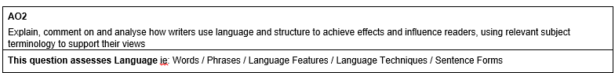
Mark Scheme Question 2.

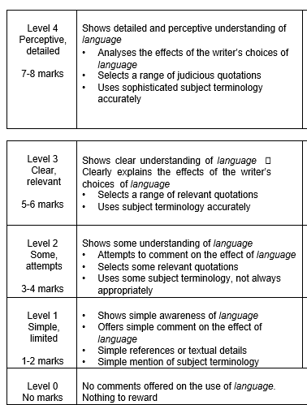

Mark Scheme Question 3.
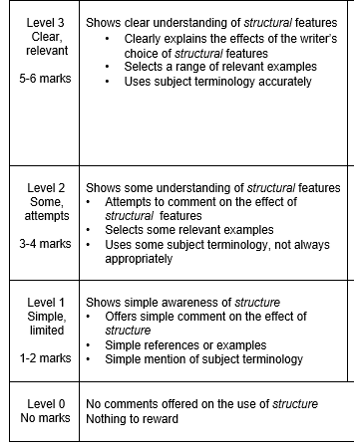
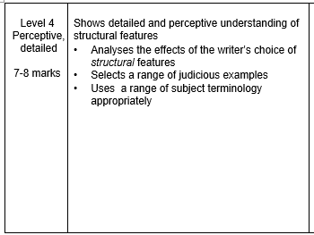

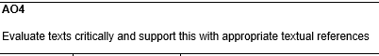
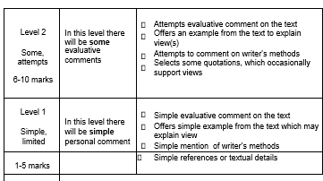
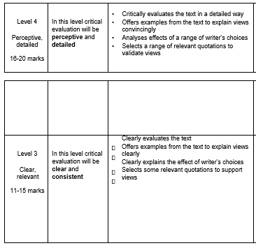

Mark Scheme Question 4

For more resources, including literacy support, visit www.deastonenglish.com

Quotes to Learn – You will be tested on them
Week One - Macbeth:
- ‘so foul and fair a day I have not seen’ – linguistic echoes – mimics witches.
- ‘But how Thane of Cawdor?’ – questions witches – involved/curious
- ‘Speak, I charge you’ – imperatives – hint of power
- ‘whose horrid image doth unfix my hair’ – first hallucination – frightens him
- ‘whose murder is but yet fantastical’ – already thinking of Duncan’s murder
- Banquo: ‘look, how our partner’s rapt’ – notices he is spellbound
- ‘stars, hide your fires: let not light see my black and deep desires’ – inherently evil? Cosmic allusions – believes it is his fate?
- ‘if it were done when ‘tis done, then ‘twere well it were done quickly.’ - ponders regicide.

Quotes to Learn – You will be tested on them
Week 2 Macbeth
- ‘he’s here in double trust’ – doubt
- ‘vaulting ambition, which o’erleaps itself and fails on the other’ – hamartia
- Lady Macbeth: ‘when you durst do it, then you were a man’ – challenges his masculinity
- ‘I dare to do all that may become a man; who dares do more is none’ – flaw – wants to prove he is a man. Pride.
- ‘is this a dagger which I see before me’ – hallucination as he gets deeper
- ‘Sleep no more! Macbeth does murder sleep, the innocent sleep’ – significance of regicide compromises peace and innocence.
- ‘will all great Neptune’s ocean wash this blood clean from my hand?’ – blood foreshadows his death. Hyperbole.
- ‘never shake thy gory locks at me’ – hallucinations show vulnerability of language.

Quotes to Learn – You will be tested on them
Week 3 Macbeth
- ‘what need I fear of thee?’ - pride
- ‘give to the edge o’ the sword his wife, his babes, and all unfortunate souls’ - violence
- ‘give me my armour’ – imperatives and instructions until the end
- ‘she should have died hereafter’ – callous lack of concern – echoes ‘out damn spot!’ – shows that death brings her peace from the permanent stain of guilt
- ‘out, out, brief candle!’
- ‘life’s but a walking shadow, a poor player...signifying nothing
- ‘I bear a charmed life’ – links back to witches but also hubris.

