De Aston
English Department
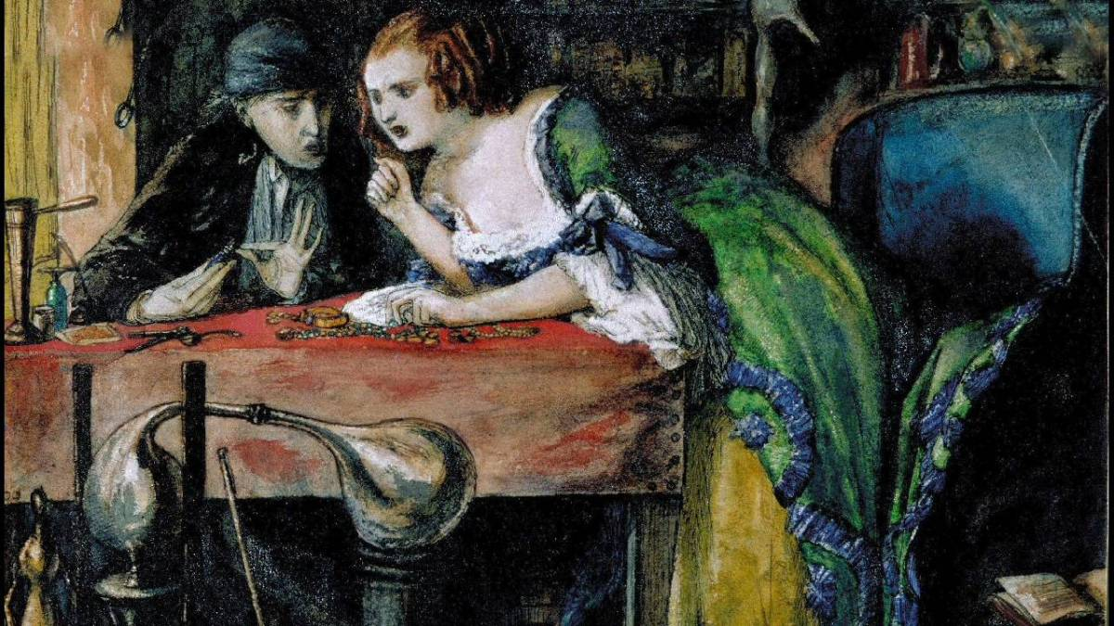
Year 13: Crime Poetry
Academic Excellence Booklet

Activity 1 – The Poems: Social Commentary
For each of the poems consider:
- What aspects of society does the writer appear to be criticising in the poem?
- To what extent does the writer present the criminal as a product of their society?
- In what ways does the writer criticise the justice system of the time the crime was committed?

Activity 2 – The Poems: The Criminal Psyche
All five poems explore the criminal psyche in some detail but in very different ways. For each poem:
- Draw a table with two columns and on one side record any ideas that make you feel sympathy for the criminal, and on the other side record any ideas that make you condemn the criminal.
- Use this table to help you draw conclusions on what the writer was trying to say about the criminal mindset.

Activity 3 – The Poems: Browning’s women
Focus on ‘My Last Duchess’ and ‘Porphyria’s Lover’ for this task.
Browning inflates and explodes romantic egotism: the lover kills the woman, not he. But the death that preserves the woman’s imputed compliance is, Browning implies, but a formalization of the romantic male speaker’s desire to fix and possess the female beloved. Romantic poetry idealizes the woman who is subject to the male gaze; she is the reflector and guarantor of male identity. Hence the male anxiety about woman’s independence, for her liberty puts masculine self-estimation at risk” (Maxwell).
- Considering Maxwell’s comments on the two poems, consider how female sexuality is commented on by the narrator and how each male character attempts to ‘fix’ sexuality.
Activity 4 – The Poems: Wilde
Read The Guardian’s Poem of the Week: Ballad of Reading Gaol and answer the following:
- Summarise the article in terms of what it reveals about Wilde’s wider context.
- How does the protagonist, and Charles Wooldridge, seem to transform in the poem?
- Finally, summarise what you think Wilde meant by the phrase ‘each man kills the thing he loves’.
Activity 5 – The Poems: Planning a response
- Plan a response to the following Section B question:
- The main focus of interest in the poems of Crabbe, Browning and Wilde is celebrating the criminal.’
To what extent do you agree with this view? Remember to include in your answer relevant detailed exploration of the poets’ authorial methods.
You should refer to ‘My Last Duchess’ and at least one other poem.
For more resources, including literacy support, visit www.deastonenglish.com

