**De Aston**

**English Department**

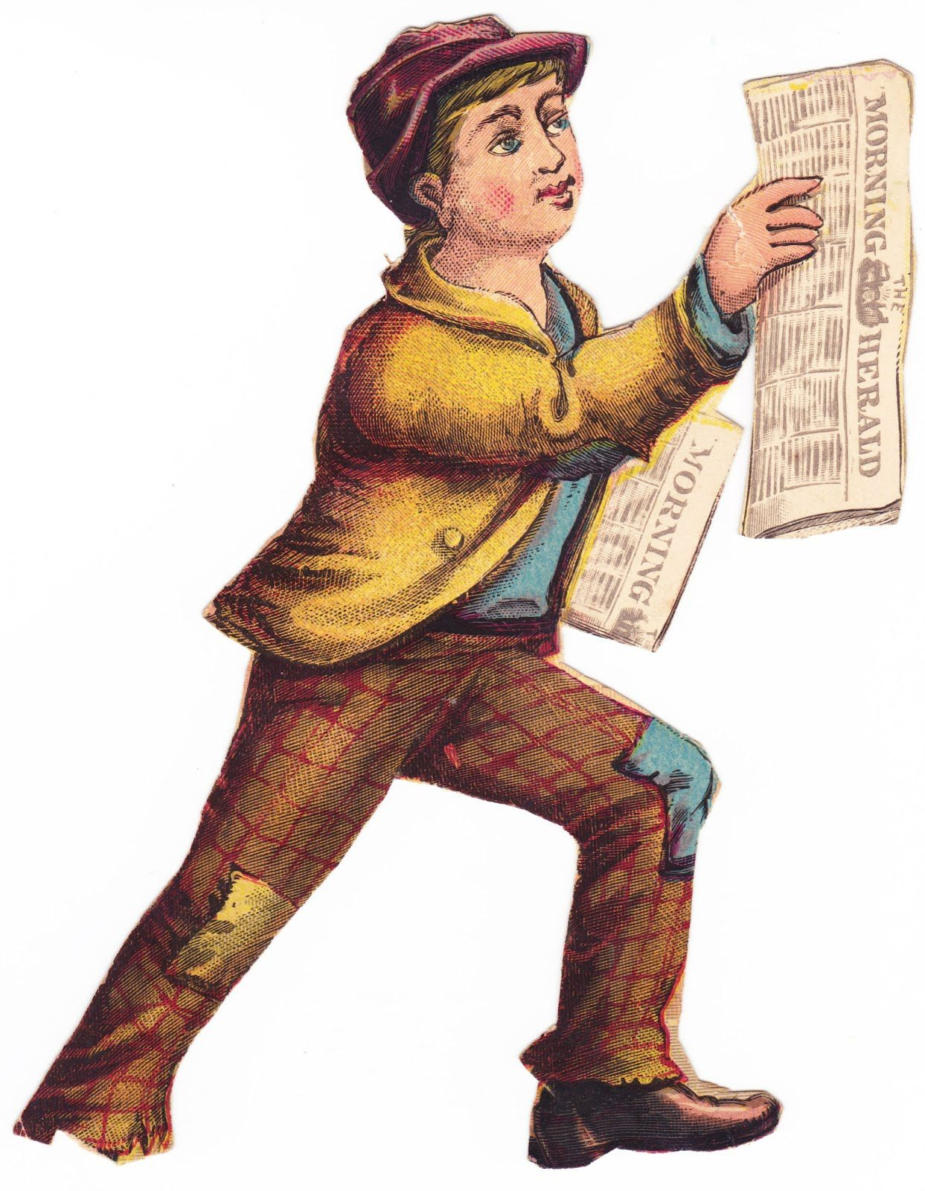

**Year 9: Read All About It!**

**Academic Excellence Booklet**

The role of the Academic Excellence Booklet is for you to complete these tasks over the next six weeks. These activities are purposely designed to challenge you, so don’t worry if you find them difficult. You’re meant to! Learning happens when people have to think hard. That being said, your English teacher is a specialist, so ask any of us for help, anytime!

1. **Sensationalism:**

* Considering your knowledge of Victorian society so far, from your study of *Dorian Gray*, write a brief summary as to why the Victorians had turned to sensationalism in the media. The Dark Histories podcast on ‘Everyday Sensationalism in Victorian Britain’ is a good place to start.

1. **Sensationalist Novel:**

As well as adding Sensationalism to their nonfiction, Victorians also loved it in their literature! The common themes in sensationalist novels included:

* bigamous marriages
* misdirected letters
* romantic triangles
* heroines placed in physical danger
* drugs, potions, and/or poisons
* characters adopt disguises
* trained coincidences
* aristocratic villains
* heightened suspense detailism

Using these tropes above, create your own sensationalist story – you can adapt an existing story if you wish.

1. **Dear Diary…**

Amy Pearce was 20 when the following diary entry was made. She was part of a middle class family and had an anxious disposition. Her only brother, Hugh left home in disgrace and suffered a loss of social position. Her writing is guarded at times and has a melodramatic tone redolent of some Victorian fiction. After reading, create your own diary entry in the same style about your day.

**July 22 1873:** As usual I make all kinds of resolutions & fail to keep them. I am feeling so wretched, so miserable, we heard today something dreadful, something I cannot & will not believe. Oh I pray it may not be true, it is enough to shake one's confidence in God, in heaven, in everything. Dear Mr Chapman: It is about him, but I cannot say what it is. I do not, I will not believe it. It makes me so wretched. I feel I want to die. Is there no good really in the world? It seems to me as though every one I ever looked to as being upright, godly men was being taken away from me and I feel inclined to think that there is not a good man living. I am so miserable. My darling brother too, his sin is a light one compared with others. He has not written yet and we are still in complete ignorance as to where he is.



For more resources, including literacy support, visit www.deastonenglish.com