De Aston
English Department

Year 12: Fiction Writing
Academic Excellence Booklet

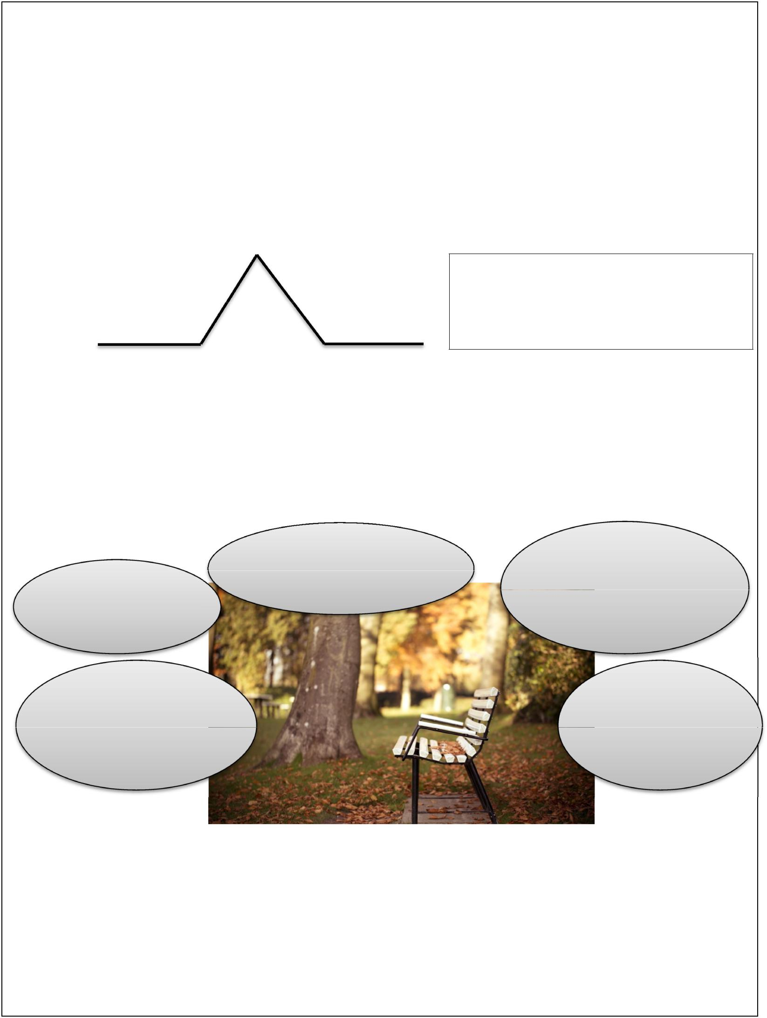
Paper 1 Q5 Tips:

You don’t have to describe the picture exactly, it’s just there to start you off. You could end up writing about something based on a very small piece of it.

You might be asked to describe, narrate, or describe & narrate. Describe: a description, it doesn’t necessarily have a plot BUT, some sort of journey/movement in your writing makes it far more engaging. Narrate: a story, or part of with a structure and dialogue.

Think about the structure of narratives. Good stories have a narrative arc:

A climax or difficulty

Setting the scene _{The resolution}

There are more complicated versions but for your exam you need to keep it relatively simple as you only have 45 minutes at the very most.

If you’re using dialogue, make sure you keep it interesting. Don’t include everything.

Use “speech marks” and avoid he said / she said. Use a different verb, or make it clear from what they are saying who it is. Start a new line for each change of speaker.

Think carefully about the perspective you write from. You don’t have to go for the obvious. For example in this picture, you could be the park bench describing what it has seen/heard during the day/night.

Who/What are

you?

Where are you? What can you see/feel/hear??
When is it - season?

time of day?

When do you reveal who / what you are?

What small details will you use?

Vocabulary: use the ambitious vocabulary from the grids BUT don’t over do it. It’s like too much chocolate sauce on your pudding and makes it sickly!

Punctuation: Use a range of punctuation to help control your writing. The basics such as capitals at the start of sentences and full stops are NON NEGOTIABLE. You should be using commas, speech marks, question and exclamation marks correctly as well. ( , ? @ @ ! )

Paper 2 Q5 Tips:

You don’t have to agree with the statement. But, you should think carefully about your reasons for either agreeing or disagreeing. Sometimes the obvious opinion is harder to argue for.

Check what you are writing: a letter, article, speech?

Think about the structure of your writing and what order you will present your ideas. Don’t put all your strong points at the start, try to finish with some impact.

Remember the techniques which can help your writing be argumentative:

Rhetorical questions - a question that doesn’t need a reply because the answer is obvious.

Eg: Are teenagers all hardened criminals?

Would you put shampoo in your rabbit’s

Facts & Statistics - used to support your point. You can just make them up, they don’t need to be real. But do state where they come from.

Eg: 40% of women are happy with their

body.

Rule of Three - Using three adjectives to

describe something is a powerful

technique.

Eg: Footballers are overpaid, juvenile &

egotistical.

Use of present tense - Creates a sense of urgency as it is a current issue that needs addressing immediately.

Eg: Right now, millions of endangered species are being hunted by poachers.

Directly addressing the reader - using words such as ‘you’, ‘we’, ‘our’ creates a bond and encourages your audience to agree with you.

Eg: Together we can do this. You wouldn’t want it to happen to you.

Emotive Language - powerful words used to create emotions in the reader.

Eg: Speeding motorists are murderers.

STRUCTURE

‘Number’ or order your paragraphs in a logical order - ‘Firstly, I strongly believe… Finally… Use of connectives - Furthermore, it is vital that… However, it is believed that… In addition… Repetition - Using a particular word or phrase throughout your argument is a powerful tool.

Topic sentences - The opening sentence of your paragraph should indicate what your paragraph is focussing on. Eg: Plastic surgery has many dangers...

Task 1 (Paper 1 Q5 – Writing to describe and/or narrate):

- Vocabulary: Complete the exercise finding the alternative words for the vocabulary below. The first two have been done for you.

Ambitious word | Alternative word | Ambitious word | Alternative word
electrified | excited | tenacious
ensnare | trap | zenith
wretched |  |  | happy
 | dead | tumultuous
mendacious |  |  | honest

- Writing task: Write the opening to a short story suggested by this picture.

Plan all these elements before you write:

 | Perspective: | Who or what are | A narrator? The sand? The man (alive)? The
 |  | you writing as? | body (dead)? A crab?
 | Setting: | Where is it? | Desert island? UK beach? Holiday beach?
 |  |  | Mysterious place?
 | Time: | What time is it? | Early morning? Middle of the day?
 |  | Why is this here? | Are they resting? Dead? Exhausted? Dumped?
 | Plot: |  | Why?
 |  | What is going to | Will they be discovered? Will they recover?
 |  | happen? | What detail are you going to focus on?
 | My Plan:
Perspective: |  |  | Setting:

Time: Plot:

Jump Start - Use one or more of these to get you started if you can’t think of your own way:

"Did you enjoy yourself last night?" | He looked familiar…
The attack was over in seconds. | I wasn’t meant to be here.
There was a smell so rancid I felt the | The sea was approaching but I couldn’t
contents of my stomach begin to
 | move a muscle.
regurgitate.

Some techniques you should try to use if they are appropriate to your writing:

- Powerful adjectives

- Adverbs to describe your verbs

- Describing things using similes, metaphors or personification.

O Dialogue between characters – use speech marks (keep it brief)

O Range of sentences and sentence openings

O Appeal to the senses in your writing when describing a scene.

……………………………………………………………………………………………………………………

……………………………………………………………………………………………………………………

……………………………………………………………………………………………………………………

……………………………………………………………………………………………………………………

……………………………………………………………………………………………………………………

……………………………………………………………………………………………………………………

……………………………………………………………………………………………………………………

……………………………………………………………………………………………………………………

……………………………………………………………………………………………………………………

……………………………………………………………………………………………………………………

……………………………………………………………………………………………………………………

……………………………………………………………………………………………………………………

……………………………………………………………………………………………………………………

……………………………………………………………………………………………………………………

……………………………………………………………………………………………………………………

……………………………………………………………………………………………………………………

……………………………………………………………………………………………………………………

……………………………………………………………………………………………………………………

……………………………………………………………………………………………………………………

……………………………………………………………………………………………………………………

……………………………………………………………………………………………………………………

……………………………………………………………………………………………………………………

……………………………………………………………………………………………………………………

……………………………………………………………………………………………………………………

……………………………………………………………………………………………………………………

……………………………………………………………………………………………………………………

……………………………………………………………………………………………………………………

……………………………………………………………………………………………………………………

……………………………………………………………………………………………………………………

……………………………………………………………………………………………………………………

……………………………………………………………………………………………………………………

……………………………………………………………………………………………………………………

……………………………………………………………………………………………………………………

……………………………………………………………………………………………………………………

……………………………………………………………………………………………………………………

……………………………………………………………………………………………………………………

……………………………………………………………………………………………………………………

……………………………………………………………………………………………………………………

……………………………………………………………………………………………………………………

……………………………………………………………………………………………………………………

……………………………………………………………………………………………………………………

……………………………………………………………………………………………………………………

……………………………………………………………………………………………………………………

……………………………………………………………………………………………………………………

……………………………………………………………………………………………………………………

……………………………………………………………………………………………………………………

……………………………………………………………………………………………………………………

……………………………………………………………………………………………………………………

……………………………………………………………………………………………………………………

……………………………………………………………………………………………………………………

……………………………………………………………………………………………………………………

……………………………………………………………………………………………………………………

……………………………………………………………………………………………………………………

……………………………………………………………………………………………………………………

……………………………………………………………………………………………………………………

……………………………………………………………………………………………………………………

……………………………………………………………………………………………………………………

……………………………………………………………………………………………………………………

3. Don’t forget to proof read & tick off the basics as you do them.

Get the basics right & the rest will follow.

Tick these when you’ve checked them.

- All my sentences have a capital letter & full stop.

- All my basic spelling is right & I’ve checked ones I don’t know.

- I’ve used a range of punctuation including commas, question marks

and speech marks.

- I’ve varied the types of sentence starts and sentence lengths. O I’ve used paragraphs correctly (change of Time, Topic, Place,

Person).

O I’ve read through my work to make sure it makes sense. O Spellings I’m not sure about:

-

-

-

Task 2 (Paper 2 Q5 – Writing viewpoints and perspectives):

- Vocabulary: Complete the exercise finding the alternative words for the vocabulary below. The first two have been done for you.

Ambitious word | Alternative word | Ambitious word | Alternative word
encompassing | including | abhorrent
vitriol | hatred |  | strange
jeopardy |  | eccentric
 | dangerous |  | trapped
egotistic |  | harbour (as a verb)

- Read the article on animal testing. Using two different colours highlight reasons for and against animal testing. Make a key on the text.

Source: An online newspaper article about companies reducing the amount of testing on animals called, ‘Drug and cosmetics firms back plan to cut animal testing’ by Richard Gray.

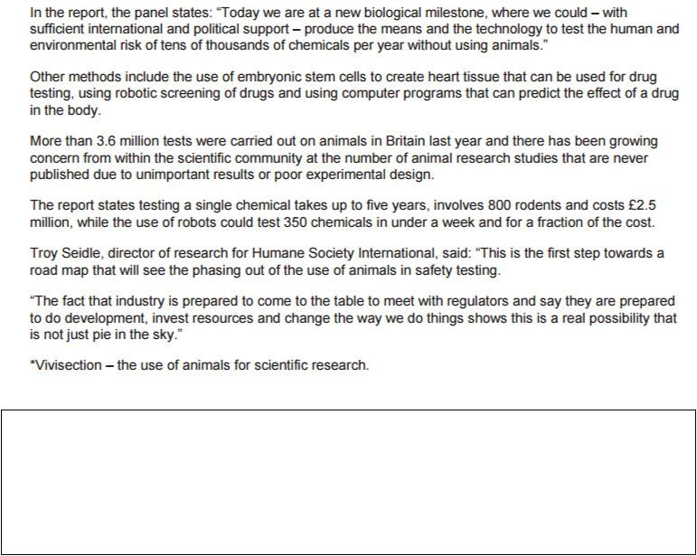

- Read the following statement and write a letter to your local MP in which you argue your case, for or against the use of animal testing.

‘Animal Testing is barbaric and should be made illegal no matter what the benefits.’

Plan all these elements before you write: (An example has been given for this first task)

Text Type |  | What and to whom are you |  |  | Letter – remember addresses,
Audience |  | writing? |  |  | Dear/Yours Faithfully
Purpose |  | Agree or |  |  | Agree
 |  | Disagree?
 | Point 1 |  |  | Animals aren’t the same as humans.
Reason 1 |  |  |  | Testing is ineffective & unreliable.
Benefit 1 |  |  |  | Animals don’t suffer pointlessly
 | Point 2 |  |  | Animals don’t lead natural life.

Reason 2 | Confined to cages. No natural daylight.
Benefit 2 | Animals aren’t bred simply for experiments.
Point 3 | Cosmetics don’t need to be tested on animals.
Reason 3 | Already successfully tested without using animals.
Benefit 3 | Money can be invested into non cruel ways of
 | testing cosmetics.
What are the opposing | Essential medical drugs need testing.
 | Testing on humans ineffective.
ideas you will challenge?
 | Less chance of it going wrong & harming humans.

Now complete your own plan.

Text Type
What and to whom are you writing?
Audience

Purpose | Agree or Disagree?

Point 1

Reason 1

Benefit 1

Point 2

Reason 2

Benefit 2

Point 3

Reason 3

Benefit 3

What are the opposing ideas

you will challenge?

Jump Start - Use one or more of these to get you started if you can’t think of your own way:

Start with a statistic | Start with a rhetorical question
Imagine life as a rat in a cage, never seeing | Imagine your loved ones taking a drug
the light of day. | that has never been tested.
Animal testing has long been debated but | Only the weak minded would put the
in a cancerous world how can we put the | lives of animals before those of
lives of animals before our own species? | humans.

Some techniques you should try to use if they are appropriate to your writing:

- Rhetorical Questions

- Facts & Statistics – say where the stats are from (eg Department of Education, Chief

medical advisor to the Government)

- Direct Address

- Emotive vocabulary

- Rule of 3 – why not try 4? O Repetition

……………………………………………………………………………………………………………………

……………………………………………………………………………………………………………………

……………………………………………………………………………………………………………………

……………………………………………………………………………………………………………………

……………………………………………………………………………………………………………………

……………………………………………………………………………………………………………………

……………………………………………………………………………………………………………………

……………………………………………………………………………………………………………………

……………………………………………………………………………………………………………………

……………………………………………………………………………………………………………………

……………………………………………………………………………………………………………………

……………………………………………………………………………………………………………………

……………………………………………………………………………………………………………………

……………………………………………………………………………………………………………………

……………………………………………………………………………………………………………………

……………………………………………………………………………………………………………………

……………………………………………………………………………………………………………………

……………………………………………………………………………………………………………………

……………………………………………………………………………………………………………………

……………………………………………………………………………………………………………………

……………………………………………………………………………………………………………………

……………………………………………………………………………………………………………………

……………………………………………………………………………………………………………………

……………………………………………………………………………………………………………………

……………………………………………………………………………………………………………………

……………………………………………………………………………………………………………………

……………………………………………………………………………………………………………………

……………………………………………………………………………………………………………………

……………………………………………………………………………………………………………………

……………………………………………………………………………………………………………………

……………………………………………………………………………………………………………………

……………………………………………………………………………………………………………………

……………………………………………………………………………………………………………………

……………………………………………………………………………………………………………………

……………………………………………………………………………………………………………………

……………………………………………………………………………………………………………………

……………………………………………………………………………………………………………………

……………………………………………………………………………………………………………………

……………………………………………………………………………………………………………………

……………………………………………………………………………………………………………………

……………………………………………………………………………………………………………………

……………………………………………………………………………………………………………………

……………………………………………………………………………………………………………………

……………………………………………………………………………………………………………………

……………………………………………………………………………………………………………………

……………………………………………………………………………………………………………………

……………………………………………………………………………………………………………………

……………………………………………………………………………………………………………………

……………………………………………………………………………………………………………………

……………………………………………………………………………………………………………………

……………………………………………………………………………………………………………………

……………………………………………………………………………………………………………………

……………………………………………………………………………………………………………………

3. Don’t forget to proof read & tick off the basics as you do them.

Get the basics right & the rest will follow.

Tick these when you’ve checked them.

- All my sentences have a capital letter & full stop.

- All my basic spelling is right & I’ve checked ones I don’t know.

- I’ve used a range of punctuation including commas, question marks

and speech marks.

- I’ve varied the types of sentence starts and sentence lengths.

- I’ve used paragraphs correctly (change of Time, Topic, Place, Person). O I’ve read through my work to make sure it makes sense.

O Spellings I’m not sure about:

-

-

-

Task 3 (Paper 1 Q5 – Writing to describe and/or narrate):

- Vocabulary: Complete the exercise finding the alternative words for the vocabulary below. The first two have been done for you.

Ambitious word | Alternative word | Ambitious word | Alternative word
valiant | brave | crestfallen
teeming | filled |  | dark
 | screamed | malevolent
repugnant |  |  | trapped
 | broken | apocalyptic

- Writing task: Write a description suggested by this picture. or

Write the opening part of a suspense story.
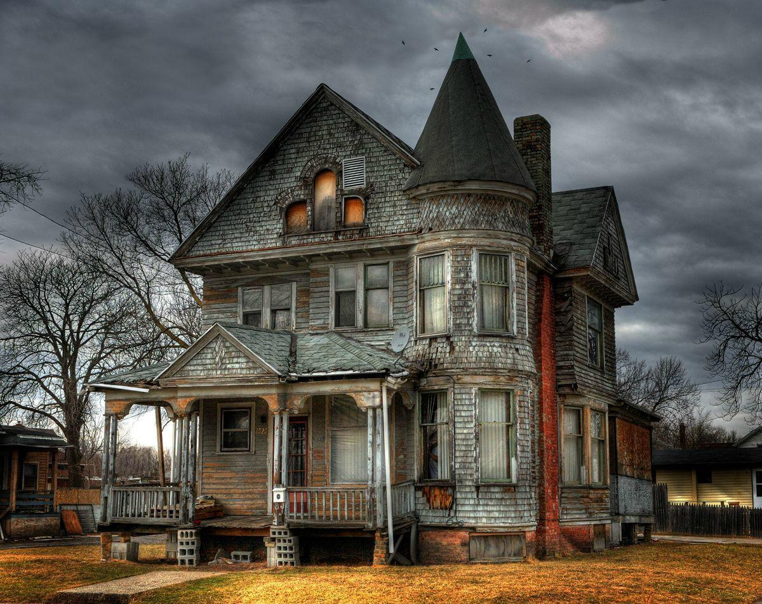

Plan all these elements before you write:

 | Perspective: | Who or what are | A narrator? The house? A visitor? Someone
 |  | you writing as? | inside the house? The trees? A bird in the sky?
 | Setting: | Where is it? | In the middle of a forest? In a new estate? In a
 |  |  | remote & isolated location?
 | Time: | What time is it? | Early morning? Middle of the day? Dusk/Dawn?
 |  | What is | Is some one trapped? Has the house been
 | Plot: | happening? | bought to be restored? Has it been abandoned?
 |  |  | Is someone who used to live there visiting it?
 | My Plan:
Perspective: |  |  | Setting:

Time: Plot:

Jump Start - Use one or more of these to get you started if you can’t think of your own way:

As the policeman pulled up in front of the | Under normal circumstances he would
house, he knew immediately that there | speak his mind, but, with a gun against
would be trouble. | his head…
The pink glove lay on the ground, almost | The entrance to the house was his
covered by leaves. | only way escape.
He had waited twenty years to return. | They had to make sure that none of
 | the neighbours noticed.

Some techniques you should try to use if they are appropriate to your writing:

- Powerful adjectives

- Adverbs to describe your verbs

- Describing things using similes, metaphors or personification.

O Dialogue between characters – use speech marks (keep it brief)

O Range of sentences and sentence openings

O Appeal to the senses in your writing when describing a scene.

……………………………………………………………………………………………………………………

……………………………………………………………………………………………………………………

……………………………………………………………………………………………………………………

……………………………………………………………………………………………………………………

……………………………………………………………………………………………………………………

……………………………………………………………………………………………………………………

……………………………………………………………………………………………………………………

……………………………………………………………………………………………………………………

……………………………………………………………………………………………………………………

……………………………………………………………………………………………………………………

……………………………………………………………………………………………………………………

……………………………………………………………………………………………………………………

……………………………………………………………………………………………………………………

……………………………………………………………………………………………………………………

……………………………………………………………………………………………………………………

……………………………………………………………………………………………………………………

……………………………………………………………………………………………………………………

……………………………………………………………………………………………………………………

……………………………………………………………………………………………………………………

……………………………………………………………………………………………………………………

……………………………………………………………………………………………………………………

……………………………………………………………………………………………………………………

……………………………………………………………………………………………………………………

……………………………………………………………………………………………………………………

……………………………………………………………………………………………………………………

……………………………………………………………………………………………………………………

……………………………………………………………………………………………………………………

……………………………………………………………………………………………………………………

……………………………………………………………………………………………………………………

……………………………………………………………………………………………………………………

……………………………………………………………………………………………………………………

……………………………………………………………………………………………………………………

……………………………………………………………………………………………………………………

……………………………………………………………………………………………………………………

……………………………………………………………………………………………………………………

……………………………………………………………………………………………………………………

……………………………………………………………………………………………………………………

……………………………………………………………………………………………………………………

……………………………………………………………………………………………………………………

……………………………………………………………………………………………………………………

……………………………………………………………………………………………………………………

……………………………………………………………………………………………………………………

……………………………………………………………………………………………………………………

……………………………………………………………………………………………………………………

……………………………………………………………………………………………………………………

……………………………………………………………………………………………………………………

……………………………………………………………………………………………………………………

……………………………………………………………………………………………………………………

……………………………………………………………………………………………………………………

……………………………………………………………………………………………………………………

……………………………………………………………………………………………………………………

……………………………………………………………………………………………………………………

……………………………………………………………………………………………………………………

……………………………………………………………………………………………………………………

……………………………………………………………………………………………………………………

……………………………………………………………………………………………………………………

……………………………………………………………………………………………………………………

……………………………………………………………………………………………………………………

3. Don’t forget to proof read & tick off the basics as you do them.

Get the basics right & the rest will follow.

Tick these when you’ve checked them.

- All my sentences have a capital letter & full stop.

- All my basic spelling is right & I’ve checked ones I don’t know.

- I’ve used a range of punctuation including commas, question marks

and speech marks.

- I’ve varied the types of sentence starts and sentence lengths.

- I’ve used paragraphs correctly (change of Time, Topic, Place, Person). O I’ve read through my work to make sure it makes sense.

O Spellings I’m not sure about:

-

-

-

-

Task 4 (Paper 2 Q5 – Writing viewpoints and perspectives):

- Vocabulary: Complete the exercise finding the alternative words for the vocabulary below. The first two have been done for you.

Ambitious word | Alternative word | Ambitious word | Alternative word
contextualise | study or understand |  | mature
unjust | not fair | camaraderie
vindicated |  |  | fair (to be fair)
 | strong | manipulate
choleric |  |  | important

2. Read the article on child labour.

Source: An online newspaper article about clothing factories employing children called, ‘Admit it. You love cheap clothes. And you don’t care about child slave labour’ by Gethin Chamberlain.
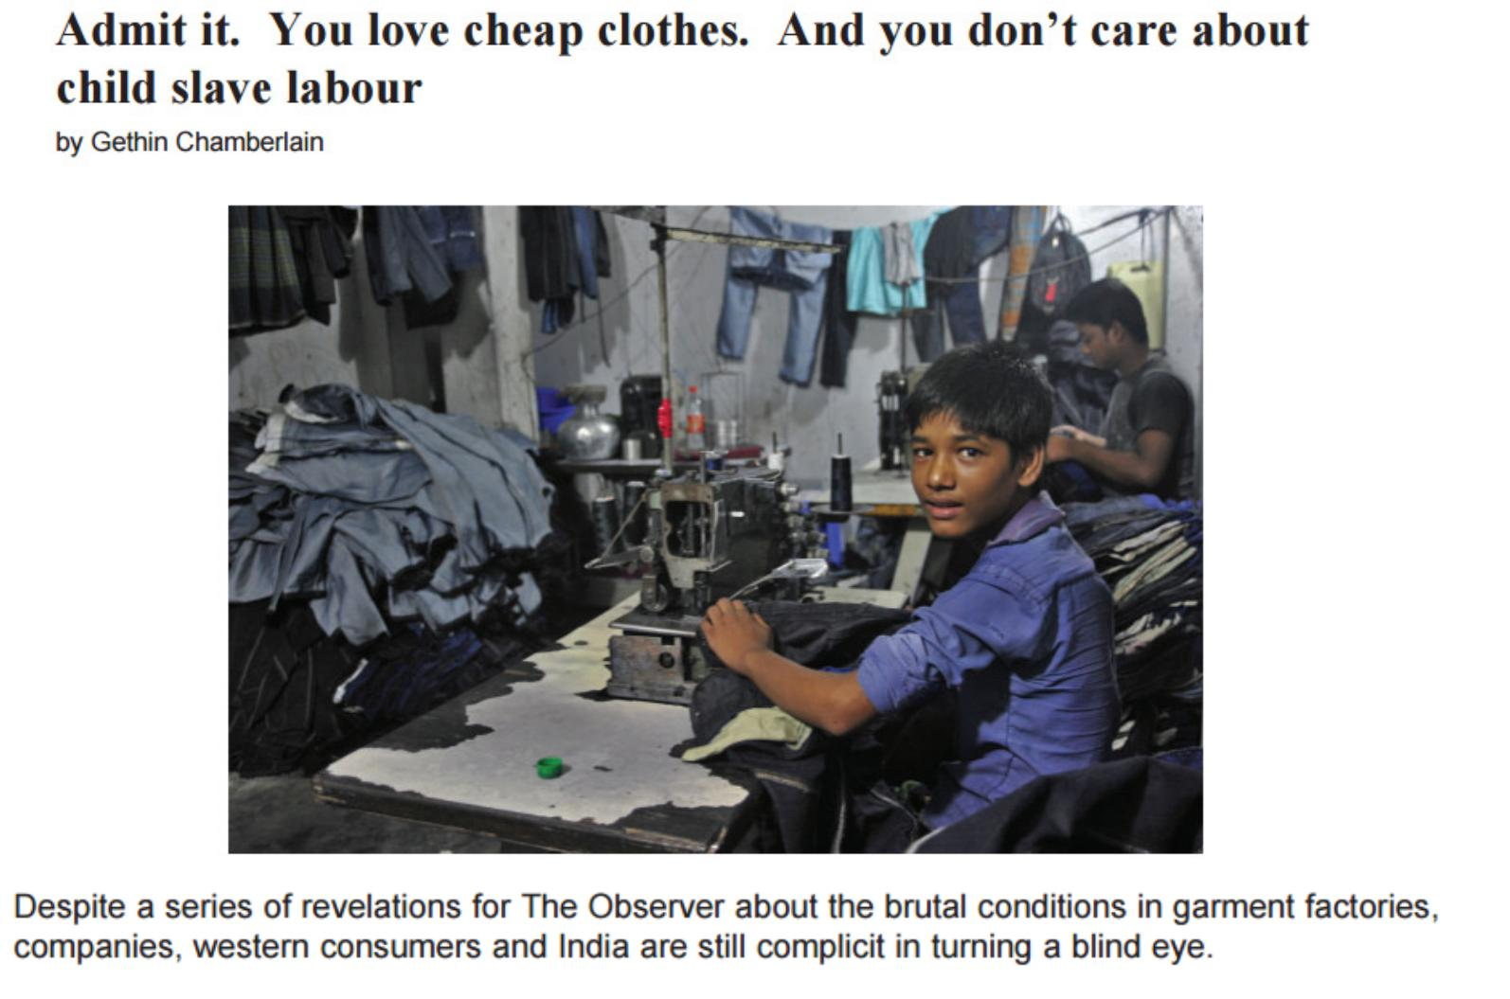

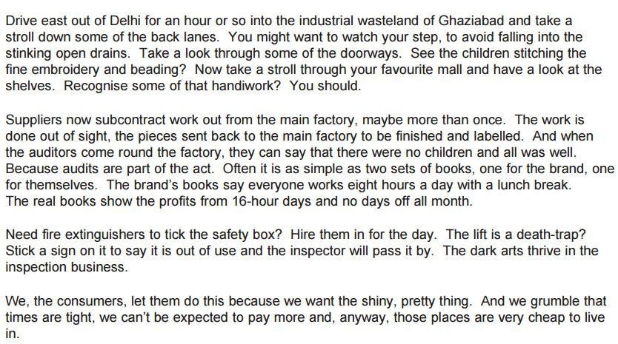

- TASK: Read the following statement and write a letter to the Principal of your school in which you explain your point of view on Work Experience.

‘Work Experience is just an excuse for child labour. Students should be in school completing their education so they can reach their full potential.’

Plan all these elements before you write:

Text Type
What and to whom are you writing?
Audience

Purpose | Agree or Disagree?

Point 1

Reason 1

Benefit 1

Point 2

Reason 2

Benefit 2

Point 3

Reason 3

Benefit 3

What are the opposing ideas

you will challenge?

Jump Start - Use one or more of these to get you started if you can’t think of your own way:

Start with a statistic | Start with a rhetorical question
Children are children and we should | Imagine your first impression of working life
stop treating them like adults. | being stacking shelves in TK Maxx
Students always want to be treated | Imagine choosing a career in animal care
like adults so why not let them see | only to realise you spend all day clearing up
the reality? | cat vomit.

Some techniques you should try to use if they are appropriate to your writing:

- Rhetorical Questions

- Facts & Statistics – say where the stats are from (eg Department of Education, Chief

medical advisor to the Government)

- Direct Address

- Emotive vocabulary

- Rule of 3 – why not try 4? O Repetition

……………………………………………………………………………………………………………………

……………………………………………………………………………………………………………………

……………………………………………………………………………………………………………………

……………………………………………………………………………………………………………………

……………………………………………………………………………………………………………………

……………………………………………………………………………………………………………………

……………………………………………………………………………………………………………………

……………………………………………………………………………………………………………………

……………………………………………………………………………………………………………………

……………………………………………………………………………………………………………………

……………………………………………………………………………………………………………………

……………………………………………………………………………………………………………………

……………………………………………………………………………………………………………………

……………………………………………………………………………………………………………………

……………………………………………………………………………………………………………………

……………………………………………………………………………………………………………………

……………………………………………………………………………………………………………………

……………………………………………………………………………………………………………………

……………………………………………………………………………………………………………………

……………………………………………………………………………………………………………………

……………………………………………………………………………………………………………………

……………………………………………………………………………………………………………………

……………………………………………………………………………………………………………………

……………………………………………………………………………………………………………………

……………………………………………………………………………………………………………………

……………………………………………………………………………………………………………………

……………………………………………………………………………………………………………………

……………………………………………………………………………………………………………………

……………………………………………………………………………………………………………………

……………………………………………………………………………………………………………………

……………………………………………………………………………………………………………………

……………………………………………………………………………………………………………………

……………………………………………………………………………………………………………………

……………………………………………………………………………………………………………………

……………………………………………………………………………………………………………………

……………………………………………………………………………………………………………………

……………………………………………………………………………………………………………………

……………………………………………………………………………………………………………………

……………………………………………………………………………………………………………………

……………………………………………………………………………………………………………………

……………………………………………………………………………………………………………………

……………………………………………………………………………………………………………………

……………………………………………………………………………………………………………………

……………………………………………………………………………………………………………………

……………………………………………………………………………………………………………………

……………………………………………………………………………………………………………………

……………………………………………………………………………………………………………………

……………………………………………………………………………………………………………………

……………………………………………………………………………………………………………………

……………………………………………………………………………………………………………………

……………………………………………………………………………………………………………………

……………………………………………………………………………………………………………………

……………………………………………………………………………………………………………………

……………………………………………………………………………………………………………………

……………………………………………………………………………………………………………………

……………………………………………………………………………………………………………………

……………………………………………………………………………………………………………………

……………………………………………………………………………………………………………………

……………………………………………………………………………………………………………………

……………………………………………………………………………………………………………………

……………………………………………………………………………………………………………………

……………………………………………………………………………………………………………………

……………………………………………………………………………………………………………………

……………………………………………………………………………………………………………………

……………………………………………………………………………………………………………………

……………………………………………………………………………………………………………………

……………………………………………………………………………………………………………………

……………………………………………………………………………………………………………………

……………………………………………………………………………………………………………………

3. Don’t forget to proof read & tick off the basics as you do them.

Get the basics right & the rest will follow.

Tick these when you’ve checked them.

- All my sentences have a capital letter & full stop.

- All my basic spelling is right & I’ve checked ones I don’t know.

- I’ve used a range of punctuation including commas, question marks and speech marks.

- I’ve varied the types of sentence starts and sentence lengths.

- I’ve used paragraphs correctly (change of Time, Topic, Place, Person). O I’ve read through my work to make sure it makes sense.

O Spellings I’m not sure about:

-

-

-

Task 5 (Paper 1 Q5 – Writing to describe and/or narrate):

- Vocabulary: Complete the exercise finding the alternative words for the vocabulary below. The first two have been done for you.

Ambitious word | Alternative word | Ambitious word | Alternative word
charismatic | has influence over | complacent
coerce | force |  | showy
 | role model | alleviate
nadir |  |  | worsen
 | forgive | melancholic

- Writing task: Write a story set in a place like this.

or

Write a story set in a busy or colourful place.
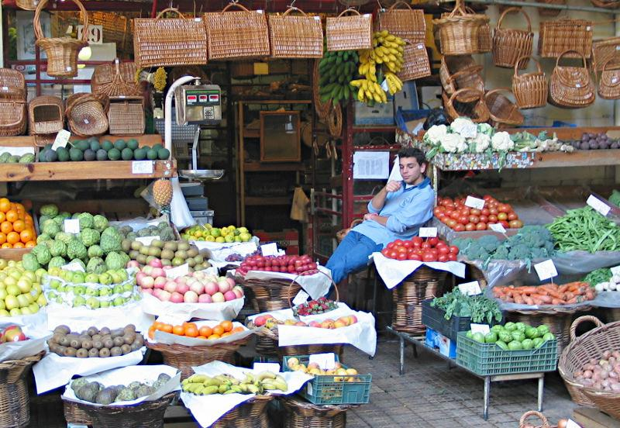

Plan all these elements before you write:

 | Perspective: | Who or what are | A narrator? The stall holder? A piece of fruit? A
 |  | you writing as? | customer? The employers boss?
 | Setting: | Where is it? | In a foreign country? A local market? A busy
 |  |  | market? A quiet market with no customers?
 | Time: | What time is it? | Early morning? Middle of the day? Late
 |  |  | afternoon?
 | Plot: | What is | Is he tired after an eventful night? Is he love-
 |  | happening? | sick? Is he about to be fired?
 | My Plan:
Perspective: |  |  | Setting:

Time: Plot:

Jump Start - Use one or more of these to get you started if you can’t think of your own way:

After five years, she just happened to be | He was back in a place he'd hoped he
walking down this street? | would never see again.
I’ve been here in this pile for days. | The scar faced men had finally walked
 | away.
I can’t possibly work all day and look after | I slowly realised that this was my last
my three children. | day alive.

Some techniques you should try to use if they are appropriate to your writing:

- Powerful adjectives

- Adverbs to describe your verbs

- Describing things using similes, metaphors or personification.

O Dialogue between characters – use speech marks (keep it brief)

O Range of sentences and sentence openings

O Appeal to the senses in your writing when describing a scene.

……………………………………………………………………………………………………………………

……………………………………………………………………………………………………………………

……………………………………………………………………………………………………………………

……………………………………………………………………………………………………………………

……………………………………………………………………………………………………………………

……………………………………………………………………………………………………………………

……………………………………………………………………………………………………………………

……………………………………………………………………………………………………………………

……………………………………………………………………………………………………………………

……………………………………………………………………………………………………………………

……………………………………………………………………………………………………………………

……………………………………………………………………………………………………………………

……………………………………………………………………………………………………………………

……………………………………………………………………………………………………………………

……………………………………………………………………………………………………………………

……………………………………………………………………………………………………………………

……………………………………………………………………………………………………………………

……………………………………………………………………………………………………………………

……………………………………………………………………………………………………………………

……………………………………………………………………………………………………………………

……………………………………………………………………………………………………………………

……………………………………………………………………………………………………………………

……………………………………………………………………………………………………………………

……………………………………………………………………………………………………………………

……………………………………………………………………………………………………………………

……………………………………………………………………………………………………………………

……………………………………………………………………………………………………………………

……………………………………………………………………………………………………………………

……………………………………………………………………………………………………………………

……………………………………………………………………………………………………………………

……………………………………………………………………………………………………………………

……………………………………………………………………………………………………………………

……………………………………………………………………………………………………………………

……………………………………………………………………………………………………………………

……………………………………………………………………………………………………………………

……………………………………………………………………………………………………………………

……………………………………………………………………………………………………………………

……………………………………………………………………………………………………………………

……………………………………………………………………………………………………………………

……………………………………………………………………………………………………………………

……………………………………………………………………………………………………………………

……………………………………………………………………………………………………………………

……………………………………………………………………………………………………………………

……………………………………………………………………………………………………………………

……………………………………………………………………………………………………………………

……………………………………………………………………………………………………………………

……………………………………………………………………………………………………………………

……………………………………………………………………………………………………………………

……………………………………………………………………………………………………………………

……………………………………………………………………………………………………………………

……………………………………………………………………………………………………………………

……………………………………………………………………………………………………………………

……………………………………………………………………………………………………………………

……………………………………………………………………………………………………………………

……………………………………………………………………………………………………………………

……………………………………………………………………………………………………………………

……………………………………………………………………………………………………………………

3. Don’t forget to proof read & tick off the basics as you do them.

Get the basics right & the rest will follow.

Tick these when you’ve checked them.

- All my sentences have a capital letter & full stop.

- All my basic spelling is right & I’ve checked ones I don’t know.

- I’ve used a range of punctuation including commas, question marks

and speech marks.

- I’ve varied the types of sentence starts and sentence lengths.

- I’ve used paragraphs correctly (change of Time, Topic, Place, Person). O I’ve read through my work to make sure it makes sense.

O Spellings I’m not sure about:

-

-

-

-

Task 6 (Paper 2 Q5 – Writing viewpoints and perspectives):

- Vocabulary: Complete the exercise finding the alternative words for the vocabulary below. The first two have been done for you.

Ambitious word | Alternative word | Ambitious word | Alternative word
emulate | copy |  | adventurous
endeavour | try | tenacious
crescendo |  |  | question (verb)
 | vengeful | narcissistic
retaliate |  |  | childish

2. Read the article on the devastation caused by a hurricane in Australia.

Source: An online newspaper article about a hurricane in Australia called, ‘Homes and crops wrecked, but relief sweeps Queensland in Yasi’s wake’ by Adam Gabbatt.
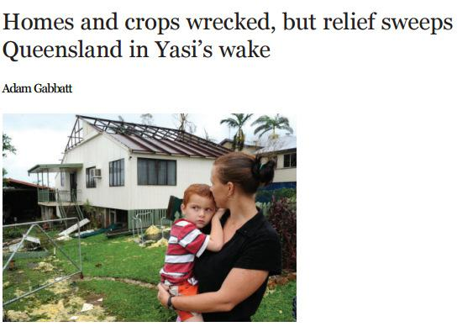

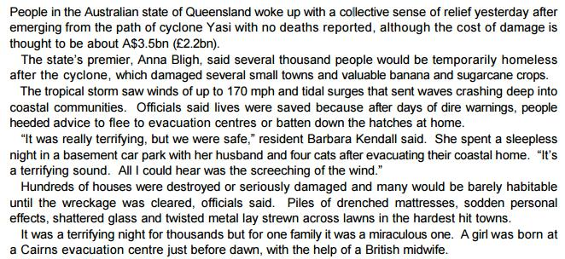

- TASK: Read the following statement and write a speech to your year group on

the dangers of climate change.

‘Climate change is nonsense. We’ve been here before with the Ice Age. We’re

worrying about nothing.’

Plan all these elements before you write:

Text Type
What and to whom are you writing?
Audience

Purpose | Agree or Disagree?

Point 1

Reason 1

Benefit 1

Point 2

Reason 2

Benefit 2

Point 3

Reason 3

Benefit 3

What are the opposing ideas

you will challenge?

Jump Start - Use one or more of these to get you started if you can’t think of your own way:

Start with a statistic | Start with a rhetorical question
Our planet is a living thing perfectly | Imagine living in a continual winter; rain,
capable of dying when neglected. | rain and more rain.
Ever heard of the Ice-Age? Climate | Maybe we should learn from what
change is just scare mongering. | happened to Noah and his ark?

Some techniques you should try to use if they are appropriate to your writing:

- Rhetorical Questions

- Facts & Statistics – say where the stats are from (eg Department of

- Direct Address

- Emotive vocabulary

- Rule of 3 – why not try 4? O Repetition

……………………………………………………………………………………………………………………

……………………………………………………………………………………………………………………

……………………………………………………………………………………………………………………

……………………………………………………………………………………………………………………

……………………………………………………………………………………………………………………

……………………………………………………………………………………………………………………

……………………………………………………………………………………………………………………

……………………………………………………………………………………………………………………

……………………………………………………………………………………………………………………

……………………………………………………………………………………………………………………

……………………………………………………………………………………………………………………

……………………………………………………………………………………………………………………

……………………………………………………………………………………………………………………

……………………………………………………………………………………………………………………

……………………………………………………………………………………………………………………

……………………………………………………………………………………………………………………

……………………………………………………………………………………………………………………

……………………………………………………………………………………………………………………

……………………………………………………………………………………………………………………

……………………………………………………………………………………………………………………

……………………………………………………………………………………………………………………

……………………………………………………………………………………………………………………

……………………………………………………………………………………………………………………

……………………………………………………………………………………………………………………

……………………………………………………………………………………………………………………

……………………………………………………………………………………………………………………

……………………………………………………………………………………………………………………

……………………………………………………………………………………………………………………

……………………………………………………………………………………………………………………

……………………………………………………………………………………………………………………

……………………………………………………………………………………………………………………

……………………………………………………………………………………………………………………

……………………………………………………………………………………………………………………

……………………………………………………………………………………………………………………

……………………………………………………………………………………………………………………

……………………………………………………………………………………………………………………

……………………………………………………………………………………………………………………

……………………………………………………………………………………………………………………

……………………………………………………………………………………………………………………

……………………………………………………………………………………………………………………

……………………………………………………………………………………………………………………

……………………………………………………………………………………………………………………

……………………………………………………………………………………………………………………

……………………………………………………………………………………………………………………

……………………………………………………………………………………………………………………

……………………………………………………………………………………………………………………

……………………………………………………………………………………………………………………

……………………………………………………………………………………………………………………

……………………………………………………………………………………………………………………

……………………………………………………………………………………………………………………

……………………………………………………………………………………………………………………

……………………………………………………………………………………………………………………

……………………………………………………………………………………………………………………

……………………………………………………………………………………………………………………

……………………………………………………………………………………………………………………

……………………………………………………………………………………………………………………

……………………………………………………………………………………………………………………

……………………………………………………………………………………………………………………

……………………………………………………………………………………………………………………

……………………………………………………………………………………………………………………

……………………………………………………………………………………………………………………

……………………………………………………………………………………………………………………

……………………………………………………………………………………………………………………

……………………………………………………………………………………………………………………

……………………………………………………………………………………………………………………

……………………………………………………………………………………………………………………

……………………………………………………………………………………………………………………

……………………………………………………………………………………………………………………

……………………………………………………………………………………………………………………

……………………………………………………………………………………………………………………

……………………………………………………………………………………………………………………

3. Don’t forget to proof read & tick off the basics as you do them.

Get the basics right & the rest will follow.

Tick these when you’ve checked them.

- All my sentences have a capital letter & full stop.

- All my basic spelling is right & I’ve checked ones I don’t know.

- I’ve used a range of punctuation including commas, question marks and speech marks.

- I’ve varied the types of sentence starts and sentence lengths.

- I’ve used paragraphs correctly (change of Time, Topic, Place, Person). O I’ve read through my work to make sure it makes sense.

O Spellings I’m not sure about:

-

-

-

Task 7 (Paper 1 Q5 – Writing to describe and/or narrate):

- Vocabulary: Complete the exercise finding the alternative words for the vocabulary below. The first two have been done for you.

Ambitious word | Alternative word | Ambitious word | Alternative word
exacerbate | worsen |  | calm
ostracise | to leave out / alienate | eloquent
augment |  |  | tempt
 | work together | empathise
intrepid |  |  | hatred

- Write a description from the viewpoint of someone in the picture.

or

Write a story about a scarecrow.
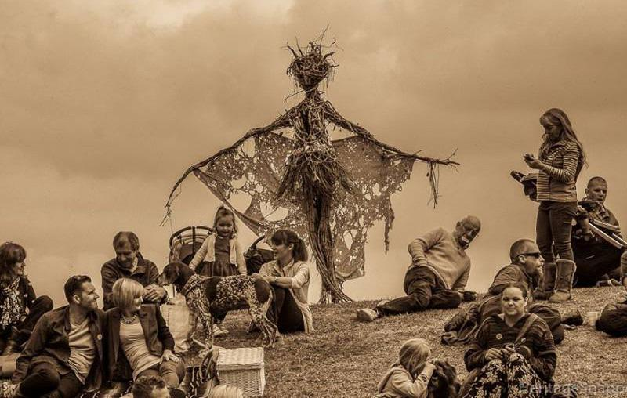

Plan all these elements before you write:

 | Perspective: | Who or what are | A narrator? The scarecrow? A person on the
 |  | you writing as? | hill? A parent of one of the children?
 | Setting: | Where is it? | At a fair? A local park? A post war scene? A
 |  |  | special event?
 | Time: | What time is it? | Early morning? Middle of the day? Late
 |  |  | afternoon?
 | Plot: | What is | Can they see the scarecrow? Is he a frightening
 |  | happening? | scarecrow or not? Why are the people there?
 | My Plan:
Perspective: |  |  | Setting:

Time: Plot:

Jump Start - Use one or more of these to get you started if you can’t think of your own way:

The boy hadn't spoken since he arrived on | They had to work together to beat
the hill. | this.
“Hello?” | "I daren't stay long. I just had to see
 | you."
I’ve been here years but no one pays any | "You don't think that was just
notice. | lemonade in your glass, do you?"

Some techniques you should try to use if they are appropriate to your writing:

- Powerful adjectives

- Adverbs to describe your verbs

- Describing things using similes, metaphors or personification.

O Dialogue between characters – use speech marks (keep it brief)

O Range of sentences and sentence openings

O Appeal to the senses in your writing when describing a scene.

……………………………………………………………………………………………………………………

……………………………………………………………………………………………………………………

……………………………………………………………………………………………………………………

……………………………………………………………………………………………………………………

……………………………………………………………………………………………………………………

……………………………………………………………………………………………………………………

……………………………………………………………………………………………………………………

……………………………………………………………………………………………………………………

……………………………………………………………………………………………………………………

……………………………………………………………………………………………………………………

……………………………………………………………………………………………………………………

……………………………………………………………………………………………………………………

……………………………………………………………………………………………………………………

……………………………………………………………………………………………………………………

……………………………………………………………………………………………………………………

……………………………………………………………………………………………………………………

……………………………………………………………………………………………………………………

……………………………………………………………………………………………………………………

……………………………………………………………………………………………………………………

……………………………………………………………………………………………………………………

……………………………………………………………………………………………………………………

……………………………………………………………………………………………………………………

……………………………………………………………………………………………………………………

……………………………………………………………………………………………………………………

……………………………………………………………………………………………………………………

……………………………………………………………………………………………………………………

……………………………………………………………………………………………………………………

……………………………………………………………………………………………………………………

……………………………………………………………………………………………………………………

……………………………………………………………………………………………………………………

……………………………………………………………………………………………………………………

……………………………………………………………………………………………………………………

……………………………………………………………………………………………………………………

……………………………………………………………………………………………………………………

……………………………………………………………………………………………………………………

……………………………………………………………………………………………………………………

……………………………………………………………………………………………………………………

……………………………………………………………………………………………………………………

……………………………………………………………………………………………………………………

……………………………………………………………………………………………………………………

……………………………………………………………………………………………………………………

……………………………………………………………………………………………………………………

……………………………………………………………………………………………………………………

……………………………………………………………………………………………………………………

……………………………………………………………………………………………………………………

……………………………………………………………………………………………………………………

……………………………………………………………………………………………………………………

……………………………………………………………………………………………………………………

……………………………………………………………………………………………………………………

……………………………………………………………………………………………………………………

……………………………………………………………………………………………………………………

……………………………………………………………………………………………………………………

……………………………………………………………………………………………………………………

……………………………………………………………………………………………………………………

……………………………………………………………………………………………………………………

……………………………………………………………………………………………………………………

……………………………………………………………………………………………………………………

……………………………………………………………………………………………………………………

3. Don’t forget to proof read & tick off the basics as you do them.

Get the basics right & the rest will follow.

Tick these when you’ve checked them.

- All my sentences have a capital letter & full stop.

- All my basic spelling is right & I’ve checked ones I don’t know.

- I’ve used a range of punctuation including commas, question marks

and speech marks.

- I’ve varied the types of sentence starts and sentence lengths.

- I’ve used paragraphs correctly (change of Time, Topic, Place, Person). O I’ve read through my work to make sure it makes sense.

O Spellings I’m not sure about:

-

-
Task₋ 8 (Paper 2 Q5 – Writing viewpoints and perspectives):

-

- Vocabulary: Complete the exercise finding the alternative words for the vocabulary below. The first two have been done for you.

Ambitious word | Alternative word | Ambitious word | Alternative word
patriotic | devoted to your country |  | forgive
collaborate | work together | epitomise
ostentatious |  |  | lazy
 | praise | belligerent
hypocritical |  |  | scruffy

2. Read the article on tattoos.

Source: A Guardian newspaper article about pensioners who have had tattoos later in life
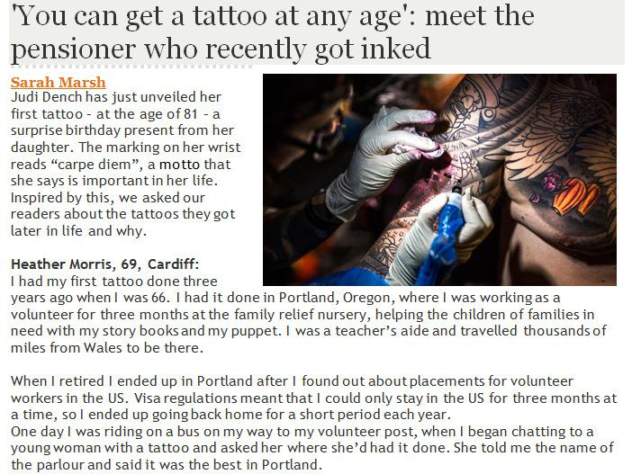

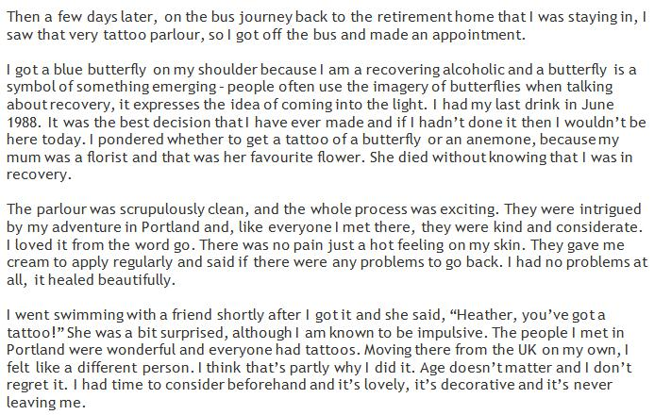

- TASK: Read the following statement and write a letter to the Principal of your school in which you explain your point of view on tattoos.

‘Tattoos are an expression of identity and should not be stigmatised in the workplace or anywhere in society.’

Plan all these elements before you write:

Text Type
What and to whom are you writing?
Audience

Purpose | Agree or Disagree?

Point 1

Reason 1

Benefit 1

Point 2

Reason 2

Benefit 2

Point 3

Reason 3

Benefit 3

What are the opposing ideas

you will challenge?

Jump Start - Use one or more of these to get you started if you can’t think of your own way:

Start with a statistic | Start with a rhetorical question
Your body is your own. Who else can tell | Imagine going for a job interview with a tattoos of
you what to do with it? | Tweety Pie on your arm.
Tattoos are a way of expressing who we | Tattoos are just fashion that will come and go. But
are. | we don’t all carry on wearing flares and tie-dye.

Some techniques you should try to use if they are appropriate to your writing:

- Rhetorical Questions

- Facts & Statistics – say where the stats are from (eg Department of

- Direct Address

- Emotive vocabulary

- Rule of 3 – why not try 4? O Repetition

……………………………………………………………………………………………………………………

……………………………………………………………………………………………………………………

……………………………………………………………………………………………………………………

……………………………………………………………………………………………………………………

……………………………………………………………………………………………………………………

……………………………………………………………………………………………………………………

……………………………………………………………………………………………………………………

……………………………………………………………………………………………………………………

……………………………………………………………………………………………………………………

……………………………………………………………………………………………………………………

……………………………………………………………………………………………………………………

……………………………………………………………………………………………………………………

……………………………………………………………………………………………………………………

……………………………………………………………………………………………………………………

……………………………………………………………………………………………………………………

……………………………………………………………………………………………………………………

……………………………………………………………………………………………………………………

……………………………………………………………………………………………………………………

……………………………………………………………………………………………………………………

……………………………………………………………………………………………………………………

……………………………………………………………………………………………………………………

……………………………………………………………………………………………………………………

……………………………………………………………………………………………………………………

……………………………………………………………………………………………………………………

……………………………………………………………………………………………………………………

……………………………………………………………………………………………………………………

……………………………………………………………………………………………………………………

……………………………………………………………………………………………………………………

……………………………………………………………………………………………………………………

……………………………………………………………………………………………………………………

……………………………………………………………………………………………………………………

……………………………………………………………………………………………………………………

……………………………………………………………………………………………………………………

……………………………………………………………………………………………………………………

……………………………………………………………………………………………………………………

……………………………………………………………………………………………………………………

……………………………………………………………………………………………………………………

……………………………………………………………………………………………………………………

……………………………………………………………………………………………………………………

……………………………………………………………………………………………………………………

……………………………………………………………………………………………………………………

……………………………………………………………………………………………………………………

……………………………………………………………………………………………………………………

……………………………………………………………………………………………………………………
Get the basics right & the rest will follow.
……………………………………………………………………………………………………………………

……………………………………………………………………………………………………………………Tickthesewhenyou’vecheckedthem.

……………………………………………………………………………………………………………………OAllmysentenceshaveacapitalletter&fullstop.

……………………………………………………………………………………………………………………OAllmybasicspellingisright&I’vecheckedonesIdon’tknow.

……………………………………………………………………………………………………………………OI’veusedarangeofpunctuationincludingcommas,questionmarks

……………………………………………………………………………………………………………………andspeechmarks.

3.ODon’tI’ve vaforiedget thetoprooftypesreadofsentence&tickoffstartsthe andbasicssentenceasyou dolengthsthem..

- I’ve used paragraphs correctly (change of Time, Topic, Place, Person). O I’ve read through my work to make sure it makes sense.

O Spellings I’m not sure about:

-

-

-

Task 9 (Paper 1 Q5 – Writing to describe and/or narrate):

- Vocabulary: Complete the exercise finding the alternative words for the vocabulary below. The first two have been done for you.

Ambitious word | Alternative word | Ambitious word | Alternative word
reconcile | resolve | unrivalled
schadenfreude | pleasure in seeing misery |  | strong
 | climax | stoicism
interrogate |  |  | determined
 | selfish | tantalise
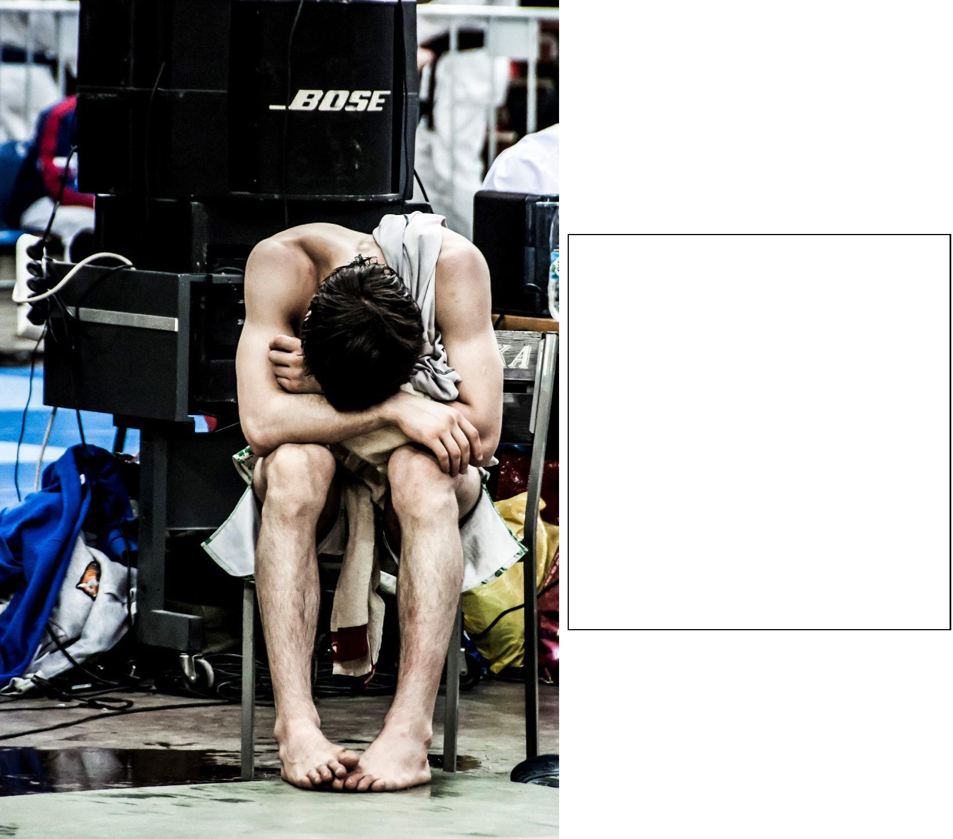

3. Write a description inspired by this picture.

or

Write a short story about someone who fails at something and what they learn from the experience.

Plan all these elements before you write:

 | Perspective: | Who or what are | A narrator? The sportsman? His coach/parent?
 |  | you writing as? | The speaker behind him?
 | Setting: | Where is it? | A national sporting event? A school sports day?
 |  |  | The finals of a worldwide competition?
 | Time: | What time is it? | Early morning? Middle of the day? Late
 |  |  | evening?
 |  | What is | Has he failed at the competition? Is he
 | Plot: | happening? | overwhelmed with his win? Is he preparing
 |  |  | mentally for what is to come?
 | My Plan:
Perspective: |  |  | Setting:

Time: Plot:

Jump Start - Use one or more of these to get you started if you can’t think of your own way:

"Why didn't he come and talk to me
"You embarrassed me this evening."
himself?"
He watched, helpless, as his coach
There was no way to hide the damage.
closed the door behind him.
It was time. He'd trained for this for
They found his diary under his bed.
years.

Some techniques you should try to use if they are appropriate to your writing:

- Powerful adjectives

- Adverbs to describe your verbs

- Describing things using similes, metaphors or personification.

O Dialogue between characters – use speech marks (keep it brief)

O Range of sentences and sentence openings

O Appeal to the senses in your writing when describing a scene.

……………………………………………………………………………………………………………………

……………………………………………………………………………………………………………………

……………………………………………………………………………………………………………………

……………………………………………………………………………………………………………………

……………………………………………………………………………………………………………………

……………………………………………………………………………………………………………………

……………………………………………………………………………………………………………………

……………………………………………………………………………………………………………………

……………………………………………………………………………………………………………………

……………………………………………………………………………………………………………………

……………………………………………………………………………………………………………………

……………………………………………………………………………………………………………………

……………………………………………………………………………………………………………………

……………………………………………………………………………………………………………………

……………………………………………………………………………………………………………………

……………………………………………………………………………………………………………………

……………………………………………………………………………………………………………………

……………………………………………………………………………………………………………………

……………………………………………………………………………………………………………………

……………………………………………………………………………………………………………………

……………………………………………………………………………………………………………………

……………………………………………………………………………………………………………………

……………………………………………………………………………………………………………………

……………………………………………………………………………………………………………………

……………………………………………………………………………………………………………………

……………………………………………………………………………………………………………………

……………………………………………………………………………………………………………………

……………………………………………………………………………………………………………………

……………………………………………………………………………………………………………………

……………………………………………………………………………………………………………………

……………………………………………………………………………………………………………………

……………………………………………………………………………………………………………………

……………………………………………………………………………………………………………………

……………………………………………………………………………………………………………………

……………………………………………………………………………………………………………………

……………………………………………………………………………………………………………………

……………………………………………………………………………………………………………………

……………………………………………………………………………………………………………………

……………………………………………………………………………………………………………………

……………………………………………………………………………………………………………………

……………………………………………………………………………………………………………………

……………………………………………………………………………………………………………………

……………………………………………………………………………………………………………………

……………………………………………………………………………………………………………………

……………………………………………………………………………………………………………………

……………………………………………………………………………………………………………………

……………………………………………………………………………………………………………………

……………………………………………………………………………………………………………………

……………………………………………………………………………………………………………………

……………………………………………………………………………………………………………………

……………………………………………………………………………………………………………………

……………………………………………………………………………………………………………………

……………………………………………………………………………………………………………………

……………………………………………………………………………………………………………………

……………………………………………………………………………………………………………………

……………………………………………………………………………………………………………………

……………………………………………………………………………………………………………………

……………………………………………………………………………………………………………………

……………………………………………………………………………………………………………………

3. Don’t forget to proof read & tick off the basics as you do them.

Get the basics right & the rest will follow.

Tick these when you’ve checked them.

- All my sentences have a capital letter & full stop.

- All my basic spelling is right & I’ve checked ones I don’t know.

- I’ve used a range of punctuation including commas, question marks

and speech marks.

- I’ve varied the types of sentence starts and sentence lengths.

- I’ve used paragraphs correctly (change of Time, Topic, Place, Person). O I’ve read through my work to make sure it makes sense.

O Spellings I’m not sure about:

-

-

-

-

Task 10 (Paper 2 Q5 – Writing viewpoints and perspectives):

- Vocabulary: Complete the exercise finding the alternative words for the vocabulary below. The first two have been done for you.

Ambitious word | Alternative word | Ambitious word | Alternative word
pandemic | widespread |  | powerful
adversity | hardship/obstacles | grandiose
visceral |  |  | try
 | succeed | humility
plethora |  |  | discipline

2. Read the article on.

Source: A newspaper article about a quadruple amputee swimming the English Channel.
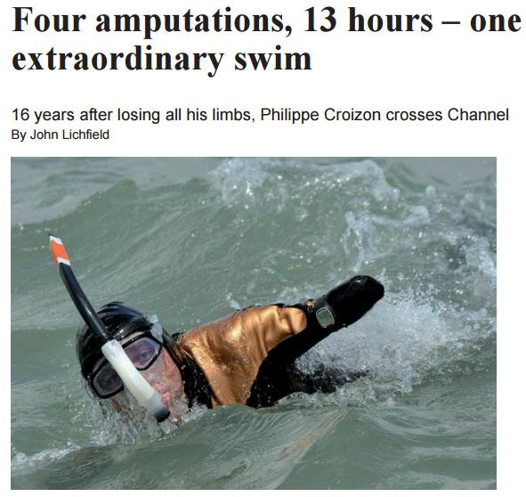

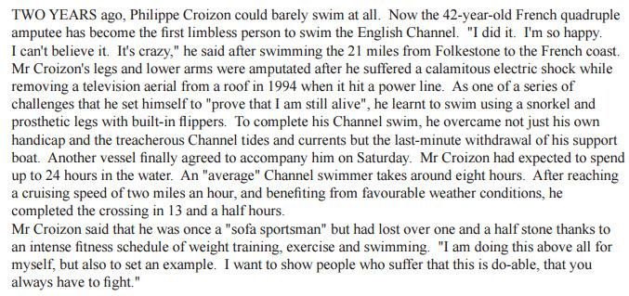

- TASK: Read the following statement and write an article for your school newspaper in which you persuade more students to take part in sports day.

‘Sportsmen are the ultimate humans, pushing themselves to the highest level of pain and endurance.’

Plan all these elements before you write:

Text Type

Audience
What and to whom are you writing?

Purpose Opinion?

Point 1

Reason 1

Benefit 1

Point 2

Reason 2

Benefit 2

Point 3

Reason 3

Benefit 3

What are the opposing

ideas you will challenge?

Jump Start - Use one or more of these to get you started if you can’t think of your own way:

Start with a statistic | Start with a rhetorical question
Teenagers these days are lazy | Disability is a word that should be banished.
layabouts.
How can you justify not running | Have you ever considered just how lucky
100m because of an imaginary pain | you are?
when…?

Some techniques you should try to use if they are appropriate to your writing:

- Rhetorical Questions

- Facts & Statistics – say where the stats are from (eg Department of

- Direct Address

- Emotive vocabulary

- Rule of 3 – why not try 4? O Repetition

……………………………………………………………………………………………………………………

……………………………………………………………………………………………………………………

……………………………………………………………………………………………………………………

……………………………………………………………………………………………………………………

……………………………………………………………………………………………………………………

……………………………………………………………………………………………………………………

……………………………………………………………………………………………………………………

……………………………………………………………………………………………………………………

……………………………………………………………………………………………………………………

……………………………………………………………………………………………………………………

……………………………………………………………………………………………………………………

……………………………………………………………………………………………………………………

……………………………………………………………………………………………………………………

……………………………………………………………………………………………………………………

……………………………………………………………………………………………………………………

……………………………………………………………………………………………………………………

……………………………………………………………………………………………………………………

……………………………………………………………………………………………………………………

……………………………………………………………………………………………………………………

……………………………………………………………………………………………………………………

……………………………………………………………………………………………………………………

……………………………………………………………………………………………………………………

……………………………………………………………………………………………………………………

……………………………………………………………………………………………………………………

……………………………………………………………………………………………………………………

……………………………………………………………………………………………………………………

……………………………………………………………………………………………………………………

……………………………………………………………………………………………………………………

……………………………………………………………………………………………………………………

……………………………………………………………………………………………………………………

……………………………………………………………………………………………………………………

……………………………………………………………………………………………………………………

……………………………………………………………………………………………………………………

……………………………………………………………………………………………………………………

……………………………………………………………………………………………………………………

……………………………………………………………………………………………………………………

……………………………………………………………………………………………………………………

……………………………………………………………………………………………………………………

……………………………………………………………………………………………………………………

……………………………………………………………………………………………………………………

……………………………………………………………………………………………………………………

……………………………………………………………………………………………………………………

……………………………………………………………………………………………………………………

……………………………………………………………………………………………………………………
Get the basics right & the rest will follow.
……………………………………………………………………………………………………………………

……………………………………………………………………………………………………………………Tickthesewhenyou’vecheckedthem.

……………………………………………………………………………………………………………………OAllmysentenceshaveacapitalletter&fullstop.

……………………………………………………………………………………………………………………OAllmybasicspellingisright&I’vecheckedonesIdon’tknow.

……………………………………………………………………………………………………………………OI’veusedarangeofpunctuationincludingcommas,questionmarks

……………………………………………………………………………………………………………………andspeechmarks.

3.ODon’tI’ve vaforiedget thetoprooftypesreadofsentence&tickoffstartsthe andbasicssentenceasyou dolengthsthem..

- I’ve used paragraphs correctly (change of Time, Topic, Place, Person). O I’ve read through my work to make sure it makes sense.

O Spellings I’m not sure about:

-

-

-

