Your first task is to choose a book to read. It can be fiction or non-fiction. You will be writing a book review in Week 6.

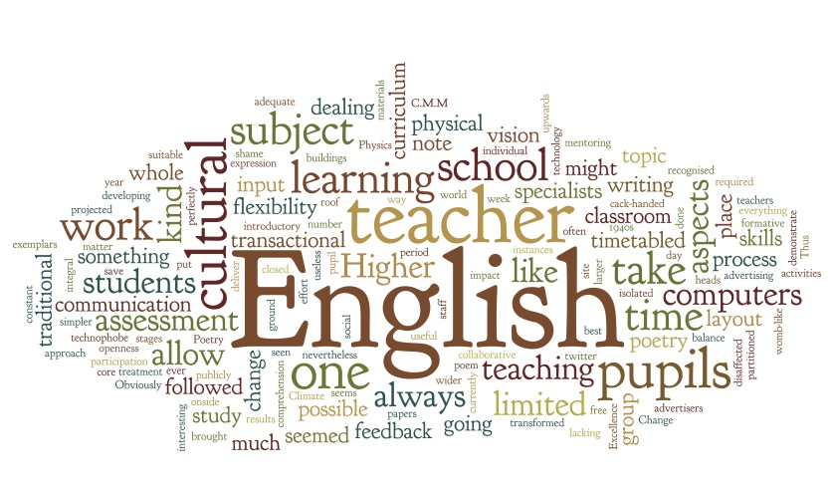
GCSE Prep Booklet
The six reading and/or writing tasks in this booklet are designed to strengthen your skills in all areas of your English studies
They will help you reach your potential in Year 9, as well as preparing you for the your GCSEs in English Language and Literature

Name: _________________________________
GCSE Prep Booklet
Contents
Week 1
An article in favour of school uniform, written by a school student, and a chance to have your own say on this issue
Week 2
A poem by W.H. Auden about loss and grief, with questions to answer
Week 3
An article about bomb-hoax bridegroom Neil McArdle, with a creative writing task
Week 4
An extract from travel writing, and a written response to it
Week 5
Two anti-smoking adverts, and a chance to create your own
Week 6
Your final writing task: a review of the book you’ve been reading over the past six weeks

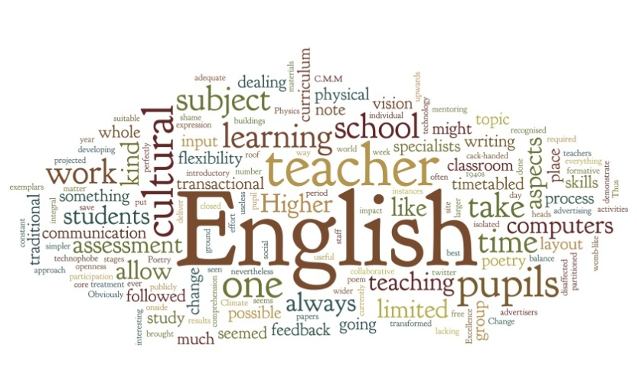

What's the point of school uniform?
You might hate your school uniform, but I think it's there for good reason, says 15-year-old Chloe Spencer
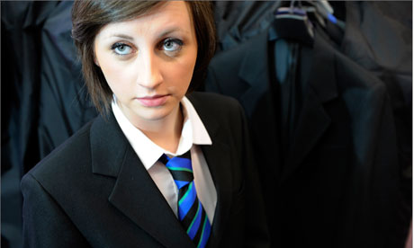 Why wear a school uniform? Photograph: Christopher Thomond for the Guardian
A shirt, tie and blazer may not be the ingredients for my favourite outfit, but if I were given the choice, I wouldn’t throw away the idea of school uniform. Wearing a uniform is a badge of pride, creates an identity for a school and is an important part of being a school student.
“Uniforms show that you are part of an organisation. Wearing it says we’re all in this together,” Jason Wing, head teacher at the Neale-Wade academy in Cambridgeshire, says.
“Also, if you wear your uniform with pride, it means you are half way there to being respectful, buying into what the organisation is all about.”
Claire Howlette, an English teacher, agrees: “Uniforms give students a sense of belonging to a particular school and create an identity for the school in the community.”
My school is one of many that seem to be reverting to a more formal uniform – this September I will be wearing a shirt and blazer instead of my old jumper and polo shirt. A number of students have complained about the change, but general opinion is that the jumpers and polo shirts were “childish”.
A school uniform teaches students to dress smartly and take pride in their appearance. Howlette says: “Uniforms help students to prepare for when they leave school and may have to dress smartly or wear a uniform.”
Some people believe that a school uniform can improve learning by reducing distraction, sharpening focus on schoolwork and making the classroom a more serious environment, allowing students to perform better academically.
Perhaps most importantly, a uniform means students don’t have to worry about peer pressure when it comes to their clothes. When everyone is dressed the same, worrying about what you look like isn’t so important. There is no competition about being dressed in the latest trend, which would put a great deal of financial pressure on students and parents. Potential bullies have one less target for their insults; it’s hard to make fun of what someone is wearing when you’re dressed exactly the same
In America, where a majority of schools do not have a uniform, roughly 160,000 children miss school every day due to fear of attack or intimidation by other students. This might not be directly linked to what they’re wearing, but having a uniform can be a safety net for many students who might otherwise suffer from bullying. A strict uniform gives the impression that rules are strict too, perhaps helping maintain a sense of order at school.
Although wearing a school uniform is less expensive than buying a whole wardrobe of outfits, uniform can still be pricey. Many schools have a specific supplier, and wearing cheaper alternatives can result in punishment if the black skirt you’re wearing isn’t exactly the right black skirt. Finding uniform that fits you, especially if you’re limited to one shop, can also be a struggle.
Recently the Liberal Democrats held a conference about the cost of school uniforms across England. The education minister David Laws is to issue new guidance to end the practice of using a single uniform supplier, enabling parents to shop around for uniform. If schools decide to change their uniform, for example with a new emblem or colour, changes should be restricted to one or two items, preferably with sew-on logos. Changing from a one-supplier system could help families with the cost of school uniform.
Although it might seem a shame to miss out on those two years of dressing as you like at school, I welcome the smart dress code. Not only does it make getting dressed each morning a lot easier, but it sets sixth formers up as role models for younger students, and that’s important.
Macy Vallance, a year-eight student, says I like uniforms because everyone is the same and no one can be left out by the way they are dressed. Our new uniform looks smarter, which is good.
My uniform might not be what I would wear in my own time, but it gives me a sense of belonging, takes away the presure of what to wear and deterrs the bullies. School uniform isnt fashionable, but thats exactly why I think it should be here to stay.

Task: In the final two paragraphs of the article…
Add…
A colon (:) to introduce a quote (direct speech)
Speech marks (“…”) around the speech
Two missing apostrophes ( ’) used to turn two words into one
Find…
Two misspelt words, and write their correct spellings below…

Summarise the arguments for school uniform that this student presents in her article

Now summarise your arguments for or against school uniform
Task: On the following pages, write your own article in a similar style to the one above (for instance, you might imagine you’ve interviewed teachers and students about the issue). You could do some research to help you back up your ideas.
Remember to clearly structure your writing in paragraphs. Give your article a headline and sub-headline, like the one you’ve read (you might include your own name and age in the sub-headline, like ‘15-year-old Chloe Spencer’ has done).
____________________________________________________________________________________________________________________________________________________________________________________________________________________________________________________________________________________________________________________________________________________________________________________________________________________________________________________________________________________________________________________________________________________________________________________________________________________________________________________________________________________________________________________________________________________________________________________________________________________________________________________________________________________________________________________________________________________________________________________________________________________________________________________________________________________________________________________________________________________________________________________________________________________________________________________________________________________________________________________________________________________________________________________________________________________________________________________________________________________________________________________________________________________________________________________________________________________________________________________________________________________________________________________________________________________________________________________________________________________________________________________________________________________________________________________________________________________________________________________________________________________________________________________________________________________________________________________________________________________________________________________________________________________________________________________________________________________________________________________________________________________________________________________________________________________________________________________________________________________________________________________________________________________________________________________________________________________________________________________________________________________________________________________________________________________________________________________________________________________________________________________________________________________________________________________________________________________________________________________________________________________________________________________________________________________________________________________________________________________________________________________________________________________________________________________________________________________________________________________________________________________________________________________________________________________________________________________________________________________________________________________________________________________________________________________________________________________________________________________________________________________________________________________________________________________________________________________________________________________________________________________________________________________________________________________________________________________________________________________
Funeral Blues
Stop all the clocks, cut off the telephone,
Prevent the dog from barking with a juicy bone,
Silence the pianos and with muffled drum
Bring out the coffin, let the mourners come.
Let aeroplanes circle moaning overhead
Scribbling on the sky the message He Is Dead,
Put crêpe bows round the white necks of the public doves,
Let the traffic policemen wear black cotton gloves.
He was my North, my South, my East and West,
My working week and my Sunday rest,
My noon, my midnight, my talk, my song;
I thought that love would last forever: I was wrong.
The stars are not wanted now: put out every one;
Pack up the moon and dismantle the sun;
Pour away the ocean and sweep up the wood.
For nothing now can ever come to any good.

W.H. Auden

Task: After reading this poem, answer the questions below. You should explain your answers in as much detail as possible, using short quotes to support your ideas, and to enable you to analyse the language of the poem.
If you’re stuck with understanding the poem and its meaning, you might use the internet as a research tool to help you out.
Before you look at the questions, examine the two word banks on the next page. You will recognise them from your English lessons. These words will help you answer the questions and to analyse the language of the poem. You might mention any poetic techniques you notice, commenting on why the poet has used them.

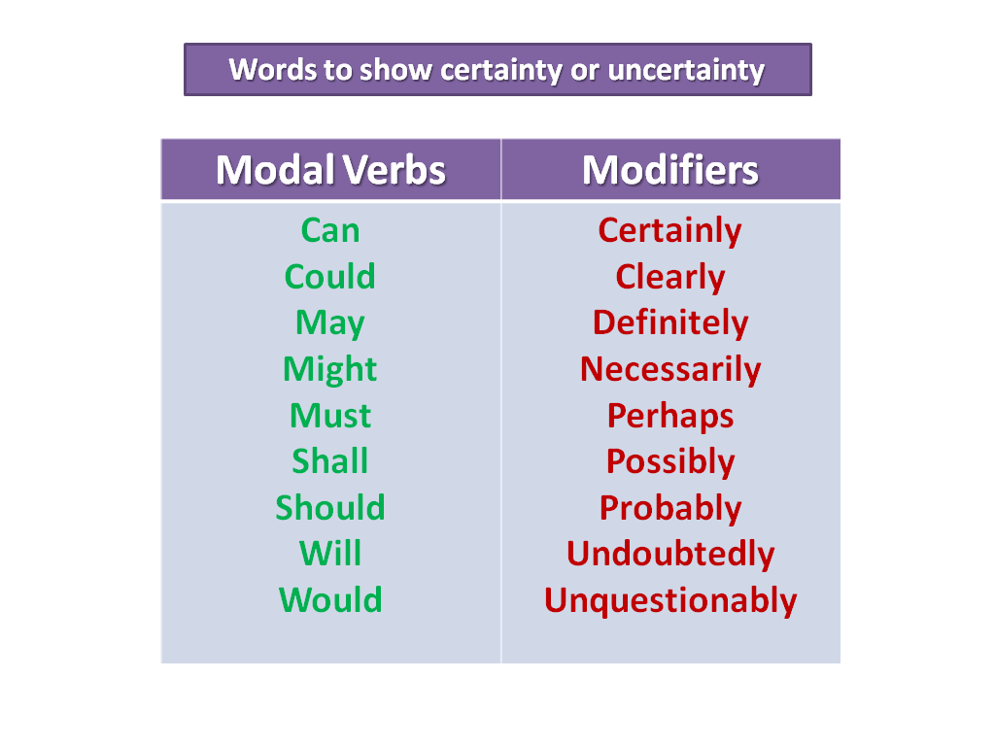

How would you describe the mood of the narrator? What’s the reason for this mood?
______________________________________________________________________________________________________________________________________________________________________________________________________________________________________________________________________________________________________________________________________________________________________________________________________________________________________________________________________________________________________________________________________________________________________________________________________________________________________________________________________________________________________________________________________________________________________________________________________________________________________________________________________________________________________
What does ‘He’ (the person being talked about) mean to the narrator?
______________________________________________________________________________________________________________________________________________________________________________________________________________________________________________________________________________________________________________________________________________________________________________________________________________________________________________________________________________________________________________________________________________________________________________________________________________________________________________________________________________________________________________________________________________________________________________________________________________________________________________________________________________________________________
What does the poem convey (suggest to its readers) about death and grief?
________________________________________________________________________________________________________________________________________________________________________________________________________________________________________________________________________________________________________________________________________________________________________________________________________________________________________________________________________________________________________________________________________________________________________________________________________________________________________________________________________________________________________________________________________________________________________________________________________________________________________________________________________________________________________________________________________________________________________________________________________________________________________________________________________________________________________________________________________________________________________________________________________________________________________________________________________________________________________________________________________________________________________________________________________________________________________________________________________________________________________________________________________________________________________________________________________________________________________________________________________________________________________________________________________________________________________________________________________________________________________________________________________________________________________________________________

Groom jailed over wedding day bomb hoax to try to prevent bride discovering failure to confirm venue

Neil McArdle could not face telling fiancee he had failed to fill in forms for wedding in Liverpool

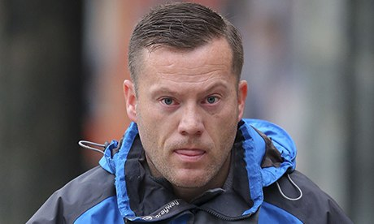

Neil McArdle outside court. Photograph: Dave Thompson/PA

A bridegroom has been jailed for 12 months after staging a bomb hoax on his wedding day to try to prevent his bride discovering he had failed to complete the paperwork required for them to marry.
Neil McArdle, 36, had forgotten to fill in the necessary forms but could not face telling his fiancee, Amy Williams, because the wedding was “all she talked about”, Liverpool crown court heard.

Instead, as she got ready on their wedding morning, he slipped out of their house and went to a phone box. Disguising his voice, he rang Liverpool register office and said: “This is not a hoax call. There's a bomb in St George’s Hall and it will go off in 45 minutes.”
The call, 11 days after the Boston marathon bombing in the US, caused the building to be evacuated and the emergency services called. When McArdle, his bride and both families arrived at the building in the centre of Liverpool, the area swarmed with police.
Later, after the building was checked and staff tried to help with the “delayed” ceremony, it was discovered that no booking for the wedding had been made. McArdle’s would-be in-laws were already suspicious, the court heard, and Williams’s sister was overheard telling a flustered McArdle: “You probably done the bomb scare yourself.”
Police quickly traced the call and he was arrested the same day. He admitted to his “embarrassment and shame” that he had panicked over bungling the forms and staged the bomb scare.
Williams has stood by the defendant, the court heard, and they are still together.
McArdle, of Kirby, Merseyside, pleaded guilty at an earlier hearing to a single charge of communicating false information with intent on 26 April 2013.
Derek Jones, prosecuting, said: “He realised the day before the wedding was not going to take place and because he did not want to let his fiancee down or [he was too] embarrassed to tell his family, he panicked in the morning and rang St George’s Hall.
“He was hoping all weddings would be postponed and it would give him time to book the wedding in the future. He did say several times how embarrassed and ashamed he was and how sorry he was.”
Charles Lander, defending, told the court: “If it was not so serious, the facts of this case have all the markings of a comedy.”
He said McArdle had failed to go through the forms given to him to make sure the wedding was legal and would go ahead as planned. Only the night before the big day did he notice a checklist of what needed to be done.
He tried to tell Williams, but she got up at 4am on the day and put on her wedding gown. “She looked amazing. He just could not get out the words to her to tell her what he had not done in relation to the forms,” said Lander.
The judge Norman Wright said the bomb hoax “must have shook sheer terror in the heart” of the receptionist and those responsible for security at St George’s Hall.
“She [Williams] was getting ready, expecting you were going to be man and wife and a very solemn public event in her life and you knew that was not going to take place,” Wright said.
“You did not say ‘we need to talk’. You tried to weasel your way out by creating a bomb hoax so the wedding would not take place. You have to understand, bomb hoaxes are extremely serious.”
As well as serving 12 months in jail, McArdle was also ordered to pay £100 court costs.

Task: You are going to pretend you are the jailed ‘groom’ Neil McArdle. You are writing a letter to your girlfriend, Amy Williams, from prison. You might explain…
- Why you did what you did
- How you feel about it
- What prison is like. What’s going through your mind, and how the other prisoners are viewing your crime
- Your hopes for your future life together (note that the article reveals that Neil McArdle’s girlfriend is standing by him!)
HM Prison Liverpool 68 Hornby Rd Merseyside L9 3DF
__________________________________________________________________________________________________________________________________________________________________________________________________________________________________________________________________________________________________________________________________________________________________________________________________________________________________________________________________________________________________________________________________________________________________________________________________________________________________________________________________________________________________________________________________________________________________________________________________________________________________________________________________________________________________________________________________________________________________________________________________________________________________________________________________________________________________________________________________________________________________________________________________________________________________________________________________________________________________________________________________________________________________________________________________________________________________________________________________________________________________________________________________________________________________________________________________________________________________________________________________________________________________________________________________________________________________________________________________________________________________________________________________________________________________________________________________________________________________________________________________________________________________________________________________________________________________________________________________________________________________________________________________________________________________________________________________________________________________________________________________________________________________________________________________________________________________________________________________________________________________________________________________________________________________________________________________________________________________________________________________________________________________________________________________________________________________________________________________________________________________________________________________________________________________________________________________________________________________________________________________________________________________________________________________________________________________________________________________________________________________________________________________
A travel writing extract: Red Dust by Ma Jian

*As you’re reading the extract, highlight any words or phrases you don’t fully understand.*

After an hour’s descent I reach the desert. Sweat pours from my body and evaporates in seconds. My water is half-finished, and the lake has sunk from view. I must rely on my compass from now on.

The sun is still overhead. As I breathe the hot air in and out, my mouth becomes as dry as dust. The compass in my hand burns like the gravel underfoot. The dry noodles have reached my stomach and seem to be sucking the moisture from my blood. I long to reach the shore of the lake and plunge my head in its cool water. For brief moments, refracted through the heat waves on the right, I see villages, moving trucks, or a sweep of marsh. If I didn’t have a compass, I might be tempted to walk straight into the mirage.

Four or five hours go by. At last I see clumps of weed rise from the gravel. The land starts to dip. I check the compass. Sugan should be right in front of me now, but all I see is the wide stony plain.

Suddenly it dawns on me that distances can be deceptive in the transparent atmosphere of the desert. The lake that from the pass seemed so near could be a hundred kilometres away. After all, what looked like a tiny blue spot is in fact a huge lake. It is too late to turn back now though - my bottle is empty. I have no choice but to keep walking towards the water. Where there is water there are people, and where there are people there is life. There is no other path I can take.

As the sun sinks to the west, the lake reappears at last. It is not a lake exactly, just a line of grey slightly brighter than the desert stones, not wavering in the heat haze this time, but lying still at the edge of the sky. I am on course, but my legs can barely hold. There is camel-thorn underfoot now and the earth is covered with a thick saline crust. The sun sinks slowly below me, then reddens and disappears.

When my feet tread on to damp grass the sky is almost black. I move forward in a daze. The ground gets wetter and wetter. Through the green weeds ahead I glimpse a cold sweep of water. Hurriedly I drop my pack and wade down through the marsh towards the lake. I have arrived at last. Let me plunge into your waters! I stamp to the shore, throw myself down and scoop the water into my mouth. The taste is foul and brackish. A fire burns down my chest and my stomach explodes. I roll over and retch and my mind goes black.

A while later I wake up shivering with cold. Instinctively, I start moving away from the lake. A briny taste rises from my stomach and sticks to the vomit on my tongue. I long for a sip of clean water to rinse my mouth and throat. My body and mind are frazzled but if I don't leave now I will die here on the shore. I try to crawl, but my hands give way. I fall and sink into the mud.

When I left Beijing I thought to myself, it doesn’t matter where I go because I can dig my grave anywhere in China's yellow soil. But now that my life hangs on a thread, my only thought is of survival. I force my eyes open and try to see what lies ahead. A soft light falls on my brow. I crawl out of the marsh and see a full moon at the horizon, clear and round. I can almost touch it. I want to walk towards it, but stop myself. Its beauty is as beguiling as the lake’s, and would prove just as murderous.

I scramble to my pack, pull everything out and rummage through the mess, ripping bags open, tossing things aside. At last I find a sachet of coffee granules in a small plastic bag. I stuff the bag into my mouth and chew through the plastic and foil. The granules are hard and dry. I swallow a few, and spit out the rest.
My mind begins to clear. I sense the need to pass water, so I hold out my bottle and wait. A few drops fall to the bottom. I swig them back and feel my blood start to flow again.

In the moonlight I sort through my belongings and discard everything unnecessary: books, magazines, clothes, socks. Then I swing on my pack and struggle to my feet.

I check my compass and decide to walk 10 degrees north. That should take me back to the Qinghai road. Li Anmei, the Qiaozi announcer, told me her parents live in Tuanjie village on the road between Gansu and Qinghai.

Apart from the echo of my dragging footsteps, the desert is silent. The full moon rises into the night sky. After a few hours of slow march I see a light in the distance. At first I suspect I am imagining it. I walk for a while with my eyes closed, but when I open them again the light is still there. I walk towards it. The light grows larger. It appears to be a lamp. I stop and rest, still gazing at the light, afraid that if I blink it will vanish. Now that I have a goal to walk to, I feel my body being pulled towards it.

Soon I can see it is a truck. A lamp hangs over the boot. I hear noises. My legs move excitedly.

Getting closer, I see a man hammering at the wheel. The sound bangs through the night air. It is a comforting noise. I do not shout, in case it startles him.

Then I spot the lid of a thermos flask set on the path ahead. I pounce on it and empty the water into my throat. My body trembles with life. Moisture seeps into my eyes. I crouch down and look at the driver. He is 10 metres away, sitting in front of his truck, staring right back at me.

“Thank you, brother,” I say, putting the lid down.

Task: Note the words whose meaning you were unsure of in the left hand column on the following page. Look up their definitions in a dictionary or online, and write the meaning beside the new word.

New words or phrases | Definitions

Task: Now you are going to complete the written task below, using short quotes from the text to support your answer. The analytical verbs and modal verbs and modifiers in this booklet will help you write your response. Begin discussing the start of the extract, noticing the development of this character’s thoughts and feelings as his journey progresses. Look for clues in the language he uses. You could begin your paragraphs with connectives like ‘Firstly’, ‘Secondly’, ‘Next’, ‘Furthermore’, ‘Moreover’ and so on. Explain in as much detail as you can.

Explain some of the thoughts and feelings the narrator, Ma Jian, experiences as he travels through a Chinese desert.
______________________________________________________________________________________________________________________________________________________________________________________________________________________________________________________________________________________________________________________________________________________________________________________________________________________________________________________________________________________________________________________________________________________________________________________________________________________________________________________________________________________________________________________________________________________________________________________________________________________________________________________________________________________________________________________________________________________________________________________________________________________________________________________________________________________________________________________________________________________________________________________________________________________________________________________________________________________________________________________________________________________________________________________________________________________________________________________________________________________________________________________________________________________________________________________________________________________________________________________________________________________________________________________________________________________________________________________________________________________________________________________________________________________________________________________________________________________________________________________________________________________________________________________________________________________________________________________________________________________________________________________________________________________________________________________________________________________________________________________________________________________________________________________________________________________________________________________________________________________________________________________________________________________________________________________________________________________________________________________________________________________________________________________________________________________________________________________________________________________________________________________________________________________________________________________________________________________________________________________________________________________________________________________________________________________________________________________________________________________________________________________________________________________________________________________________________________________________________________________________________________________________________________________________________________________________________________________________________________________________________________________________________________________________________________________________________________________________________________________________________________________________________________________________________________________________________________________________________________________________________________________________________________________________________________________________________________________________________________________________________________________________________________________________________________________________________________________________________________________________________________________________________________________________________________________________________________________________________________________________________________________________________________________________________________________________________________________________________________________________________________________________

Anti-smoking adverts
What’s the message in this advert? How do you know? _____________________________________________________________________________________________________________________________________________________________________________________________________________________________________________________________________________________________________________________________________________________
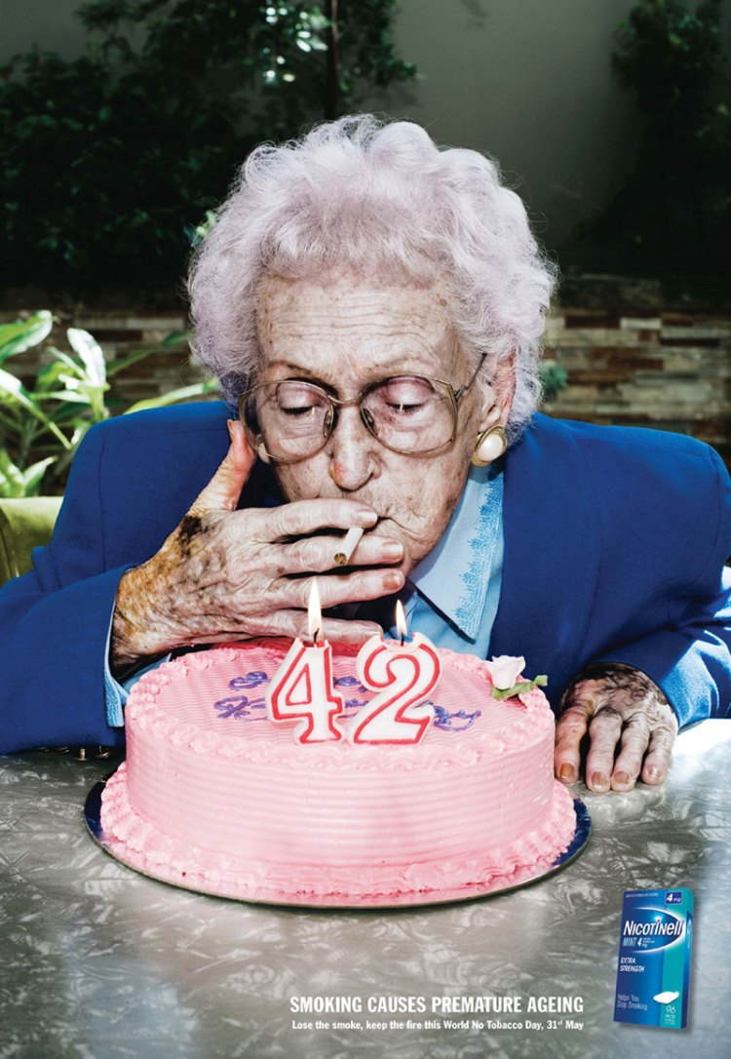
Texts reads: ‘SMOKING CAUSES PREMATURE AGEING’

Do you think this advert would be effective? Would it work? Explain your answer.

________________________________________________________________________________________________________________________________________________________________________________________________________________________________________________________________________________________________________________________________________________________________________________________________________________________________________________________________________________________________________________________________________________________________________________________________________________________________________________________________________________________________________________________
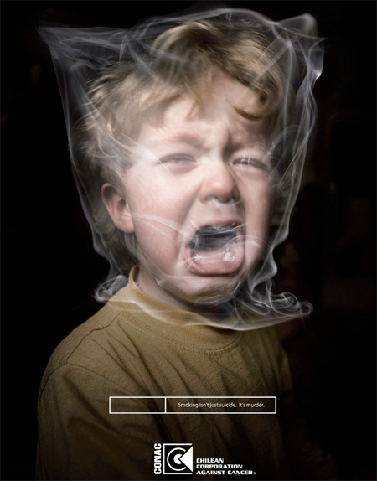
What’s the message in this advert? How do you know? _____________________________________________________________________________________________________________________________________________________________________________________________________________________________________________________________________________________________________________________________________________________
Text reads: ‘Smoking isn’t just suicide. It’s murder.’
Do you think this advert would be effective? Would it work? Explain your answer.

____________________________________________________________________________________________________________________________________________________________________________________________________________________________________________________________________________________________________________________________________________________________________________________________________________________________________________________________________________________________________________________________________________________________________________________________________________________________________________________________________________________________________________________________________________________________________________________________________________________________________________
Task: In the box below, create your own anti-smoking advert. Think about the message you wish to convey to your audience (e.g. that smoking is risky, unhealthy, irresponsible, antisocial, expensive, addictive, unpleasant…)

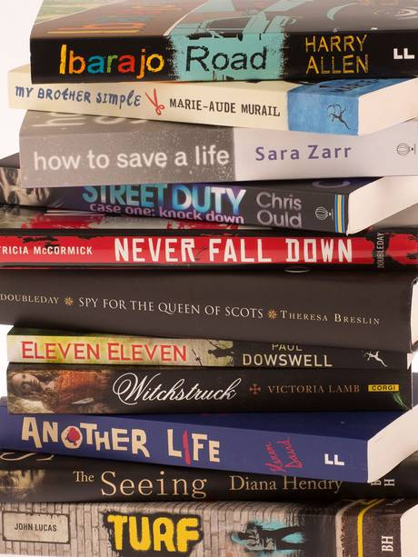
Task: Writing a book review
Structure:
Introduce the book and its author, and suggest what genre the book belongs to
Summarise/explain the story or content
Give an example of something you liked or disliked about it (a character, something you learnt, the plot, the style of writing etc.)
Would you recommend this book? Who to?

__________________________________________________________________________________________________________________________________________________________________________________________________________________________________________________________________________________________________________________________________________________________________________________________________________________________________________________________________________________________________________________________________________________________________________________________________________________________________________________________________________________________________________________________________________________________________________________________________________________________________________________________________________________________________________________________________________________________________________________________________________________________________________________________________________________________________________________________________________________________________________________________________________________________________________________________________________________________________________________________________________________________________________________________________________________________________________________________________________________________________________________________________________________________________________________________________________________________________________________________________________________________________________________________________________________________________________________________________________________________________________________________________________________________________________________________________________________________________________________________________________________________________________________________________________________________________________________________________________________________________________________________________________________________________________________________________________________________________________________________________________________________________________________________________________________________________________________________________________________________________________________________________________________________________________________________________________________________________________________________________________________________________________________________________________________________________________________________________________________________________________________________________________________________________________________________________________________________________________________________________________________________________________________________________________________________________________________________________________________________________________________________________________________________________________________________________________________________________________________________________________________________________________________________________________________________________________________________________________________________________________________________________________________________________________________________________________________________________________________________________________________________________________________________________________________________________________________________________________________________________________________________________________________________________________________________________________________________________________________________________________________________________________________________________________________________________________________________________________________________________________________________________________________________________________________________________________________________________________________________________________________________________________________________________________________________________________________________________________________________________________________________________________________________________________________________________________________________________________________________________________________________________________________________________________________________________________________________________________________________________________________________________________________________________________________________________________________________________________________________________________________________________________________________________________________________________________________________________________________________________________________________________________________________________________________________________________________________________________________________________________________________________________

