**De Aston**

**English Department**

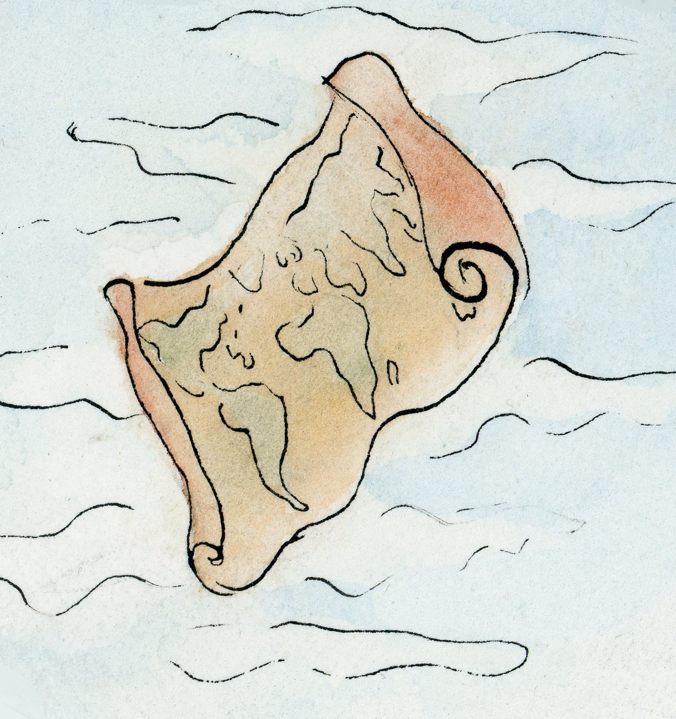

**Year 10: Power and Conflict Part 2**

**Academic Excellence Book**

The role of the Academic Excellence Booklet is for you to complete these tasks over the next six weeks. These activities are purposely designed to challenge you, so don’t worry if you find them difficult. You’re meant to! Learning happens when people have to think hard. That being said, your English teacher is a specialist, so ask any of us for help, anytime!

1. ***Kamikaze* and Shame**

The samurai code of Bushido allows us insight into the mind of the kamikaze pilots who swore an oath to serve their country. In pre-modern Japanese samurai culture, ‘the notion of shame [was] a powerful public concept even while rooted in the innermost depth of an individual’s dignity.’ (Ikegami, 2003) Shame was felt by anyone associated with doing something dishonourable. Shame is linked to pride, dignity and honour; soldiers were chosen to complete kamikaze missions because their deep desire to preserve their honour and dignity meant that they were likely to successfully complete the missions.

**How does Garland reflect on individual and social shame in the poem?** Use SQuAD

**2. *War Photographer* and Detachment**

When writing *War Photographer*, Duffy wanted to provoke us to consider our own response when confronted with terrible and horrific events broadcasted on the news and published in papers. It is implied, through the poem, that the nation has become desensitised and are no longer able to absorb more and more tragic war zones so the ‘editor will [only] pick out five or six for Sunday’s supplement.’ Perhaps Duffy is highlighting the pointlessness of publicising human cruelties when little is done to prevent it.

Kevin Carter, a south African photojournalist, committed suicide after viewing true horrors around the world. Portions of Carter’s suicide note wrote: ‘I am haunted by the vivid memories of killings & corpses & anger & pain ... of starving or wounded children, of trigger-happy madmen, often police, of killer executioners ...’

**How does Duffy challenge the morality of the photographer’s profession in the poem?** Use SQuAD

**Write a letter to the editor of ‘Sunday’s supplement’, arguing for or against the publishing of war photography.** Remember to use REDHEARTS/AFOREST

**3. *Remains* and PTSD**

During WW1, PTSD was referred to as ‘shell-shock’ and there were some 80,000 cases in the British army alone by the end of war. Due to the lack of understanding about the disorder, soldiers often returned to the warzone after only a few days’ rest. In WW2, traumatic responses to war were referred to as ‘battle or combat fatigue.’ It wasn’t until the 1980’s when the term post-traumatic stress order, along with more understanding, was first coined. In can be argued that Armitage wrote *Remains* to stress the invisible war trauma thousands of soldiers have to struggle against and highlight the lack of awareness and help that is still not given; the narrator of the poem thinks his only options are to ‘flush’ out the trauma with ‘drink and the drugs.’

Wilfred Owen wrote the poem *The Sentry*, describing the horrors seen in war can have a long lasting effect, he also references how he (and many others) dealt or did not deal with the trauma.

***The Sentry***

We'd found an old Boche dug-out, and he knew,  
And gave us hell, for shell on frantic shell  
Hammered on top, but never quite burst through.  
Rain, guttering down in waterfalls of slime  
Kept slush waist high, that rising hour by hour,  
Choked up the steps too thick with clay to climb.  
What murk of air remained stank old, and sour  
With fumes of whizz-bangs, and the smell of men  
Who'd lived there years, and left their curse in the den,  
If not their corpses. . . .  
                        There we herded from the blast  
Of whizz-bangs, but one found our door at last.  
Buffeting eyes and breath, snuffing the candles.  
And thud! flump! thud! down the steep steps came thumping  
And splashing in the flood, deluging muck —  
The sentry's body; then his rifle, handles  
Of old Boche bombs, and mud in ruck on ruck.  
We dredged him up, for killed, until he whined  
"O sir, my eyes — I'm blind — I'm blind, I'm blind!"  
Coaxing, I held a flame against his lids  
And said if he could see the least blurred light  
He was not blind; in time he'd get all right.  
"I can't," he sobbed. Eyeballs, huge-bulged like squids  
Watch my dreams still; but I forgot him there  
In posting next for duty, and sending a scout  
To beg a stretcher somewhere, and floundering about  
To other posts under the shrieking air.

Those other wretches, how they bled and spewed,  
And one who would have drowned himself for good, —  
I try not to remember these things now.  
Let dread hark back for one word only: how  
Half-listening to that sentry's moans and jumps,  
And the wild chattering of his broken teeth,  
Renewed most horribly whenever crumps  
Pummelled the roof and slogged the air beneath —  
Through the dense din, I say, we heard him shout  
"I see your lights!" But ours had long died out.

*Sentry: a soldier stationed to keep guard or to control access to a place.

**Compare how the horrors and trauma of war is presented in *Remains* and *The Sentry***. Aim to write at least 4 SQuAD paragraphs



For more resources, including literacy support, visit www.deastonenglish.com