**De Aston**

**English Department**

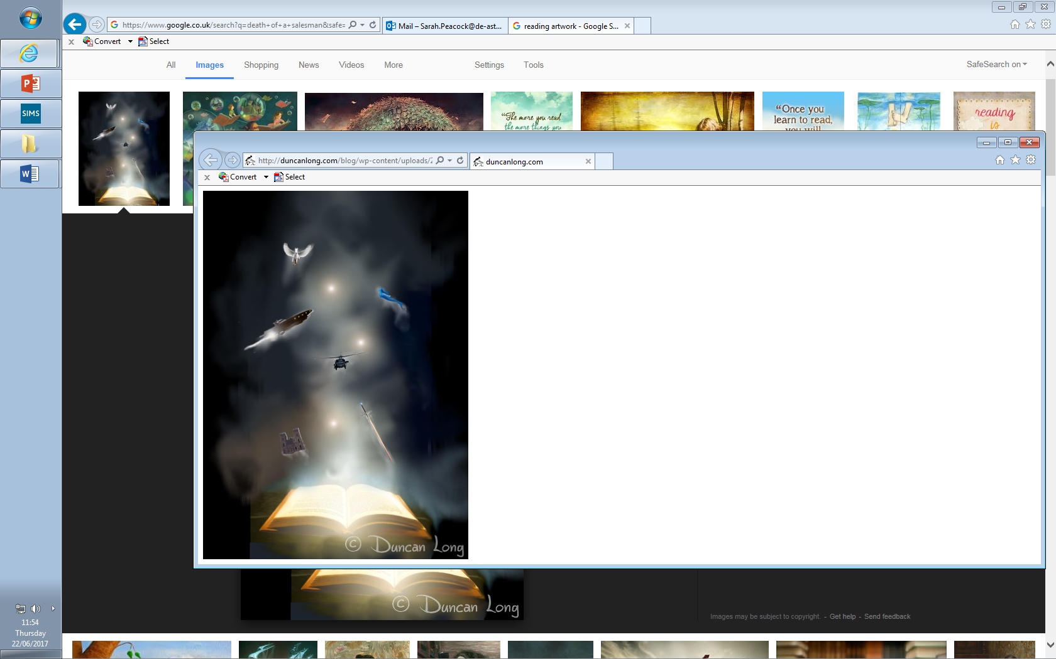

**Year 12 GCSE: Reading & Writing Non- Fiction**

**Challenge Tasks**

**Name:**

**Source A:**

This is an extract from a letter Oscar Wilde wrote to *The Daily Chronicle* newspaper after his release in 1897 from Reading prison. The letter, entitled ‘The Case of Warder Martin: Some Cruelties of Prison Life’, shows his concern over the treatment of children in prisons.

Dear Sir,

The present treatment of children is terrible, primarily from people not understanding the peculiar psychology of a child’s nature. A child cannot understand a punishment inflicted by society.

The child consequently, being taken away from its parents by people whom it has never seen, and of whom it knows nothing, and finding itself in a lonely and unfamiliar cell, waited on by strange faces, and ordered about and punished by representatives of a system that it cannot understand, becomes an immediate prey to the first and most prominent emotion produced by modern prison - the emotion of terror.

The terror of a child in prison is quite limitless. I remember once, in Reading, as I was going out to exercise, seeing in the dimly-lit cell right opposite my own, a small boy. Two warders — not unkindly men — were talking to him with some sternness apparently, or perhaps giving him some useful advice about his conduct. One was in the cell with him, the other was standing outside. The child’s face was like a white wedge of sheer terror. There was in his eyes the terror of a hunted animal.

The next morning I heard him at breakfast time crying and calling to be let out. His cry was for his parents. From time to time I could hear the deep voice of the warder on duty telling him to keep quiet. Yet he was not even convicted of whatever little offence he had been charged with. He was simply on remand. That I knew by his wearing his own clothes, which seemed neat enough. He was, however, wearing prison socks and shoes. This showed that he was a very poor boy, whose own shoes, if he had any, were in a bad state. Justices and magistrates, an entirely ignorant class as a rule, often remand children for a week, and then perhaps remit whatever sentence they are entitled to pass. They call this "not sending a child to prison". It is, of course, a stupid view on their part. To a little child whether he is in prison on remand, or after conviction is not a subtlety of social position he can comprehend. To him the horrible thing is to be there at all. In the eyes of humanity it should be a horrible thing for him to be there at all.

**Source B:**

**‘Land where killers are free to go hunting’ – article in The Guardian Newspaper in 1999.**

"During the reindeer season we take the convicts out hunting - even the murderers," said Torben Thrue, head of the correctional institution in Nuuk.

"Obviously, we don't take the mentally unstable," he said. "They get to go fishing."

The centre's 54 felons, whose offences include sex crimes, murder and drug-dealing, also hold down jobs, often attending to business on mobile telephones from their cells.

The self-governing Danish colony of [Greenland](https://www.theguardian.com/world/greenland) has no closed prisons.

Convicted rapists, murderers and paedophiles are free to walk Nuuk's streets, visit friends and family - even go to a bar. They can buy clothes, television sets, hi-fis and coffee machines for their cells.

Only those considered "a danger to society" are sent to the Herstedvester closed prison in Denmark.

Imprisonment has never been used in Greenland, the world's largest island with a population of 56,076, of which 80% are Inuit.

Traditionally, villains were rarely pushed out of the community. Living in one of the world's harshest habitats, the Inuit hunters needed everyone, including criminals, to survive.

The Danes retained the essence of this system when they made Greenland their largest county in 1954. They established lay courts, a police force and three correctional institutions.

"We don't believe in punishment," said Mille Pederson, a lay magistrate at the high court in Nuuk. "We achieve more by trying to re-socialise people. Locking someone up for 10 years isn't going to make them a better person."

But convicts at the Nuuk correctional institution said they were more restricted than those in closed prisons. They are locked in their cells between 9.30pm and 6am. They have to pay the centre 735 Danish krone (£63) a week for their board, and send money to their families. Counselling is compulsory.

"It's very hard to be here," said Abel Lennect, a multiple murderer. "They write reports on me all the time. I have to ask permission to do things."

Hans Jensen, a drug-smuggler, doubts the system works. Caught with 30kg of hashish in his boat off the coast of Greenland, he said he would be prepared to smuggle again.

But fewer than 1% of criminals in Greenland reoffend. Very few try to escape, as there are no roads connecting towns.

"Closed prisons are simply factories for new criminals. This system makes it possible for people to change their lives and return to society," said Yoan Meyer, the chief constable of Greenland.

But for the victims of crime, especially those who have been raped, it can be difficult to live near the perpetrator of the offence.

At the Women Working Together Centre, Bodil Karlshaj Poulsen, a Danish volunteer, helps women prepare to meet their attackers.

"You can't hide among 56,000 people," she said. "We tell the women that they will meet that man again."

However, there are plans to change the system. The government has set up a commission to review the judiciary.

It is expected to recommend building a closed prison in Greenland to accommodate the handful of Greenlanders who serve sentences in Denmark, the training of lay court officials and a wider use of the Greenlandic language.

"But the spirit of the system will remain the same, said Solya Olavsstovu, the director of the commission. "Murderers and rapists will still live among us. It might be an unusual system - but the criminals and society accept it."

**Week Three:**

1. ‘Prisoners have it too easy nowadays. We should bring back capital punishment.’

Write a newspaper article detailing whether your agree or disagree with the above statement.

[40 marks]

Remember to use paragraphs, language devices, varied sentences and vocabulary. Check your SPAG once finished.

**Week Two:**

**Q3. [AO2]** Refer to Source B.

How does the writer use language to convey a sense of scepticism about Greenland’s treatment of criminals?

**[12 marks]**

**Q4. [AO4]** Refer to Source A and Source B.

Compare the differences between the two writers’ attitudes to prison as a form of punishment.

In your answer, you should:

* Compare the writer’s attitudes;
* Compare the methods they sue to convey their attitudes.
* Support your ideas with quotations from the text. **[16 marks]**

**Week One:**

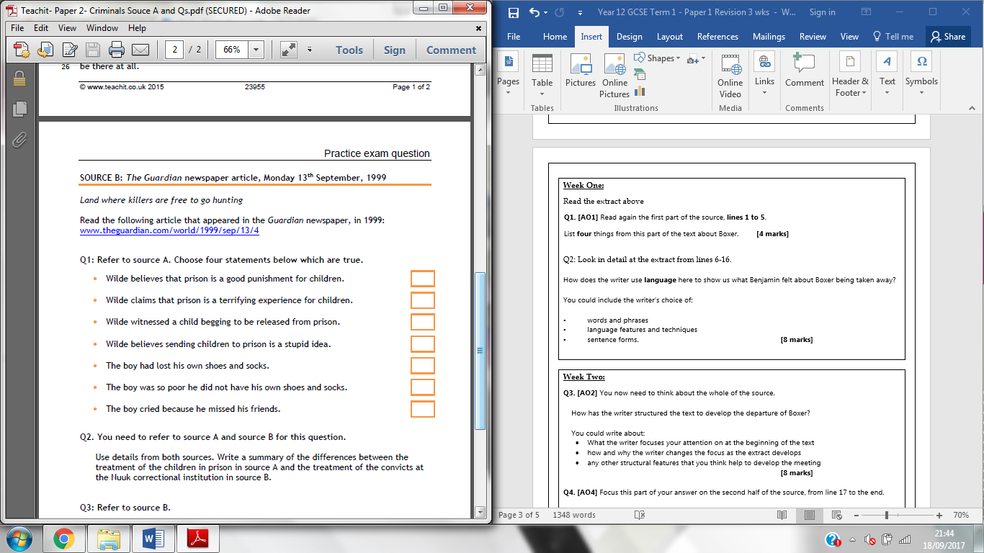



For more resources, including literacy support, visit www.deastonenglish.com