**De Aston**

**English Department**

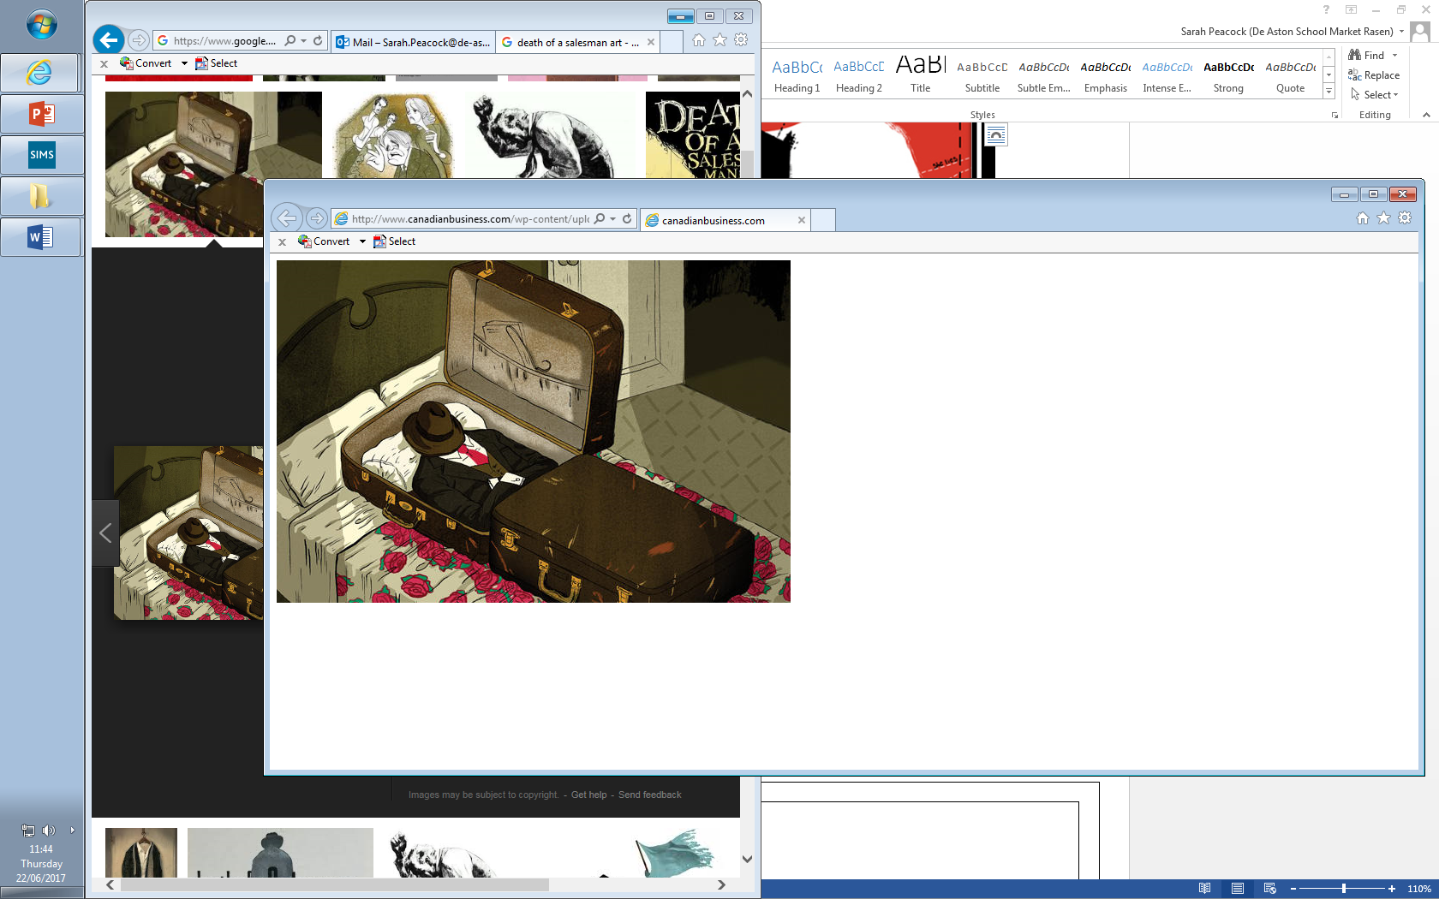

**Year 13: DOAS Revision**

**Challenge Tasks**

**Name:**

**Week Two:**

Select five quotations from each of the acts and annotate them for language devices.

Learn them and revise them!

Consider: tragic victims/heroes, expressionism, fate, inevitability to help.

**Week Three:**

Using your learnt quotations from last week, plan an essay response to the following question:

‘What significance can you find in the settings used in tragedies?’

To what extent do you agree with this view in relation to the two texts you have studied?

Challenge: plan for Keats too! It’s a good way to revise.

**Week One:**

Conduct a Marxist reading of DOAS – how does the text deal with significant Marxist ideas from your critical anthology?

**Week Four:**

Using your learnt quotations from last week, plan an essay response to the following question:

‘In tragedies, the characters are depicted as playthings of the gods in a cruel and hostile universe.’

To what extent do you agree with this view in relation to the two texts you have studied?

Challenge: plan for Keats too! It’s a good way to revise.

**Week Five:**

Using your learnt quotations from last week, plan an essay response to the following question:

‘Despite their suffering, the protagonist’s journey is ultimately redemptive.’

To what extent do you agree with this view in relation to the two texts you have studied?

Challenge: plan for Keats too! It’s a good way to revise.

Challenge: plan for DOAS too! It’s a good way to revise.

**Week Six:**

Using your learnt quotations, plan an essay response to the following question:

‘Seeing’ and ‘blindness’ are powerful motifs in many tragedies. What significance can you find in motifs of seeing and blindness in the tragedies you have studied?’

To what extent do you agree with this view in relation to the two texts you have studied?

Challenge: plan for DOAS too! It’s a good way to revise.



For more resources, including literacy support, visit www.deastonenglish.com