**De Aston**

**English Department**

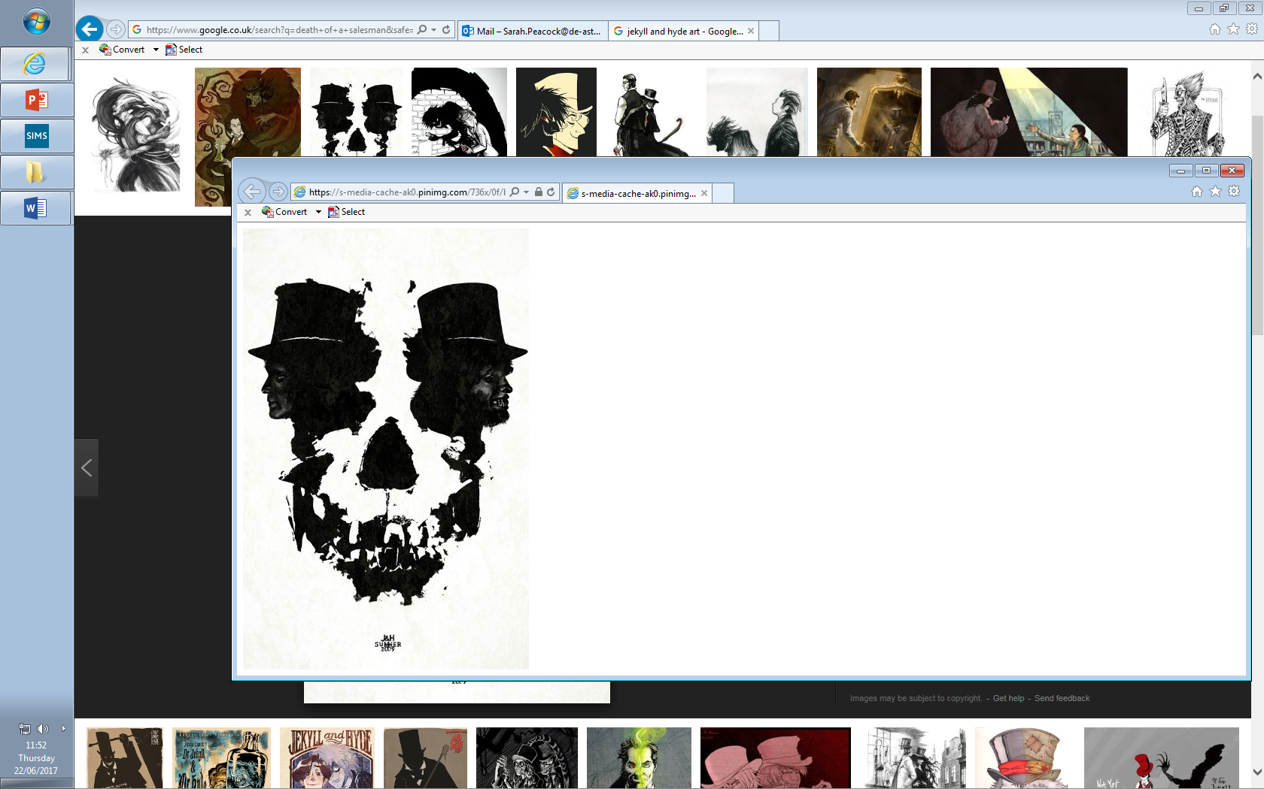

**Year 11: Dr Jekyll and Mr Hyde**

**Challenge Tasks**

**Name:**

**Week One:**

To enhance your understanding of ‘Jekyll and Hyde’, you must know about the context. Research the following elements of context: The author (R.L. Stevenson); The Victorian Age and its Values; Jack the Ripper; Darwinism; Gothic Novel and Science/Religion in Victorian time.

You can choose how you present your research. Here are some suggestions:

* A rap or poem about the genre;
* A short video about the genre;
* An artistic representation;
* A presentation to the class.

**Week Two:**

As we read on, we are learning lots about Jekyll and Hyde. Choose a task below to show your understanding:

**Hard** – draw an image of the settings we have heard about so far. Decorate it with quotations.

**Harder** – Create your own Dr Jekyll journal based upon the events of the novel so far.

**Hardest** – create a newspaper article detailing Mr Hyde’s crimes – use language from the text to help you learn quotations.

**Week Three:**

This week is analysis week. Show your understanding of the text so far by choosing a task below:

**Hard** – how is Hyde presented in the text? Write one SQUAD paragraph.

**Harder** – how is Utterson presented in the text? Write one SQUAD paragraph.

**Hardest** – How does the setting reveal the duality in the novel? Write one SQUAD paragraph.

**Additional challenge tasks:**

See the next page for the challenging vocabulary in Jekyll and Hyde – each week, learn the vocab from the chapters you have read in class.

**Final challenge:**

Read Ian Rankin’s article in the Guardian on Jekyll and Hyde and note down his key ideas.

Finally, read other texts in the Gothic genre to extend your knowledge and to allow you to link to other texts in your analysis of Dr Jekyll and Mr Hyde. Here are some suggestions:

* **Dracula by Bram Stoker**
* **Castle of Otranto by Horace Walpole**
* **Northanger Abbey: Jane Austen (1798)**
* **Frankenstein: Mary Shelley (1818)**
* **The Picture of Dorian Gray: Oscar Wilde(1890/91)**
* **The Monkey’s Paw: W.W. Gibbins (1902)**
* **The Yellow Wallpaper: Charlotte Perkins(1892)**

**Bonus week:**

Read the extract below and complete the ‘all’ question and one more of the questions below:

**All:** Where else in the text is Hyde presented as evil?

**Hard:** Analyse the language in the extract – annotate key quotations for language devices.

**Harder:** Analyse the language in the extract – annotate key quotations for language devices. How could you link this extract to context?

**Hardest:** **Starting with this extract, how does Stevenson present Mr Hyde to be an evil, unforgiving criminal? Plan your response to this question.**

Presently her eye wandered to the other, and she was surprised to recognise in him a certain Mr Hyde, who had once visited her master, and for whom she had conceived a dislike. He had in his hand a heavy cane, with which he was trifling; but he answered never a word, and seemed to listen with an ill-contained impatience. And then all of a sudden he broke out in a great flame of anger, stamping with his foot, brandishing the cane, and carrying on (as the maid described it) like a madman. The very old gentleman took a step back, with the air of one very much surprised and a trifle hurt; and at that Mr Hyde broke out of all bounds, and clubbed him to the earth. And next moment, with ape-like fury, he was trampling his victim under foot, and hailing down a storm of blows, under which the bones were audibly shattered and the body jumped upon the roadway. At the horror of these sights and sounds, the maid fainted.

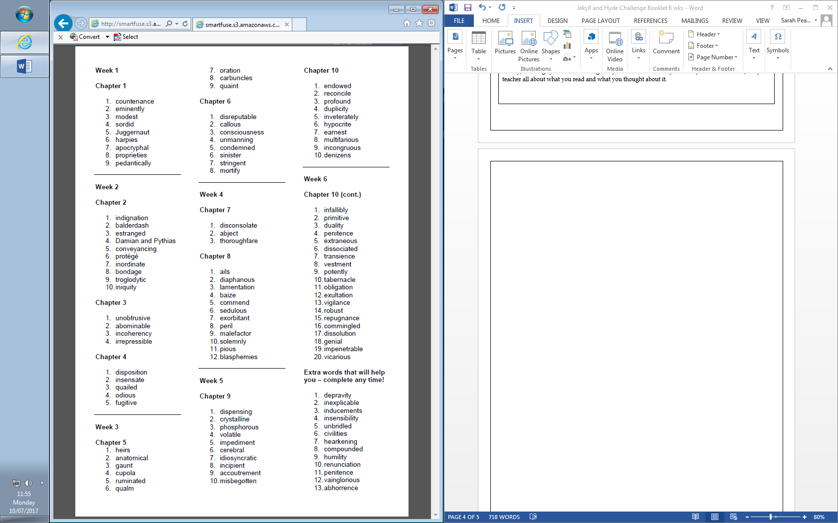



For more resources, including literacy support, visit www.deastonenglish.com