**De Aston**

**English Department**

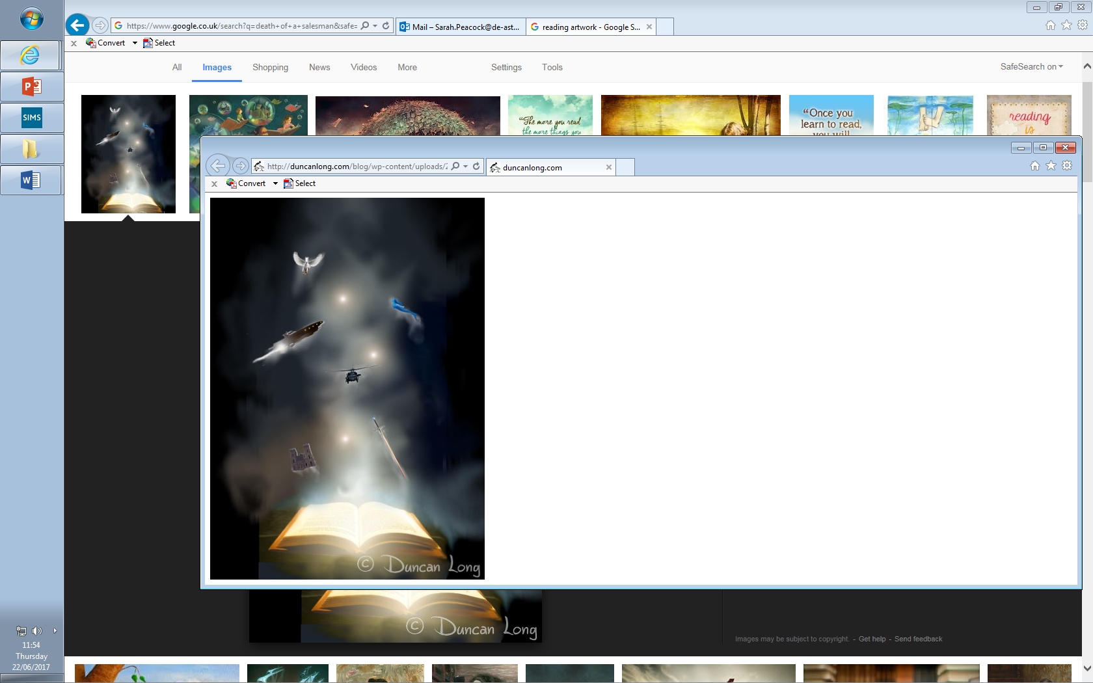

**Year 11: Reading and Writing Fiction**

**Challenge Tasks**

**Name:**

**Week Three:**

Now it’s time to write and embrace your creativity! Find an image of an interesting setting and choose one of the tasks below. You should spend 40 minutes on this homework.

1. Using the image as a stimulus, describe the setting.

Or

1. Tell a story where a strange event happens in the setting in your picture.

Remember to use paragraphs, language devices, varied sentences and vocabulary. Check your SPAG once finished.

**Week Two:**

The extract below reveals character through the setting.

*There was no one save Mr Barber, a cigarette in the corner of his mouth, his jacket off, his cuffs rolled back; he was fiddling with a nasty thing he had evidently just hung on the landing wall, a combination barometer-and-clothes-brush set with a lurid orangey varnish. But lurid touches were everywhere, she saw with dismay. It was as if a giant mouth had sucked a bag of boiled sweets and then given the house a lick. The faded carpet in her mother’s old bedroom was lost beneath pseudo-Persian rugs. The lovely pier-glass had been draped slant-wise with a fringed Indian shawl. A print on one of the walls appeared to be a Classical nude in the Lord Leighton manner. The wicker birdcage twirled slowly on a ribbon from a hook that had been screwed into the ceiling; inside it was a silk-and-feather parrot on a papier-mâché perch.*

Choose a task to complete after reading the extract:

**Hard** – choose three quotations that reveal Mr Barber’s character. Annotate them with explanations as to what they reveal, also referencing language devices.

**Harder** – look at the description of the setting. Using SQUAD paragraphs, answer the question: what does the setting reveal about Mr Barber?

**Hardest** – One student said about this piece of writing: ‘Mr Barber is presented as eccentric’ – to what extent do you agree? Write your answer in SQUAD paragraphs.

**Week One:**

Read the extract below:

*THE COURTHOUSE CLOCK CHIMED SEVEN TIMES. The echoes of the chimes faded.*

*Warm summer twilight here in upper Illinois country in this little town deep far away from everything, kept to itself by a river and a forest and a meadow and a lake. The sidewalks still scorched. The stores closing and the streets shadowed. And there were two moons; the clock moon with four faces in four night directions above the solemn black courthouse, and the real moon rising in vanilla whiteness from the dark east.*

How does the writer use language to describe the setting?

Remember, aim for two SQUAD paragraphs in 10 minutes!

**Week Four:**

Using the same image you selected last week, complete one of the following tasks:

**Hard** – introduce a character into your setting and describe how they look.

**Harder** – introduce a character into your setting and use metaphors to describe them.

**Hardest** – introduce a character into your setting but use the setting to help the reader understand the character, like the Mr Barber extract from Week 2.

This homework should consist of two additional paragraphs added to your work from last week.

**Bonus week:**

Read the extract below and complete the ‘all’ question and one more of the questions below:

**All:** list four things you learn about the doll in paragraph one.

**Hard:** how has the writer used language to create an atmosphere of horror?

**Harder:** how has the writer structured the text to interest you as a reader?

**Hardest:** a student called this text ‘frightfully dystopian’ – to what extent do you agree?

*The Children of Men*

– P.D. James (prose fiction, 1992)

*Set in 2021, no human being has been able to give birth for 25 years and scientists still do not understand why. Here, Theo meets a woman as he walks through Oxford towards Magdalen College.*

It happened on the fourth Wednesday in January. Walking to Magdalen as was his custom, he had turned from St. John Street into Beaumont Street and was nearing the entrance to the Ashmolean Museum when a woman approached him wheeling a pram. The thin drizzle had stopped and as she drew alongside him she paused to fold back the mackintosh cover and push down the pram hood. The doll was revealed, propped upright against the cushions, the two arms, hands mittened, resting on the quilted coverlet, a parody of childhood, at once pathetic and sinister. Shocked and repelled, Theo found that he couldn’t keep his eyes off it. The glossy irises, unnaturally large, bluer than those of any human eye, a gleaming azure, seemed to fix on him their unseeing stare which yet horribly suggested a dormant intelligence, alien and monstrous. The eyelashes, dark brown, lay like spiders on the delicately tinted porcelain cheeks and an adult abundance of yellow crimped hair sprung from beneath the close-fitting lace-trimmed bonnet.

It had been years since he had last seen a doll thus paraded, but they had been common twenty years ago, had indeed become something of a craze. Doll-making was the only section of the toy industry which, with the production of prams, had for a decade flourished; it had produced dolls for the whole range of frustrated maternal desire, some cheap and tawdry but some of remarkable craftsmanship and beauty.

A middle-aged woman in well-fitting tweeds, hair carefully groomed, came up to the pram, smiled at the doll‘s owner and began a congratulatory patter. The first woman, simpering with pleasure, leaned forward, smoothed the satin quilted pram cover, adjusted the bonnet, tucked in a stray lock of hair. The second tickled the doll beneath its chin as she might a cat, still murmuring her baby talk.

Theo, more depressed and disgusted by the charade than surely such harmless play-acting justified, was turning away when it happened. The second woman suddenly seized the doll, tore it from the coverings and, without a word, swung it twice round her head by the legs and dashed it against the stone wall with tremendous force. The face shattered and shards of porcelain fell tinkling to the pavement. The owner was for two seconds absolutely silent. And then she screamed. The sound was horrible, the scream of the tortured, the bereaved, a terrified, high-pitched squealing, inhuman yet all too human, unstoppable. She stood there, hat askew, head thrown back to the heavens, her mouth stretched into a gape from which poured her agony, her grief, her anger. She seemed at first unaware that the attacker still stood there, watching her with silent contempt. Then the woman turned and walked briskly through the open gates, across the courtyard and into the Ashmolean. Suddenly aware that the attacker had escaped, the doll-owner galumphed after her, still screaming, then, apparently realising the hopelessness of it, returned to the pram. She had grown quieter now and, sinking to her knees, began gathering up the broken pieces, sobbing and moaning gently, trying to match them as she might a jigsaw puzzle. Two gleaming eyes, horribly real, joined by a spring, rolled towards Theo. He had a second’s impulse to pick them up, to help, to speak at least a few words of comfort. He could have pointed out that she could buy another child.

**Extending your vocabulary**

*You should be trying to expand your vocabulary throughout your studies of English, for example by using a thesaurus when completing extended writing tasks. In addition to this, find out what the following words mean, learn how to spell them and try to use them in your class work:*

1. Asinine 2. Degenerate 3. Impervious 4. Innocuous 5. Moribund

**Additional challenge:**

Complete 20 minutes of wider reading every week. Each week, tell your teacher, in your exercise book, what you have read and what you thought about it.

Here are some suggestions which Miss Peacock and all good libraries will have:

* *Mister Pip -* Lloyd Jones
* *Martyn Pyg* - Kevin Brooks
* *The Woman in Black* – Susan Hill
* *The King of the Castle* – Susan Hill
* *Lord of the Flies* – William Golding
* *The Hitchhiker’s Guide to the Galaxy* – Douglas Adams
* *His Dark Materials Trilogy* – Phillip Pullman
* *Angela’s Ashes* – Frank McCourt
* *Of Mice and Men* – John Steinbeck
* *The Hound of the Baskervilles* – Arthur Conan Doyle
* *The Spy Who Came In From The Cold* - John Le Carre
* *Tales of The Otori* (trilogy) – Lian Hearn
* *The Colour of Magic* – Terry Pratchett
* *Slumdog Millionaire* – Vikas Swarup
* *Fever Pitch* – Nick Hornby
* *Sophie’s World* Jostein Gaarder
* *Lovely Bones* Alice Sebold
* *Purple Hibiscus* - Chimamanda Ngozi Adichie
* *Never Let Me Go* Kazuo Ishiguro
* *The Kite Runner* Khaled Hosseini
* *1000 Splendid Suns* Khaled Hosseini
* *The Book Thief* Marcus Zusak

Alternatively, get involved with the English Book Club’s ’16 before 16’ challenge!

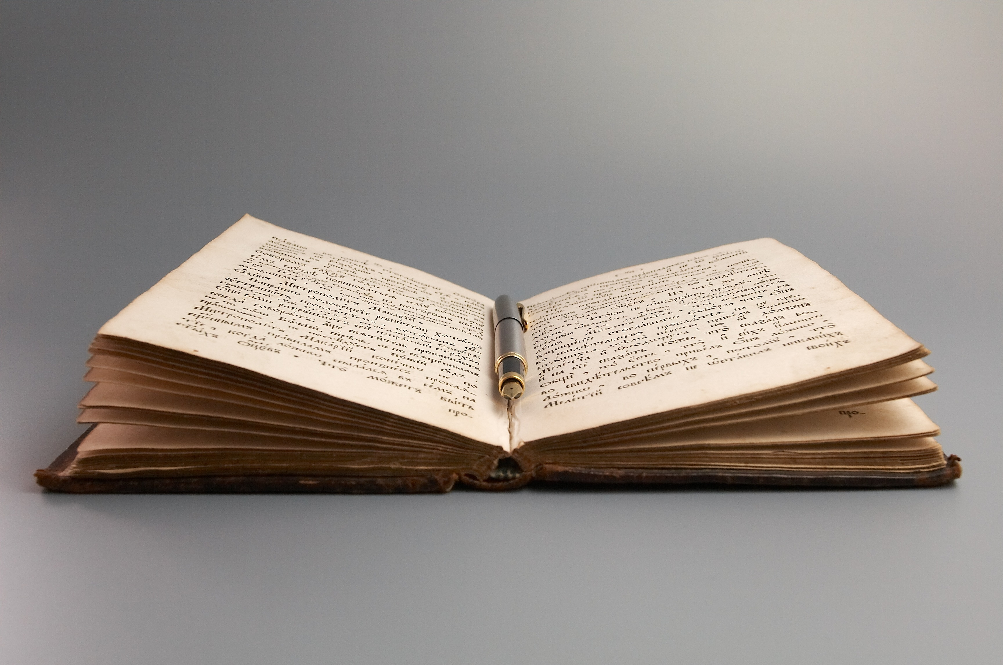

**Key terms: Structure and Sentence forms**

*Revisit these key terms from your year 10 homework booklets: these terms will all be useful to you throughout your studies of English, particularly in English Language Paper 1 where you are required to analyse structure. Make sure you understand what each term means and can identify examples in the texts you read. You will cover many of them as part of your QWC/SPAG lessons this term, so check your notes if there are any you are unsure about.*

|  |  |  |
| --- | --- | --- |
| **Hard**  chronological  climax  complex sentence  complication  compound sentence  compound-complex sentence  declarative sentence  exclamatory sentence  foreshadowing  imperative sentence  interrogative sentence  introduction  main/independent clause  minor sentence  narrative hook  resolution  simple sentence  subordinate/dependent clause | **Harder**  analepsis (flashback)  anaphora  cataphora  coherence  cohesion  counter argument  denouement  exposition  falling action  participle  prolepsis (flashforward)  rising action | **Hardest**  allofunctional implicature  appositive  complement clause  non-restrictive clause  parallel construction  relative clause  restrictive clause |



For more resources, including literacy support, visit www.deastonenglish.com