**De Aston**

**English Department**



**Year 8: Poetry Around the World**

**Academic Excellence Booklet**

The role of the Academic Excellence Booklet is for you to complete these tasks over the next six weeks. These activities are purposely designed to challenge you, so don’t worry if you find them difficult. You’re meant to! Learning happens when people have to think hard. That being said, your English teacher is a specialist, so ask any of us for help, anytime!

1. **White Teeth**

“Hi, guys.”

“Hi, Mark.”

“Off to the chess club, Mum.”

“Yes, M – M – Mark,” said Alsana, close to tears at this final snub, the replacement of “Mum” for “Amma”. “Do not be late, now.”

“I GIVE YOU A GLORIOUS NAME LIKE MAGID MAHFOOZ MURSHED MUBTASIM IQBAL!” Samad had yelled after Magid when he returned home that evening and whipped up the stairs like a bullet to hide in his room. “AND YOU WANT TO BE CALLED MARK SMITH!”

But this was just a symptom of a far deeper malaise. Magid really wanted to be *in some other family*. He wanted to own cats and not cockroaches, he wanted his mother to make the music of the cello, not the sound of the sewing machine; he wanted to have a trellis of flowers growing up one side of the house instead of the ever growing pile of other people’s rubbish; he wanted a piano in the hallway in place of the broken door off cousin Kurshed’s car; he wanted to go on biking holidays to France, not day-trips to Blackpool to visit aunties; he wanted the floor of his room to be shiny wood, not the orange and green swirled carpet left over from the restaurant; he wanted his father to be a doctor, not a one-handed waiter; and this month Magid had converted all these desires into a wish to join in with the Harvest Festival like Mark Smith would. Like everybody else would.

BUT WE WANT TO DO IT. OR WE’LL GET A DETENTION. MRS OWENS SAID IT IS TRADITION.

Samad blew his top. “Whose tradition?” he bellowed, as a tearful Magid began to scribble frantically once more. “Dammit, you are a Muslim, not a wood sprite! I *told* you, Magid, I told you the condition upon which you would be allowed. You come with me on haj. If I am to touch that black stone before I die I will do it with my eldest son by my side.”

Magid broke the pencil halfway through his reply, scrawling the second half with blunt lead. IT’S NOT FAIR! I CAN’T GO ON HAJ. I’VE GOT TO GO TO SCHOOL. I DON’T HAVE TIME TO GO TO MECCA. IT’S NOT FAIR!

* **Read the extract above from Zadie Smith’s ‘White Teeth’ -** What cultural indicators can you identify? The extract explores the idea of a conflict between two cultures – Muslim and Christian – e.g. Haj v Harvest Festival, Biking holidays v trips to Blackpool to visit Aunties, Amma v Mum, Magid v Mark etc.
* Using the extract, write a poem from Magid’s perspective.



1. **Country Lovers**

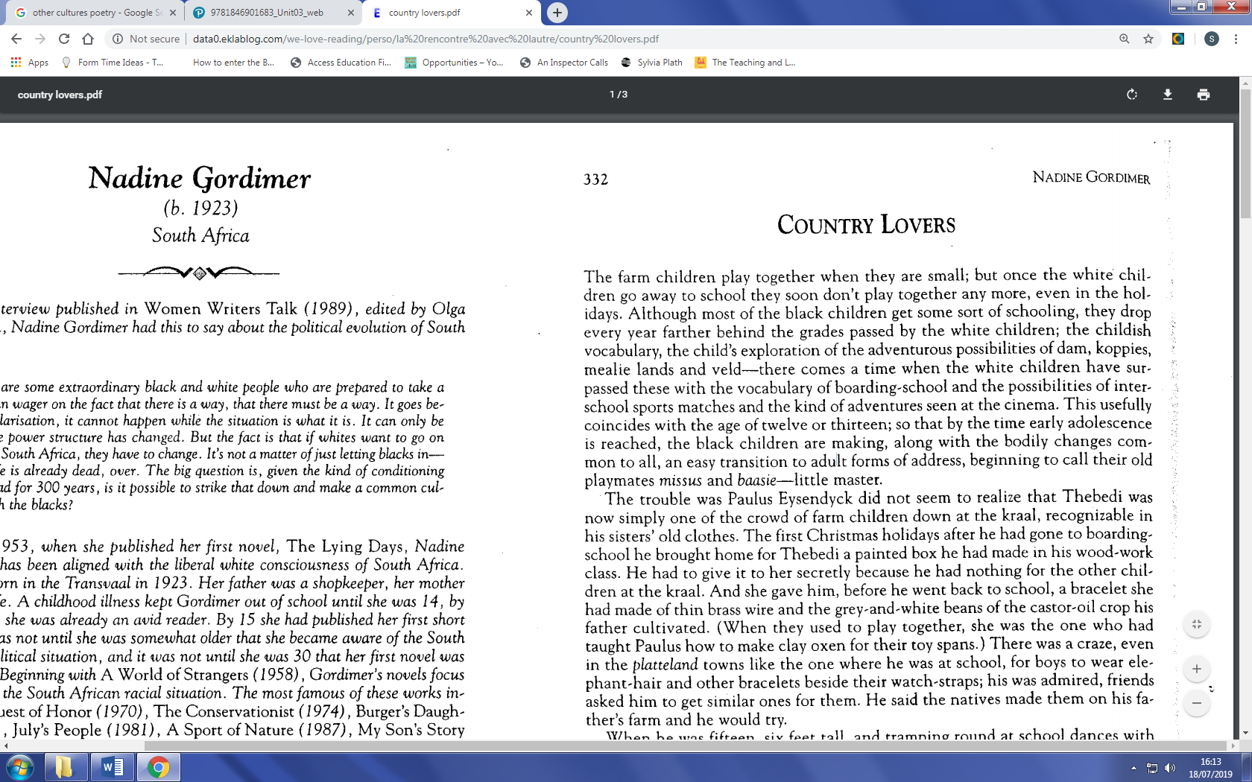

* Read the extract from Country Lovers above.
* Use it as an inspiration to research the Apartheid in South Africa.
* Finally, using some of the words from the extract, write a poem about separation.

1. **The School Teacher’s Guest**

"I think I'd better close the store," sighed Riad Halabi.

The two had known each other so long that neither could remem-

ber the exact number of years, although both recalled every detail of

the day their friendship had begun. At the time, Halabi had been one

of those salesmen who wander the byways offering their wares » a

commercial pilgrim without compass or fixed course, an Arab immi-

grant with a false Turkish passport, lonely, weary, with a palate split

like a rabbit's and a subsequent longing to sit in the shadows. She had

been a still-young woman with firm hips and proud shoulders, the

town's only schoolteacher, and the mother of a twelve-year-old son

bom of a fleeting love affair. The boy was the center of the school-

teacher's life; she cared for him with unwavering devotion but, barely

masking her inclination to indulge him, applied to him the same

norms of discipline she demanded of the other schoolchildren. She

did not want anyone to be able to say she had brought him up badly;

at the same time, she hoped to negate the father's legacy of wayward-

ness and instead form her son to be of clear mind and generous heart.

The very evening on which Riad Halabi had driven into Agua Santa

from one side of town, from the other a group of boys had carried in

the body of schoolteacher Ines's son on an improvised stretcher. He

had walked onto someone's property to pick up a fallen mango, and

the owner, an outsider whom no one really knew, had fired a blast

from his rifle meaning to scare the boy away but drilling a black hole

in the middle of his forehead through which his life rapidly escaped.

At that moment, the salesman had discovered his vocation for leader-

ship and without knowing how, had found himself at the center of

things, consoling the mother, organizing the funeral as if he were a

member of the family, and calming the people to prevent them from

tearing the perpetrator limb from limb. Meanwhile, the murderer,

realizing that his life would be worth very little if he remained there,

had fled, meaning never to return.

Considering the extract, suggest why the boy is killed. Write the next section of the story, taking care to include evidence of the culture of South America.

For more resources, including literacy support, visit www.deastonenglish.com