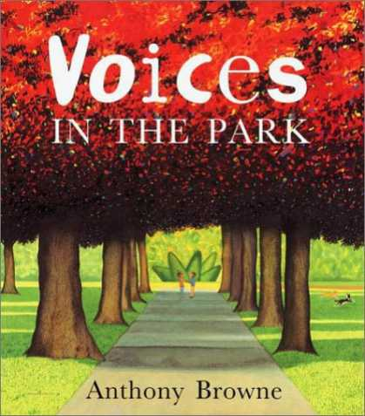
My favourite book is Voices in the Park by Anthony Browne.

Voices in the Park is a picture book for both children and young adults. It immediately captivates your imagination by the vivid, realistic setting; multidimensional, characters; and believable problems.

I like this book because of the story could happen in the real world. An upper-class mother and son walk their dog to the park and meet other people who may not be of the same socioeconomic status as they are. However in this book, the characters are not humans but are gorillas! This is a very clever notion as it not only removes the view that readers might refuse to relate to the characters due to preconceived bias about race, socioeconomic class and/or the gender of the characters; but also reading with such prejudice could limit a reader’s ability to make personal connections to the experiences of characters.
The story reads as four separate stories, each with its own voice (hence the title!). At the end the voices are blended to create one semi- ambiguous ending, letting the reader fill in the holes.

The first point of view is from the perspective of Charles' mother, she looks down at the other characters because they look different than her. She possibly perceives them as coming from a lower socioeconomic class because of the way they are dressed or groomed. She has a pedigree Labrador called Victoria and immediately takes a dislike to a mongrel called Albert.

Then there is Smudge's father who is unemployed and depressed, so his daughter cheers him up by taking him to the park. Once there, he wishes he had half of the energy that the dog had. He is in his own little world throughout his narrative because he is focused on finding a job.

Interestingly, Charles' views things differently from his mother. He saw Albert as a friendly dog, and he fails to notice Smudge's father. His perception of Smudge are that although she was a girl, she was good at going down the slide and swinging on the monkey bars. In the text, we know he is enjoying his time with her as he uses different types of adjectives such as ‘funny’, ‘amazed’, ‘great’. At the end of his narrative, he asks if Smudge would be there next time when he goes to the park.

For Smudge, she realizes that her dad was fed up with the way things were going in his life. Hence, she suggested they go to the park. When they got there, she regarded Victoria, Charles' dog, as a nice dog. Her interaction with Charles' mother made her comment how she was, "a silly twit." Smudge mentions how she noticed that he was sad when his mother found him playing with her.

Another great reason for reading this book is the font and visual imagery. Each character has their own distinctive font that reflect their character, so Charles’ mother has Times New Roman as it a very formal font, just like her! Brown also incorporates Impressionistic and Surrealistic art, such as fruit shapes trees and multi-coloured lamp posts and of course the famous Mona Lisa who is crying so much there is a puddle of water on the pavement!

This is a great story because Browne is not sending just one certain message to readers, but everyone can relate to this book in some form, because with each voice in the book comes a different personality. This is truly a remarkable book, so don’t think picture books are just for small children, go on, reignite your love of reading via this book!

