**De Aston**

**English Department**

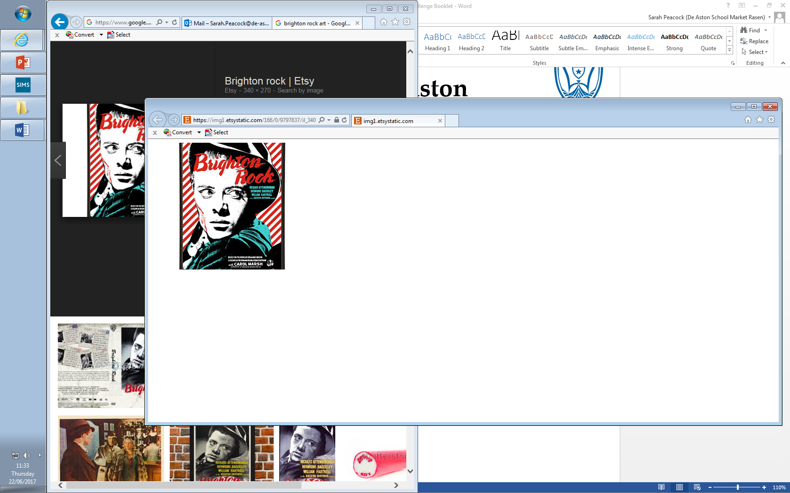

**Year 12/13: Brighton Rock**

**Challenge Tasks**

**Name:**

**Week Three:**

Hard: With your reading so far, answer the question: Is Brighton Rock just a simple thriller?

Harder: With your reading so far, answer: Is Brighton Rock a typical crime novel?

Hardest: With your reading so far, answer: Brighton Rock is a religious allegory. To what extent do you agree?

**Week Two:**

Now you have read Ch1, you will have seen an in-depth description of Brighton.

Evaluate your first impressions of the setting, linking to the text as much as possible.

Be sure to consider how it fits in the crime genre as well.

Give your first impressions of the setting and consider it as an unusual crime setting.

**Week One:**

Research the context of Brighton Rock, looking at 1930s Britain and Graham Greene as a writer.

Then write a paragraph including reasons as to why Greene set the text in Brighton.

**Week Four:**

Hard: Read The Guardian’s review of *Brighton Rock* and write down key ideas that could as criticism for the novel.

Harder: As above but explain your links to the novel.

Hardest: Evaluate the criticism – do you agree with it? Why? Why not?

**Week Five:**

Hard: Google and read Lewis’ essay on *Brighton Rock* called ‘Brighton Rock: appalling strangeness.’ Summarise the article and highlight the key ideas that could be used for criticism.

Harder: As above but link the ideas to the novel.

Hardest: As above but also consider how the novel may fit the Feminism/Marxist lens.

**Week Seven-Nine:**

In terms of your revision for this unit, track the following in the text. You can present your revision how you wish (collage, cue cards, PPT etc…). Each element should include quotes.

* Plot
* Characters
* Themes
* Context
* Language, structure and form
* Links to crime elements
* Criticism

**Week Six:**

Hard: Consider how your impressions and views of characters may now have changed. Track each character and how we feel about them in each Part of the novel. Support with quotations.

Harder: As above but also explain how the quotations included support your view.

Hardest: As above but evaluate each character. How do they fit into the crime genre?



For more resources, including literacy support, visit www.deastonenglish.com