**De Aston**

**English Department**

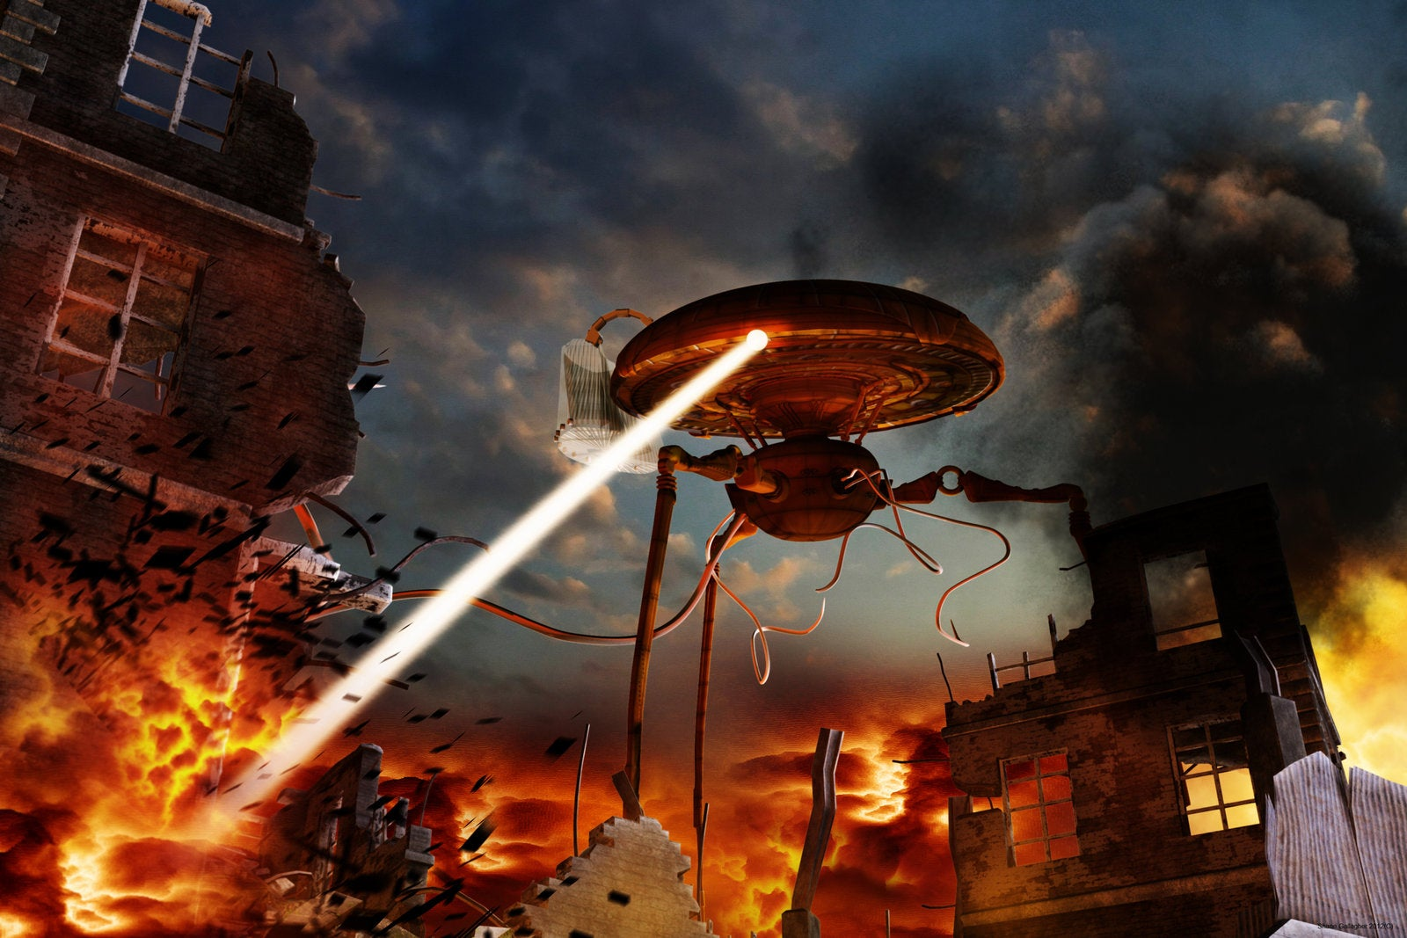

**Year 8: War of the Worlds**

**Academic Excellence Booklet**

The role of the Academic Excellence Booklet is for you to complete these tasks over the next six weeks. These activities are purposely designed to challenge you, so don’t worry if you find them difficult. You’re meant to! Learning happens when people have to think hard. That being said, your English teacher is a specialist, so ask any of us for help, anytime!

1. **Form of the novel**

‘The War of the Worlds’ can be interpreted in many different ways. Create a presentation arguing how ‘The War of the Worlds’ is one of the following:

* Science fiction novel;
* Critique of imperialism or colonialism;
* Critique of human hubris (pride);
* Critique of technology/science;
* Allegory about the damaging impacts of xenophobia.

1. **Understanding the fin de siècle novel:**

The term ‘fin de siècle’ means ‘end of the century’ and as War of the Worlds was written by H.G. Wells in 1897, it is a fin de siècle novel. The term typically discusses either a period of degeneration, criticising the century which has just passed while looking cynically at the century about to come, or it can be looking towards the next century full of hope.

Before beginning the next task, you need to look at the text as a ‘new historian’ meaning you need to consider what you know about the end of the Victorian period (when it was written in 1897) and also what you know (but H.G.Wells didn’t) about what was to come in the early 1900s.

From your knowledge of ‘War of the Worlds’ so far, consider the following:

* How does the fin de siècle novel ‘The War of the Worlds’ demonstrate attitudes of cynicism and pessimism?
* Conversely, how does the fin de siècle novel ‘The War of the Worlds’ demonstrate attitudes of optimism and hope?

1. **Cartoon Strip**

Your final task is to create a cartoon strip about how ‘The War of the Worlds’ is a representation of the ideas of Thomas Huxley or Charles Darwin (you may need to conduct some independent research first) 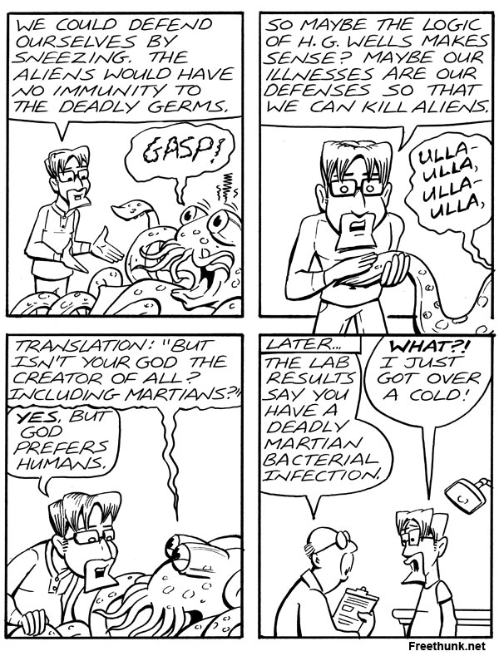



For more resources, including literacy support, visit www.deastonenglish.com