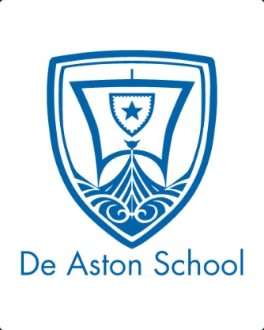
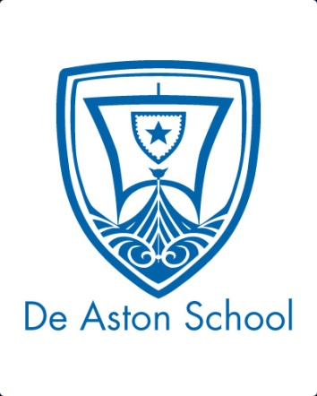
De Aston
English Department
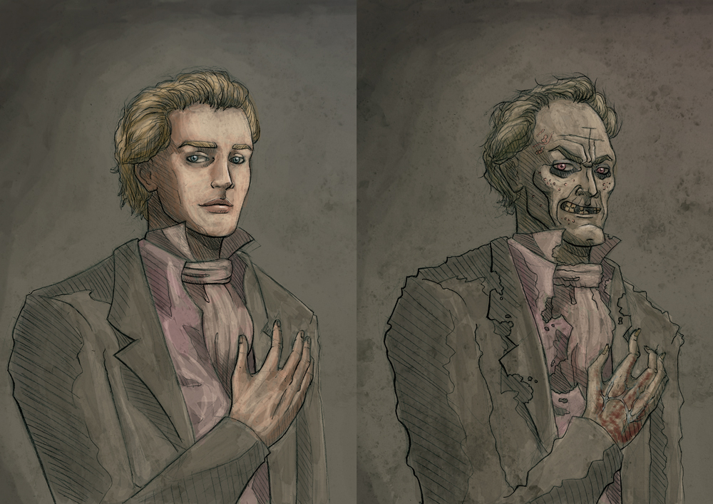
Year 9: The Picture of Dorian Gray
Academic Excellence Booklet

The role of the Academic Excellence Booklet is for you to complete these tasks over the next six weeks. These activities are purposely designed to challenge you, so don’t worry if you find them difficult. You’re meant to! Learning happens when people have to think hard. That being said, your English teacher is a specialist, so ask any of us for help, anytime!
- The context of the novel
The term 'Fin de Siècle' is a French term, translated as 'end of century', specifically the end of the 19th century. Being written in 1890, The Picture of Dorian Grey fits firmly into this literary era.
Duality, nature, and the superficial nature of society are three tropes at the core of literary works of the Fin de Siecle, and ones which form the background for Gothic fiction.
From your knowledge of 'The Picture of Dorian Gray', consider the following:
- Hours after committing murder, we are told that Dorian “felt keenly the terrible pleasure of a double life”. In which ways does he live a double life? Write a short paragraph explaining this idea.
- A major theme that prevails especially at the beginning of the novel is the importance of beauty. The characters treasure beauty and youth greatly. Find three quotes to support this, and analyse them. (Tip – look in chapter three if you're struggling)
- Wilde uses floral imagery throughout the novel. Write a short paragraph about what this motif may symbolise. Some ideas to consider may be: innocence; the ephemera nature of beauty; the importance placed on physical appearance as opposed to personality

- A synopsis of the novel, in your own words
Using as many high-level phrases from the word bank below as possible, alongside your own vocabulary, write a synopsis of 'The Picture of Dorian Gray':
Macabre (disturbing, relating to pain and death)
Quasi-religious worship (an obsession so strong it is almost religious – think of Dorian's obsession with youth and beauty)
Propriety (conventionally accepted behaviour/morals)
Malevolent (evil)
Sparagmos (destruction)
Epiphany (realisation)
Abhorrent (evil)
Deplorable (unforgivable/unacceptable)
Winsome (attractive because of innocence)
Ambicide (killing of a friend)
Vehement (feeling strongly about something)
- Exploring key themes in depth
Prominent notions in the novel, and ones which Dorian eventually realises, are the superficial and ephemeral nature of youth and beauty.
After Dorian realises that it is his portrait that will bear the scars of his corrupt and evil deeds, as opposed to his own body, he begins to ignore the piety and morality associated with the Victorian era, committing heinous acts. They have no real consequence for him.
Choose one of the following tasks to complete in order to explore the central theme of the superficial and ephemeral nature of youth and beauty:
- In the words of Dorian, write a diary entry discussing the emotional journey he embarks on when observing the new grotesque nature of the painting, and his plans to destroy it.
- Literary critic Luckhurst describes the novel as “Stevenson's story of Dr Jekyll and Mr Hyde told in reverse, Dorian keeping perfect public command of himself while his double rots in secret”, highlighting the key theme of repression. To assist in your understanding of this theme, do some independent research on men's sexual and emotional repression in Victorian England, and relate this to the text. Present this research in a document or a poster format.

- Developing your vocabulary
Below is an artist's interpretation of Dorian's portrait before and after its grotesque changes, brought about by Dorian's immorality.
Using a thesaurus if necessary, annotate each portrait with high-level and complex adjectives (or sentences) to describe the side of Dorian's personality being portrayed.
Alternatively, draw your own interpretation of the portraits and annotate those!
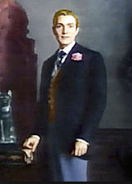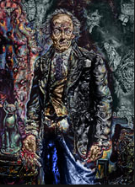

- Context
As you’ll find when studying Jekyll and Hyde for GCSE, it was necessary for some people, usually higher class gentleman, to lead double lives in Victorian England. This was due to the intense focus on reputation and the necessity to protect it. Dorian’s friend Lord Henry makes this link between the criminal and the respectable citizen clear when he observes: ‘Crime belongs exclusively to the lower orders. I don’t blame them in the smallest degree. I should fancy that crime is to them what art is to us, simply a method of procuring extraordinary sensations’ – of course, this is ironic as Dorian goes on to indulge in immoral behaviour. As a result, how is crime or immorality, shown to a sensation?

- Paintings
Paintings often play a sinister role in Gothic fiction. The first Gothic novel, Horace Walpole’s The Castle of Otranto (1764) includes a figure stepping from a painting and into reality while Melmoth the Wanderer (1820), written by Oscar Wilde’s great-uncle Charles Maturin, describes the haunting gaze of a portrait as it follows the viewer around a room. The picture hidden in Dorian’s attic may be the most disturbing portrait in Wilde’s book, but it is not the only canvas in the novel which provides a pointer to Dorian’s behaviour. At one point Dorian walks through the picture-gallery of his country home, looking at the portraits of his ancestors: ‘those whose blood flowed in his veins’. The saturnine and sensuous faces stare back at him, causing Dorian to reflect whether ‘some strange poisonous germ crept from body to body till it had reached his own?’ (ch. 11). This poses the question as to whether Dorian is free to determine his own actions, and is thus entirely responsible for his behaviour, or whether his actions are dictated by his genetic inheritance – an inheritance, as the faces of his ancestors indicate, ‘of sin and shame’. The eminent mental pathologist Henry Maudsley wrote in his book Pathology of Mind (1895): ‘Beneath every face are the latent faces of ancestors, beneath every character their characters’. This idea already seems present in much Gothic fiction, including Wilde’s novel.
To what extent do you believe that Dorian has free will?
Further reading:
The Fin de Siecle and Gothic texts revolutionised the face of literature forever They remain prevalent even in the 21st century, being popular at GCSE, A-level, and degree level, so reading around them will really benefit you in your future studies!
If you are interested in reading more about this revolutionary period of literature, here are some places to get you started:
Books:
Dracula
The Strange Case of Dr Jekyll and Mr Hyde

Websites: The British Library – Discovering Literature: Romantics and Victorians: Fin de Siècle Finding Queer Street: The Representation of Sexuality in 19th century

For more resources, including literacy support, visit www.deastonenglish.com

