De Aston School
English Department

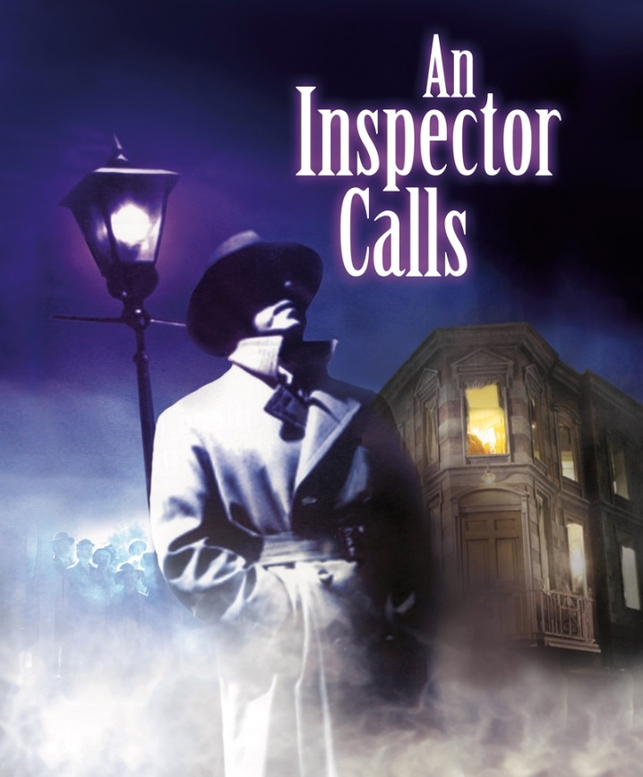

GCSE English Literature (8702)
Paper 2: Modern Texts
Exemplar Questions

Welcome!
This booklet contains a wealth of practice extracts and questions for Paper 2 of your English Literature exam. This covers the Modern Text you studied in Year 10, as well as the Anthology Cluster of Poetry and the Unseen Poetry elements you have studied in Year 11.
Section A, your question on the Modern Text, is structured simply as a single focus essay question, with no provision of an extract. Section B, which examines your Anthology Cluster, is a comparative question between a named poem, a copy of which is printed in your exam paper, and another poem of your choice from the Cluster, which you must recall from memory. Section C, your unseen question, will provide you with a main unseen poem, which you will need to analyse individually, and then provide a comparative unseen, which you must then compare to the core unseen.
Remember that all of your English Literature exams are closed-book; this means you will not have access to the texts in your exam. This means you need to have a thorough knowledge of the texts, including ideally some key memorable quotations that you have explored and analysed in lessons.

English Literature Paper 2 (8702/2)
Friday 26th May 2017 9am

Top Tips!
- You examiner awards you marks for making insightful and relevant points, making appropriate inferences from quotations, talking about language/form/structure, analysing the writer’s intentions, the effect of the text on its reader/audience, and the role of context.
- Context can mean a variety of elements, including social, cultural and historical information about when the texts are set, written or received, and how this influences our reaction to and understanding of the plot and its characters.
- You are not required to use quotations when referring to and discussing the whole text beyond the extract, but you may have remembered some. If you know them, use them.
- For poetry, make sure you use the printed poem to carry out close language analysis, picking out and focusing on individual words, phrases and language features;
- In unseen poetry, remember your focus is entirely on language, form and structural comparison.
Boundaries
Your English Literature Paper 2 Exam is worth 60% of your overall Literature grade.
Sections A and B are both out of 30 marks, with Section A (Modern Text) also carrying 4 marks for AO4 – Spelling, Punctuation and Grammar. Section C (Unseen Poetry) carries 32 marks, divided into 24 marks for Part i (Analysis of Main Unseen Poem) and 8 marks for Part ii (Comparison to 2nd Unseen Poem). The boundaries are as follows:
Grade | 1 | 2 | 3 | 4 | 5 | 6 | 7 | 8 | 9 | Max.  Marks
Section A  Modern Text | 2 | 6 | 10 | 14 | 17 | 20 | 22 | 28 | 33 | 34
Section B  Anthology | 2 | 6 | 9 | 13 | 15 | 17 | 20 | 24 | 29 | 30
Section C  Unseen | 2 | 6 | 10 | 13 | 16 | 18 | 21 | 26 | 31 | 32

Modern Texts
You are advised to spend about 45 minutes on this section.
Answer one question.

JB Priestley: An Inspector Calls

- How and why does Priestley present Inspector Goole in An Inspector Calls?

Write about:

- how the Inspector treats and deals with the other characters
- how Priestley presents the Inspector by the ways he writes.
[30 marks]
AO4 [4 marks]

- How does Priestley explore the role of women in An Inspector Calls?

Write about:

- the ideas about women presented in An Inspector Calls
- how Priestley presents these ideas by the ways he writes.
[30 marks]
AO4 [4 marks]

- How and why does Sheila change in An Inspector Calls?

Write about:

- how Sheila responds to her family and the Inspector
- how Priestley presents Sheila by the ways he writes.
[30 marks]
AO4 [4 marks]

- How does Priestley explore responsibility in An Inspector Calls?

Write about:

- the ideas about responsibility in An Inspector Calls
- how Priestley presents these ideas by the ways he writes.
[30 marks]
AO4 [4 marks]

- How does Priestley use the character of Mrs Birling to explore ideas about social class?

Write about:

- how Priestley presents the character of Mrs Birling and her ideas
- how Priestley shows ideas about social class by the ways he writes.
[30 marks]
AO4 [4 marks]

- Do you think Eva Smith is an important character in An Inspector Calls?

Write about:

- how Priestley presents the character of Eva Smith
- how Priestley presents ideas about people and society by the ways he writes.
[30 marks]
AO4 [4 marks]

- “We are members of one body. We are responsible for each other”. How far is this idea important in An Inspector Calls?

Write about:

- what you think Priestley is saying about responsibility and society
- how Priestley presents these ideas by the ways he writes.
[30 marks]
AO4 [4 marks]

- How does Priestley present Eric in An Inspector Calls?

Write about:

- how Eric is involved in the events of the play
- how Priestley presents ideas about Eric by the ways he writes.
[30 marks]
AO4 [4 marks]

- “We really must stop these silly pretences”. How does Priestley suggest that people often pretend to be things they are not in An Inspector Calls?

Write about:

- the ways characters are different from the impression they create
- how Priestley presents these differences by the ways he writes.
[30 marks]
AO4 [4 marks]

- How does Priestley criticise the selfishness of people in An Inspector Calls?

Write about:

- how Priestley presents characters’ selfishness in An Inspector Calls
- how Priestley presents these ideas by the ways he writes.
[30 marks]
AO4 [4 marks]

- How does Priestley the relationship between Sheila Birling and Gerald Croft in An Inspector Calls?

Write about:

- the way the relationship between Sheila and Gerald changes through the play
- how Priestley presents these ideas by the ways he writes.
[30 marks]
AO4 [4 marks]

- How does Priestley present the life of the Birling family?

Write about:

- what Priestley is suggesting about the different members of the Birling family
- how Priestley presents these ideas by the ways he writes.
[30 marks]
AO4 [4 marks]

- How does Priestley present the differences between two characters in An Inspector Calls?

Write about:

- what Priestley suggests are the differences between two characters
- how Priestley presents certain ideas by the ways he writes.
[30 marks]
AO4 [4 marks]

- How does Priestley explore the role of men in An Inspector Calls?

Write about:

- the ideas about men presented in An Inspector Calls
- how Priestley presents these ideas by the ways he writes.
[30 marks]
AO4 [4 marks]

