**De Aston**

**English Department**

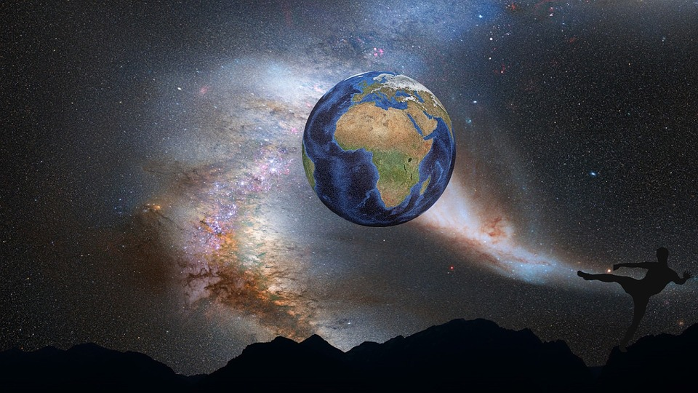

**Year 7: Fantasy Class Reader**

**Challenge Tasks**

**Name:**

**Week One:**

This week, you will have been thinking about the sorts of books you read and enjoy. As well as the blurb on the back of a book, the opening page is always really important if the writer wants you to take the plunge and carry on reading. Choose one of the tasks below.

* Visit the school library this week and spend some time browsing the books. Read the opening paragraph of three of them – and make a note of the titles and authors. Be prepared to give your view about how effective they are in hooking the reader in the first paragraph.
* Write the opening paragraph to a novel. Ask at least three people to read it to see if it is gripping. If they give you good advice – make some changes to it.

**Week Two:**

Make sure you have a book you are reading at home. If you haven’t got one on then go and spend some time finding one.

Spend two 30 minute sessions reading your book at home. Make sure you aren’t sitting anywhere near a TV or computer screen or mobile phone. Once finished, write a summary of what you read and what you think will happen next.

If it is hard to find somewhere quiet at home have a word with your teacher who will make sure there is somewhere you can sit at school.

**Week Four-Six:**

Now it’s time for some project work. This project will take you two weeks to complete.

In groups or on your own, choose a task below.

* Write a poem about the book you have read in class – challenge yourself to use rhyme or a different form – present this poem for display.
* You are responsible for the advertising for the film version of the novel you have been reading. Design a poster for cinemas. Write the ‘blurb’ for the back of the DVD case.
* Read ‘The Day of the Triffids’ by John Wyndham. (You probably won’t finish this in two weeks but you will have made a good start).

**Week Three:**

Imagining an original fantasy world is not easy! This week you should spend some time thinking about a world you could imagine writing about. Choose the task which best suits your skills.

* + Using the internet, magazines, your imagination, films and other sources to put together an A4 poster full of images which you might use as part of your fantasy world.
  + Write a description of your fantasy world as though your main character is seeing it for the first time.
  + Draw, paint or create an image of the fantasy world you have imagined.

**Additional challenge tasks:**

Make sure you understand what each of these words means and show your understanding by trying to use them in your classwork. Then learn how to spell them – be ready for a spelling test in the last week of term.

**Hard:** 1. Characterisation 2. Narrative 3. Setting 4. Perspective 5. Structure

**Harder:** 1. Climax 2. Resolution 3. Complication 4. Intertextuality 5. Juxtaposition

**Hardest:** 1. Visceral 2. Malignant 3. Duplicitous 4. Raucous 5. Isolated

**Final challenge:**

Finally, make sure you have been working on your Reading Journal challenges. Is there any room for a fantasy novel as one of the books you need to read?

**Bonus week:**

Read the extract below and complete the ‘all’ question and one more of the questions below:

**All:** List four things you learn about the narrator’s uncle.

**Hard:** Find any words you do not know the meaning of and look them up in a dictionary.

**Harder:** Choose three phrases which help to create a tense atmosphere in this extract. Explain your choices.

**Hardest:** Reread the extract. Why is this a particularly exciting start to a novel? (Think about the information we have about the professor – and what he is doing in this extract!)

**Looking** back to all that has occurred to me since that eventful day, I am scarcely able to believe in the reality of my adventures. They were truly so wonderful that even now I am bewildered when I think of them.

My uncle was a German, having married my mother’s sister, an Englishwoman. Being very much attached to his fatherless nephew, he invited me to study under him in his home in the fatherland. This home was in a large town, and my uncle a professor of philosophy, chemistry, geology, mineralogy, and many other ologies.

One day, after passing some hours in the laboratory—my uncle being absent at the time—I suddenly felt the necessity of renovating the tissues—*i.e.*, I was hungry, and was about to rouse up our old French cook, when my uncle, Professor Von Hardwigg, suddenly opened the street door, and came rushing upstairs.

Now Professor Hardwigg, my worthy uncle, is by no means a bad sort of man; he is, however, choleric and original. To bear with him means to obey; and scarcely had his heavy feet resounded within our joint domicile than he shouted for me to attend upon him.

“Harry—Harry—Harry—”

I hastened to obey, but before I could reach his room, jumping three steps at a time, he was stamping his right foot upon the landing.

“Harry!” he cried, in a frantic tone, “are you coming up?”

Now to tell the truth, at that moment I was far more interested in the question as to what was to constitute our dinner than in any problem of science; to me soup was more interesting than soda, an omelette more tempting than arithmetic, and an artichoke of ten times more value than any amount of asbestos.

But my uncle was not a man to be kept waiting; so adjourning therefore all minor questions, I presented myself before him.

He was a very learned man. Now most persons in this category supply themselves with information, as peddlers do with goods, for the benefit of others, and lay up stores in order to diffuse them abroad for the benefit of society in general. Not so my excellent uncle, Professor Hardwigg; he studied, he consumed the midnight oil, he pored over heavy tomes, and digested huge quartos and folios in order to keep the knowledge acquired to himself.

There was a reason, and it may be regarded as a good one, why my uncle objected to display his learning more than was absolutely necessary: he stammered; and when intent upon explaining the phenomena of the heavens, was apt to find himself at fault, and allude in such a vague way to sun, moon, and stars that few were able to comprehend his meaning. To tell the honest truth, when the right word would not come, it was generally replaced by a very powerful adjective.

(‘Journey to the Centre of the Earth’ by Jules Verne)



For more resources, including literacy support, visit www.deastonenglish.com