**De Aston**

**English Department**

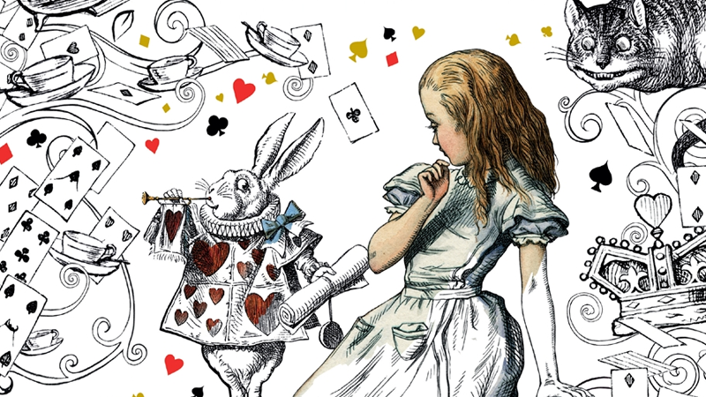

**Year 7: Alice in Wonderland**

**Name:**

**Week Three:**

Lewis Carroll was inspired by a movement started by someone called Andre Breton and that movement was called Surrealism. Each famous thinker had a different perspective though. For Dali it was about the art form and experimenting with our imaginations. For Freud, it was about exploring dreams. He believed that each person had an unconscious where lots of ideas are stored in our minds; often popping back up during our dreams.

**Hard –** Explain why Alice In Wonderland fits into the surrealism category.

**Harder** – using your understanding of the novel so far, come up with one event that is particularly surreal (strange) and explain it.

**Hardest** – choose some surreal events/characters from the novel – what do you think these might represent?

**Week Two:**

Some ideas about surrealism were inspired by dreams.

For a few nights, create a dream diary documenting the dreams you have. If you can’t remember one, ask your friends or family or write about a dream you have had in the past.

Once you have written down what your dreams were, aim to write underneath what they may mean.

**Week One:**

This week, you will get your creative hat on!

Imagine falling down the rabbit hole yourself. Choose a task from below.

* Describe what you see as you fall down the rabbit hole.
* Create a poem about Alice falling down the rabbit hole.
* Write from the perspective of the white rabbit who sees Alice fall down the hole.

**Week Four-Six:** Now it’s time for some project work. This project will take you two weeks to complete.

In groups or on your own, complete the tasks below:

Describe your own wonderland and challenge yourself by using surreal ideas or metaphors.

Next, tell us about a character that appears in your wonderland – interview them and their role in wonderland.

Finally, create a tour guide about your wonderland – tell us where to stay, what to see etc!

**Additional challenge tasks:**

Make sure you understand what each of these words means and show your understanding by trying to use them in your classwork. Then learn how to spell them – be ready for a spelling test in the last week of term.

**Hard:** 1. Victorian 2. Tone 3. Inference 4. Formality 5. Transformation

**Harder:** 1. Connective 2. Ambiguous 3.Diction 4. Hyperbole 5. Implicit

**Hardest:** 1. Surrealism 2. Benevolent 3. Callous 4. Fabricate 5. Modicum

**Bonus week:**

Read the extract below and complete the ‘all’ question and one more of the questions below:

**All:** List four things the poem describes.

**Hard:** How does the writer feel? Use evidence to explain.

**Harder:** How does the writer use language to interest the reader?

**Hardest:** To what extent does the extract remind you of Alice in Wonderland?

*All in the golden afternoon*

*Full leisurely we glide;*

*For both our oars, with little skill,*

*By little arms are plied,*

*While little hands make vain pretence*

*Our wanderings to guide.*

*Ah, cruel Three! In such an hour,*

*Beneath such dreamy weather,*

*To beg a tale of breath too weak*

*To stir the tiniest feather!  
Yet what can one poor voice avail*

*Against three tongues together?*

*Imperious Prima flashes forth*

*Her edict ‘to begin it’-*

*In gentler tone Secunda hopes*

*‘There will be nonsense in it!’-*

*While Tertia interrupts the tale*

*Not more than once a minute.*

*Anon, to sudden silence won,*

*In fancy they pursue*

*The dream-child moving through a land*

*Of wonders wild and new,*

*In friendly chat with bird or beast-*

*And half believe it true.*

*And ever, as the story drained*

*The wells of fancy dry,*

*And faintly strove that weary one*

*To put the subject by,*

*‘The rest next time-‘ ‘It is next time!’*

*The happy voices cry.*

*Thus grew the tale of Wonderland:*

*Thus slowly, one by one,*

*It’s quaint events were hammered out-*

*And now the tale is done,*

*And home we steer, a merry crew,*

*Beneath the setting sun.*

*Alice! a childish story take,*

*And with a gentle hand*

*Lay it where Childhood’s memories are twined*

*In memory’s mystic band,*

*Like pilgrim’s wither’d wreath of flowers*

*Pluck’d in a far-off land.*



For more resources, including literacy support, visit www.deastonenglish.com