**De Aston**

**English Department**

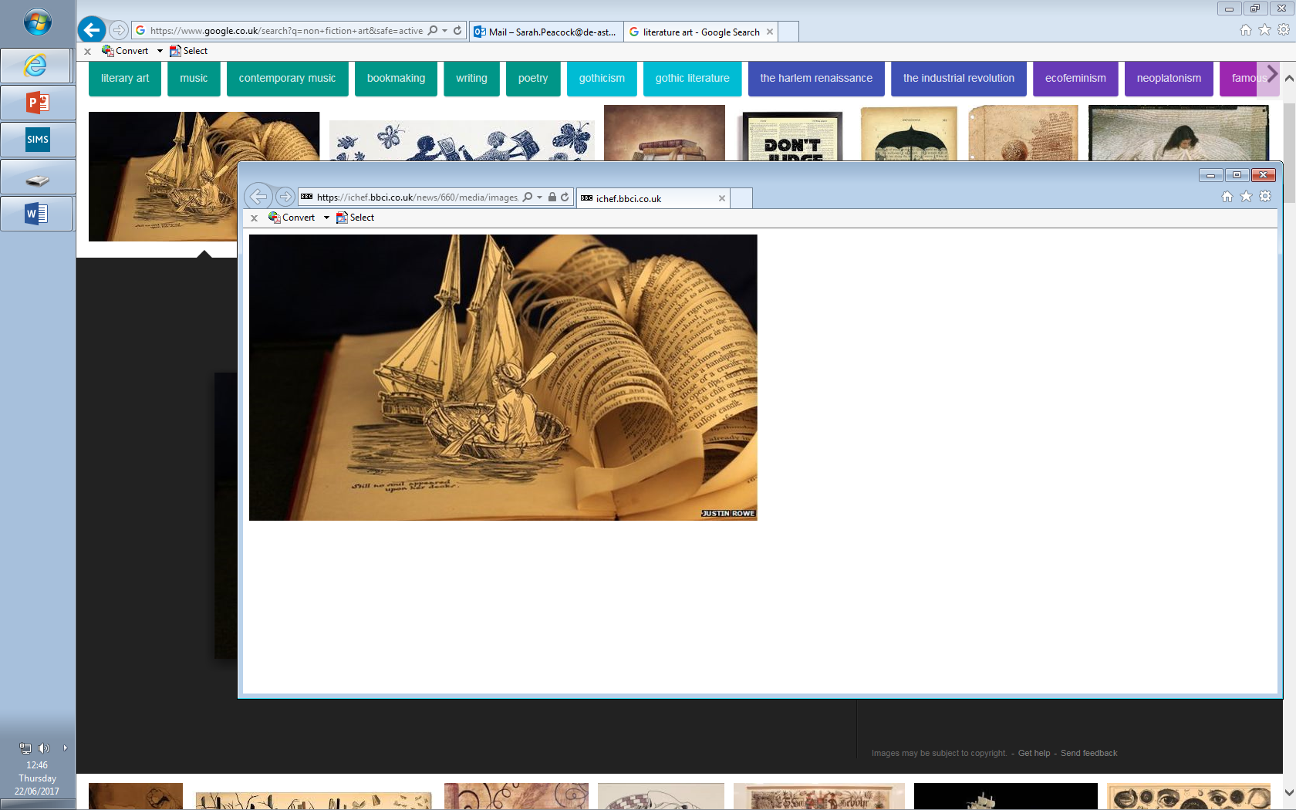

**Year 11: Literature Revision**

**Challenge Tasks**

**Name:**

**Week Two:**

This week, focus on Paper 2 (Poetry).

Revise the following ready for a small test in class:

* Key quotations for language in each poem;
* Key quotations for themes;
* Form of each poem;
* Structure of each poem;
* Context information for each poem.

**Week One:**

This week, focus on Paper 2 (Inspector).

Revise the following ready for a small test in class:

* Key quotations for important characters;
* Key quotations for themes;
* Key quotations for setting;
* Context information.

**Week One:**

This week, focus on Paper 1 (Macbeth and Jekyll).

Revise the following ready for a small test in class:

* Key quotations for important characters;
* Key quotations for themes;
* Key quotations for setting in Jekyll and Hyde;
* Context information for both texts.



**Bonus week – Paper 1:**

**Macbeth:**

Referring to Act 1, Scene 1, how are the witches presented in this scene and the rest of the play?

**Dr Jekyll and Mr Hyde:**

The most racking pangs succeeded: a grinding in the bones, deadly nausea, and a horror of the spirit that cannot be exceeded at the hour of birth or death. Then these agonies began swiftly to subside, and I came to myself as if out of a great sickness. There was something strange in my sensations, something indescribably new and, from its very novelty, incredibly sweet. I felt younger, lighter, happier in body…

Reading the extract above, how is the theme of duality shown in this extract and the novella as a whole?

**Bonus week – Paper 2:**

**An Inspector Calls** questions:

1. How is the Inspector presented in the text?

Or

1. How is the theme of social responsibility communicated to the audience?

**Power and Conflict:**

Referring to ‘Prelude’, how is nature shown to be more powerful than man? Refer to Prelude and one other poem in the anthology.

**Unseen Poetry** – how is age presented in this poem?

Old and alone, she sits at nights,

Nodding before the television.

The house is quiet now. She knits,

rises to put the kettle on,

watches a cowboy’s killing, reads

the local Births and Deaths, and falls

asleep at ‘Growing stock-piles of war-heads’.

A world that threatens worse ills

fades. She dreams of life spent

in the one house: suffers again

poverty, sickness, abandonment,

a child’s death, a brother’s brain

melting to madness. Seventy years

of common trouble; the kettle sings.

At midnight she says her silly prayers,

And takes her teeth out, and collects her night-things.



For more resources, including literacy support, visit www.deastonenglish.com