**De Aston**

**English Department**

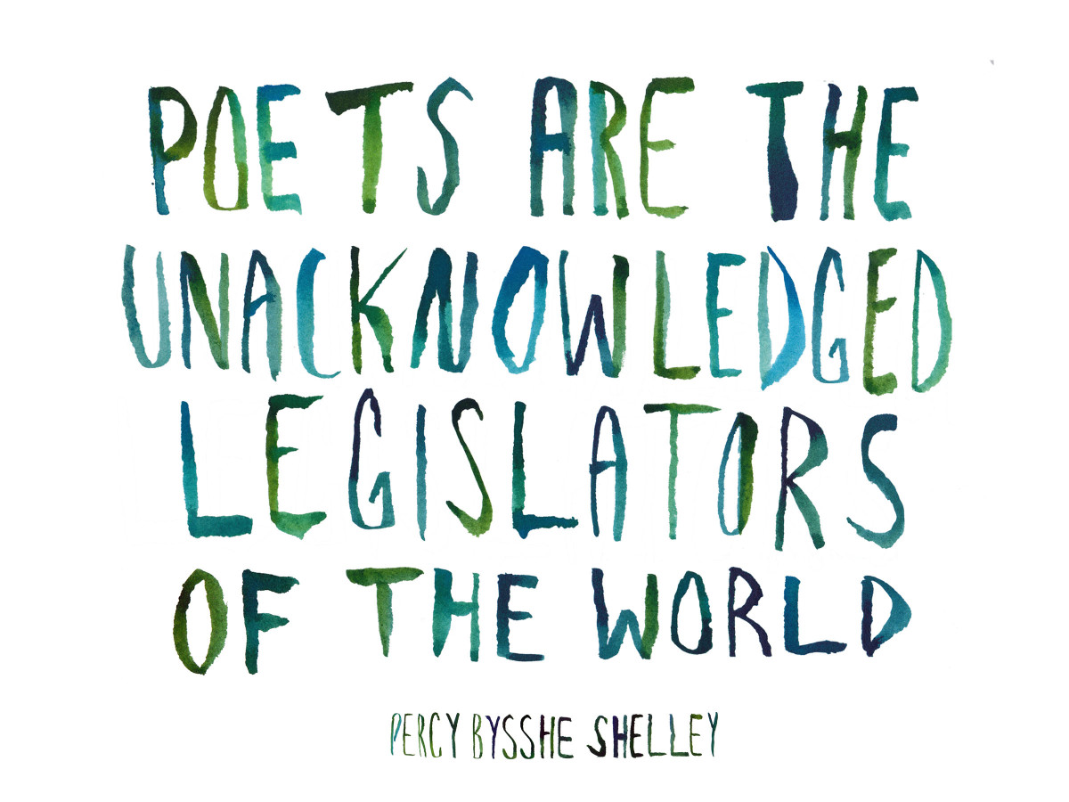

**Year 7: Poetry Please**

**Challenge Tasks**

**Name:**

**Week One:**

This week, you will have been thinking about why people write poetry and how poetry can be found all around us if we look for it. You will need a newspaper for this task – ask your teacher for one if you can’t get hold of one.

Choose a newspaper article and cut out words and phrases. Rearrange them to make a poem. Stick the words on the page or write it out yourself.

**Week Six**

Visit the poetry foundation website: <https://www.poetryfoundation.org/poems> Find 4 or 5 poems you enjoy and put them together as an anthology for Y7 students to read and enjoy. Think about presentation. Your anthology will need a little introduction explaining why you think people should read the poems you have chosen.

**Week Five**

This week you have been looking at poems about nature. Read “To Autumn” and ode by John Keats. An ode is a is an elaborately structured poem praising or glorifying an event or individual. Choose a different season and write your own ode. If you can, try to copy the rhythm and rhyme of Keats’ poem.

**Week Four:**

There is a good chance you will have come across Michael Rosen’s poetry before. Visit his website at [www.michaelrosen.co.uk](http://www.michaelrosen.co.uk) Take a look around the website.

**Hard** – Use his website to read some of his poems. Which one do you like best? Learn it off by heart!

**Harder** – Use his website to read all of his poems. Then go to ‘Links’ and scroll to the bottom to see him performing some of his poems. Either learn one of his poems off by heart or write one of your own in the same sort of style.

**Hardest** – <http://www.bbc.co.uk/programmes/b07ffxtj> Listen to Michael Rosen talking about the diaries he wrote as a teenager. If you google – ‘Michael Rosen Teenage Diaries’ you will find it. What did you learn about him?

**Week Three:**

Choose something that has already happened to you in your life, or has happened this week, or that you hope will happen in the future. Write a short ballad about it.

**Hard** – Make sure you have the right number of lines in each verse. Try to write three verses.

**Harder** – Make sure you have the right number of lines and a simple rhyme scheme. Try to write four verses.

**Hardest** – Make sure you have the right number of lines and a simple rhyme scheme. Try to write five verses.

**Week Two:**

Choose 10-20 key terms that are essential for the study of poetry. Create a page for a year 7 textbook on the topic, explaining what each term means, with examples.

**Additional challenge tasks:**

Make sure you understand what each of these words means and show your understanding by trying to use them in your classwork. Then learn how to spell them – be ready for a spelling test in the last week of term.

**Hard:** 1. Imagery 2. Simile 3. Rhyme 4. Haiku 5. Ballad

**Harder:** 1. Personification 2. Metaphor 3. Rhythm 4. Sonnet 5. Stanza

**Hardest:** 1. Explicit 2. Sublime 3. Projection 4. Alienated 5. Meticulous

**Final challenge:**

Finally, explore the ‘BBC Desert Island Discs’ website: <http://www.bbc.co.uk/radio4/features/desert-island-discs/find-a-castaway?occupation_group=writing>

Find a poet such as John Agard, Imtiaz Dharker, Liz Lochead, Lemn Sissay or Gillian Clarke. Listen to the songs they choose to take with them on a desert island. Which ones would you choose?

**Bonus week:**

Read the poem below and complete the ‘all’ question and one more of the questions below:

**All:** List four things you learn about the lone dog.

**Hard:** Why does the poet use repetition in the poem? What effect does it create?

**Harder:** Which is your favourite image in the poem? Explain why.

**Hardest:** A student once said that they didn’t believe the lone dog really means what he says. Is there any evidence to support this view?

I’m a lean dog, a keen dog, a wild dog and lone,  
I’m a rough dog, a tough dog, hunting on my own!  
I’m a bad dog, a mad dog, teasing silly sheep;  
I love to sit and bay the moon and keep fat souls from sleep.

I’ll never be a lap dog, licking dirty feet,  
A sleek dog, a meek dog, cringing for my meat.  
Not for me the fireside, the well-filled plate,  
But shut door and sharp stone and cuff and kick and hate.

Not for me the other dogs, running by my side,  
Some have run a short while, but none of them would bide.  
O mine is still the lone trail, the hard trail, the best,  
Wide wind and wild stars and the hunger of the quest.



For more resources, including literacy support, visit www.deastonenglish.com