**De Aston**

**English Department**

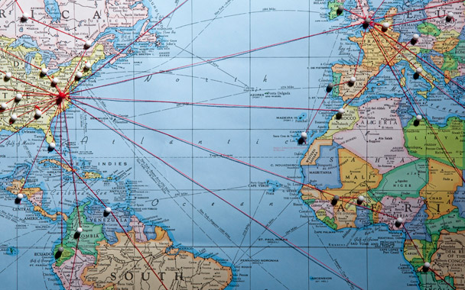

**Year 8: Globetrotting**

**Challenge Tasks**

**Name:**

**Week One:**

This week, you will have learnt about making the correct word choices in travel writing. Find or draw a picture of a place you would like to visit. Write a descriptive piece about this place, using a varied and ambitious vocabulary and trying to think about not just what you can see but using your other senses too. Aim to write 150 words.

**Week Two:**

This week is all about writing reviews. Choose a challenge! Aim for 150 words.

**Hard** – you’ve have just got back from a holiday of a life time. Write a quick review praising your accommodation using your opinion only.

**Harder** – you’ve have just got back from a holiday of a life time. Write a quick review praising your accommodation, use fact and opinion.

**Hardest** – You are devastated; your holiday was a disaster! Write a letter of complaint to the travel company telling them what was wrong and asking for a full refund.

**Week Three:**

As you have found out this week, travel writing can be humorous. This week, choose a challenge task. Aim for 150 words:

**Hard** – Write about a real (or a fictional) humorous event that happened to you on holiday;

**Harder** – Write a letter of complaint where something funny has happened to you and everybody in the hotel laughed at you. You DID NOT find it funny!

**Hardest –** Write about a place you have visited, using your tone and word choices to make your writing funny, just like Bill Bryson.

**Week Four:**

In this unit you will have been reflecting on how making precise language choices can help you to write an effective description. Below are some boring word choices that need replacing with dazzling vocabulary! For each word, think of or look up three alternatives. We will be sharing your ideas in class – will anyone have a word no one else had thought of? Who will have the longest word?

smell feel hot comfortable fun nice relaxing large amazing exotic

**Week Five:**

For this unit, you have invented your own country. This week you are going to come up with a cultural event to be celebrated in your country.

First do some research into cultural events. Ideas you could look at include: Running of the bulls in Spain; Dia de los Muertos in Mexico; Burning Man Festival in Nevada, USA; Ice Festival in China.

Now think of your own event and create a poster advertising it.

**Additional challenge tasks:**

Make sure you understand what each of these words means and show your understanding by trying to use them in your classwork. Then learn how to spell them – be ready for a spelling test in the last week of term.

**Hard:**

1. Foreign 2. Tourism 3. Culture 4. Accent 5. Dialect

**Harder:**

1. Accommodation 2. Refurbished 3. Objective 4. Subjective 5. Colloquialism

**Hardest:**

1. Gratuitous 2. Integrity 3. Impeccable 4. Intrepid 5. Plethora

**Final challenge:**

Finally, challenge yourself to read some travel writing in your own time. Bill Bryson is perhaps one of the most popular travel writers. Try to read one of his books, or find some of his articles online.

**Bonus week:**

Read the extract below and complete the ‘all’ question and one more of the questions below:

**All:** list four things you learn about the man

**Hard:** underline the adjectives;

**Harder:** how does the writer use language to interest the reader?

**Hardest:** write the next paragraph

*After an hour's descent I reach the desert. Sweat pours from my body and evaporates in seconds. My water is half-finished, and the lake has sunk from view. I must rely on my compass from now on.*

*The sun is still overhead. As I breathe the hot air in and out, my mouth becomes as dry as dust. The compass in my hand burns like the gravel underfoot. The dry noodles have reached my stomach and seem to be sucking the moisture from my blood. I long to reach the shore of the lake and plunge my head in its cool water. For brief moments, refracted through the heat waves on the right, I see villages, moving trucks, or a sweep of marsh. If I didn't have a compass, I might be tempted to walk straight into the mirage.*

*Four or five hours go by. At last I see clumps of weed rise from the gravel. The land starts to dip. I check the compass. Sugan should be right in front of me now, but all I see is the wide stony plain.*

*Suddenly it dawns on me that distances can be deceptive in the transparent atmosphere of the desert.*

**Week Six:**

Now that you are coming to the end of the unit, you need to show everything you have learnt. Imagine you now need to teach Year 7 about travel writing: produce a PowerPoint or worksheet that could be used to teach them! Areas you could include are: writing descriptively, presentation features of a brochure, writing a persuasive advert, writing a balanced review, writing with humour and writing a complaint letter.



For more resources, including literacy support, visit www.deastonenglish.com