**De Aston**

**English Department**

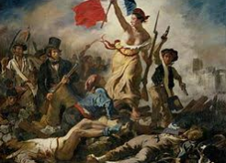

**Year 9: The Big Imitation**

**Academic Excellence Booklet**

The role of the Academic Excellence Booklet is for you to complete these tasks over the next six weeks. These activities are purposely designed to challenge you, so don’t worry if you find them difficult. You’re meant to! Learning happens when people have to think hard. That being said, your English teacher is a specialist, so ask any of us for help, anytime!

1. **Types of Narrator**

As you are aware, this term is all about the narrative voice, setting and characterisation. In Key Stage 3, we tell you that there are 3 types of narrators: first, second and third. However, there are many more! Carry out some independent research and email your power point to your teacher. Do not cut and paste as that is cheating, put your findings into your own words!

Extra Challenge – find an example of each and highlight a quote or section that proves which type of narrator it is.

Extra - Extra Challenge! - To ensure that you really understand each one, explain your findings to someone at home. If they do not understand it, revisit your work and re-draft. As always, please reference using the Harvard referencing system when you use someone else’s words.

1. **The Unreliable Narrator**

Write your own short story that has an unreliable narrator.

**Hint** - normally a short story will have no more than 3 characters. Edgar Allen Poe (1809 – 1849) was an American writer, who is best known for his short stories, particularly his tales of mystery and the macabre. He described the proper length of a short story by saying it had to be **something readable in a single sitting.** I look forward to reading it!

Extra Challenge – Set it in the Victorian/Edwardian era and think about setting and characterisation.

1. **Virginia Woolf – The Radical**

Woolf believed that the omniscient narrator of the 19th-century novel had to be replaced by a narration from multiple perspectives. Therefore, she included as many points of view and many voices.

The British Library on line has a plethora of resources about Virginia Woolf. (It is also a brilliant resource for any literary research).

Why was Woolf a radical? Present your findings in an essay form. Do not forget to reference!

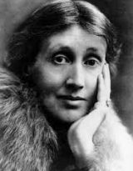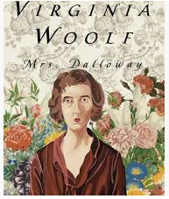



For more resources, including literacy support, visit www.deastonenglish.com