De Aston
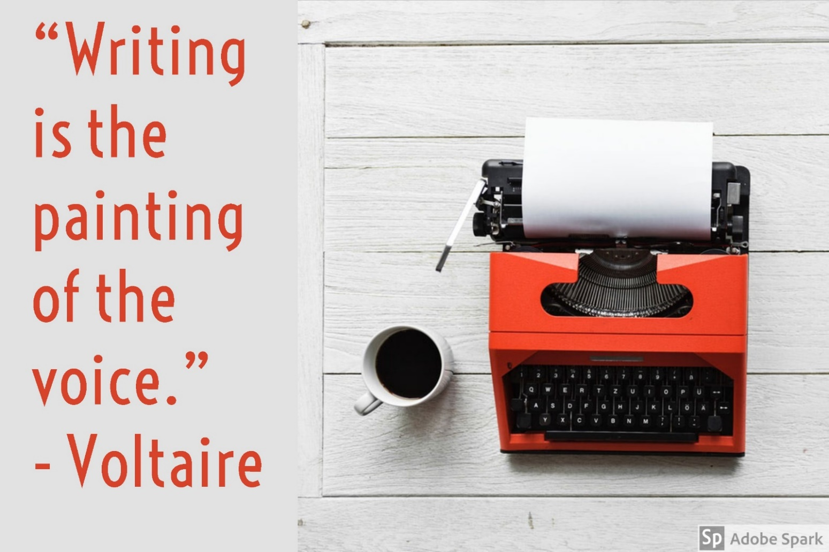
English Department

Year 12: Non-Fiction Writing
Academic Excellence Booklet

Contents

Advice for non-fiction writing page 1
Selfies Article page 2
Mental Health Letter page 4
Summer Holidays Speech page 6
Police Curfew Letter page 8
British Identity Letter page 10
Saving Money Article page 12
Popularity Speech page 14
Book, Music, TV or Film Review page 16
Pets Article page 18
Boxing Letter page 20
Model Formal Letter page 22
Model Informal Letter page 23
Model Speech page 24
Model Article page 25
Model Review page 26
Twenty-Five Persuasive Devices page 27

Writing Advice
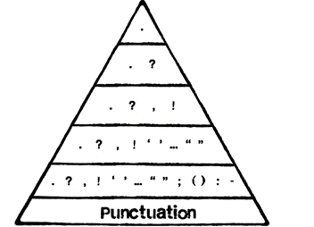
There are four key elements to remember when it comes to the exam:
Persuasive Devices | Audience Awareness (Tone)
Layout | SPaG

Persuasive Devices:
- Although there are a range of non-fiction purposes (including inform, entertain, advise, instruct), by far the most popular is persuade.
- Most questions allow for a binary decision and you must sway your audience to your point of view. Include a range of persuasive devices to do this.
- See the list of twenty-five at the end of the booklet.
- Please be advised not to overdo persuasive devices: you must have a well-constructed, detailed argument. Half a dozen persuasive devices per piece of writing is plenty – focus on placing them at key moments to make an idea memorable.
Audience Awareness:
- Perhaps the most overlooked and important aspect of non-fiction writing: deliberately show your awareness of the audience. Constantly. Refer to them directly.
- Your argument needs to take into account the intended audience – writing a letter to a friend is not similar to writing a letter to your head teacher. Your language (register) will need to be adapted, but so will the content. Think about the concerns of your audience and target them.
- Your tone is key to a high level: do you need to be lively or serious? Playful or sincere? Intense or thoughtful? Solemn or witty? Your tone needs to fit the topic, the audience and the format.
Layout:
- There are seven non-fiction writing styles at GCSE: 1) formal letter 2) informal letter 3) speech 4) article 5) review 6) report 7) leaflet (often called a guide). Each has its own layout features.
- Check the model examples in the back of the booklet for guidance.
SPaG:
- Your spelling, grammar and punctuation counts for almost half your marks in the exam.
- Be sure to vary your sentence types and openings regularly to add variety to your writing.
- Stick to the same tense (usually past).
- Remember the basics: accurate spelling, capital letter and punctuation.
- Use the punctuation triangle to try to be ambitious with punctuation.
- Try to display a range of vocabulary, but use the right word for the right situation.
1
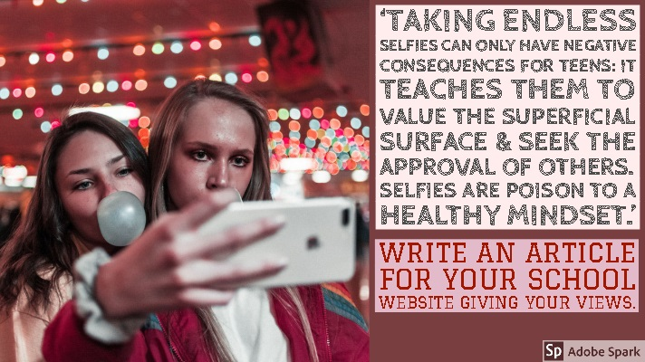
2
Using this space, create a table and/or mind-map to plan your response.
3
________________________________________________________________________________________________________________________________________________________________________________________________________________________________________________________________________________________________________________________________________________________________________________________________________________________________________________________________________________________________________________________________________________________________________________________________________________________________________________________________________________________________________________________________________________________________________________________________________________________________________________________________________________________________________________________________________________________________________________________________________________________________________________________________________________________________________________________________________________________________________________________________________________________________________________________________________________________________________________________________________________________________________________________________________________________________________________________

.
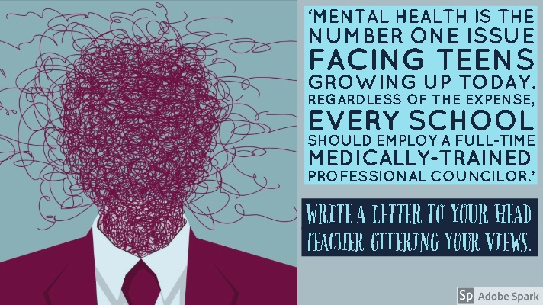
4
Using this space, create a table and/or mind-map to plan your response.
5
1
1
1
________________________________________________________________________________________________________________________________________________________________________________________________________________________________________________________________________________________________________________________________________________________________________________________________________________________________________________________________________________________________________________________________________________________________________________________________________________________________________________________________________________________________________________________________________________________________________________________________________________________________________________________________________________________________________________________________________________________________________________________________________________________________________________________________________________________________________________________________________________________________________________________________________________________________________________________________________________________________________________________________________________________________________________________________________________________________________________________

.
6
Using this space, create a table and/or mind-map to plan your response.
7
________________________________________________________________________________________________________________________________________________________________________________________________________________________________________________________________________________________________________________________________________________________________________________________________________________________________________________________________________________________________________________________________________________________________________________________________________________________________________________________________________________________________________________________________________________________________________________________________________________________________________________________________________________________________________________________________________________________________________________________________________________________________________________________________________________________________________________________________________________________________________________________________________________________________________________________________________________________________________________________________________________________________________________________________________________________________________________________

.
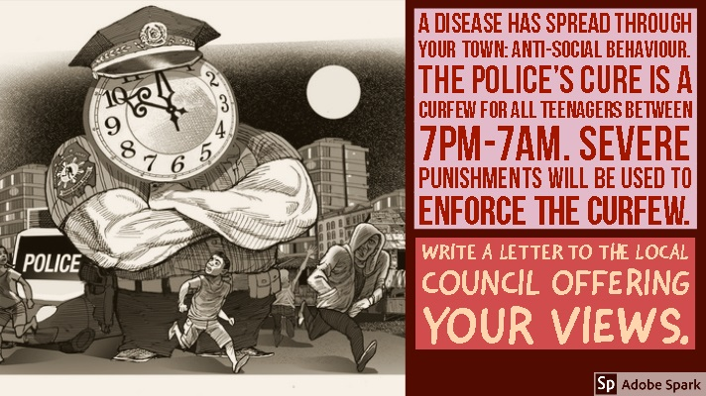
8
Using this space, create a table and/or mind-map to plan your response.
9
________________________________________________________________________________________________________________________________________________________________________________________________________________________________________________________________________________________________________________________________________________________________________________________________________________________________________________________________________________________________________________________________________________________________________________________________________________________________________________________________________________________________________________________________________________________________________________________________________________________________________________________________________________________________________________________________________________________________________________________________________________________________________________________________________________________________________________________________________________________________________________________________________________________________________________________________________________________________________________________________________________________________________________________________________________________________________________________

.
10
Using this space, create a table and/or mind-map to plan your response.
11
________________________________________________________________________________________________________________________________________________________________________________________________________________________________________________________________________________________________________________________________________________________________________________________________________________________________________________________________________________________________________________________________________________________________________________________________________________________________________________________________________________________________________________________________________________________________________________________________________________________________________________________________________________________________________________________________________________________________________________________________________________________________________________________________________________________________________________________________________________________________________________________________________________________________________________________________________________________________________________________________________________________________________________________________________________________________________________________

.
12
Using this space, create a table and/or mind-map to plan your response.
13
1
________________________________________________________________________________________________________________________________________________________________________________________________________________________________________________________________________________________________________________________________________________________________________________________________________________________________________________________________________________________________________________________________________________________________________________________________________________________________________________________________________________________________________________________________________________________________________________________________________________________________________________________________________________________________________________________________________________________________________________________________________________________________________________________________________________________________________________________________________________________________________________________________________________________________________________________________________________________________________________________________________________________________________________________________________________________________________________________

.
14
Using this space, create a table and/or mind-map to plan your response.
15
________________________________________________________________________________________________________________________________________________________________________________________________________________________________________________________________________________________________________________________________________________________________________________________________________________________________________________________________________________________________________________________________________________________________________________________________________________________________________________________________________________________________________________________________________________________________________________________________________________________________________________________________________________________________________________________________________________________________________________________________________________________________________________________________________________________________________________________________________________________________________________________________________________________________________________________________________________________________________________________________________________________________________________________________________________________________________________________

.
16
Using this space, create a table and/or mind-map to plan your response.
17
________________________________________________________________________________________________________________________________________________________________________________________________________________________________________________________________________________________________________________________________________________________________________________________________________________________________________________________________________________________________________________________________________________________________________________________________________________________________________________________________________________________________________________________________________________________________________________________________________________________________________________________________________________________________________________________________________________________________________________________________________________________________________________________________________________________________________________________________________________________________________________________________________________________________________________________________________________________________________________________________________________________________________________________________________________________________________________________

.
18
Using this space, create a table and/or mind-map to plan your response.
19
________________________________________________________________________________________________________________________________________________________________________________________________________________________________________________________________________________________________________________________________________________________________________________________________________________________________________________________________________________________________________________________________________________________________________________________________________________________________________________________________________________________________________________________________________________________________________________________________________________________________________________________________________________________________________________________________________________________________________________________________________________________________________________________________________________________________________________________________________________________________________________________________________________________________________________________________________________________________________________________________________________________________________________________________________________________________________________________

.
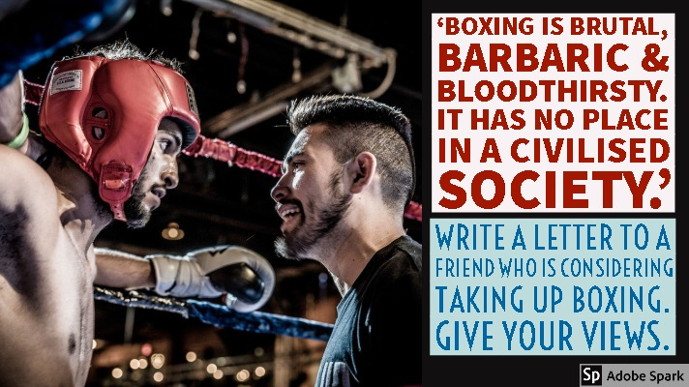
20
Using this space, create a table and/or mind-map to plan your response.
21
________________________________________________________________________________________________________________________________________________________________________________________________________________________________________________________________________________________________________________________________________________________________________________________________________________________________________________________________________________________________________________________________________________________________________________________________________________________________________________________________________________________________________________________________________________________________________________________________________________________________________________________________________________________________________________________________________________________________________________________________________________________________________________________________________________________________________________________________________________________________________________________________________________________________________________________________________________________________________________________________________________________________________________________________________________________________________________________

.
Some people believe it is preferable to stay in Britain rather than travel abroad on holiday. Write a letter to a newspaper to give your opinion on this topic.

44 Zoo Lane,
Hindley,
Wigan,
WN3 4HZ

26th March 2016
The Wigan Observer,
42 Tottenham Road,
Wigan,
WN3 6PS

Dear Editor,
Having recently read several articles that suggest it is unethical to travel abroad, I thought I would express an alternative point of view. I am the first person to express love for my country: England is my home and I’m proud to be English, however, I simply cannot agree with the idea that holidays abroad should be avoided.
I don’t mean to give Mother Nature a cough, but I fail to see how one tiny flight a year can compare to the hundreds of coal stations around the world that pump millions of tonnes of waste into the environment. Let me make it clear to every one of your readers: I am passionate about the natural world and I am not one of those fools who claims that global warming is a myth. I recycle. I never drop litter. I even have a solar panel on my roof at home. So, with all the effort I put into protecting our planet, do I not deserve a quality holiday every summer?
It’s not as if the sun usually visits us in England. Our version of summer is waking up to a sky that isn’t the same colour as the pavement! You can keep your wet weekends in Devon; I’ll sip cocktails on a beach in Mexico. I mean what would you prefer: a game of cards in a caravan or the crystal clear sea and softly swaying palm trees? I’m not putting down our home, but you must remember that travel allows you to experience a new culture and meet new people.
Have you ever seen the Eiffel Tower? The Pyramids? The Statue of Liberty? Every time I’ve been abroad it has broadened my horizons and I’ve been amazed at the beauty of the world. Staying at home and Googling pictures of these places just isn’t the same. My children have learnt more from seeing Mount Vesuvius than they have from building a model of a volcano in their science lesson. Also, consider what would happen to countries that rely on tourism. I dread to think of what would happen to Egypt, Turkey and many other places without the financial support of travellers.
I know there is a cost to the environment when we travel, but I choose to travel only once a year. It makes all the difference to my family; we work hard all year and it is our one treat. I do not deny the cost to the planet, but the look on my children’s faces the first time they saw Disneyland was priceless. I’ll never forget the incredible memories I have from travelling abroad and I would encourage your readers to travel (inside and outside the country) as much as possible.

Yours faithfully,

Tim Blake

22
You have a friend at university who is considering entering a clinical trial to earn money. Write a letter to your friend to express your opinion.

17 Bold Street,
Chester,
CH4 5ER

1st March 2016

Dear Kyle,
I thought I’d write to you straight away as I saw on Facebook that you were considering getting involved in clinical trial at university to pay your rent. Now, I’m not one for dramatics, but I have to ask: have you lost your mind? No, I’m serious! I know life at uni is difficult and that money is tight, but to allow someone to pump you full of an untested drug seems beyond stupid. I know that you can be a little… shall we say ‘rash’ sometimes… so I wanted to sort this out before it goes too far.
Now I know I sound extreme, and that I’m coming on a little intense, but you’re one of my oldest mates and there is no way I can sit back and just watch you do this. Only a total moron would consider risking their health for a few quid. I know it must sound exciting, and there were a few people on Facebook who commented on your status to encourage you, but please don’t listen to them. They don’t have your best interests at heart; they see it as entertainment and a bit of laugh, but the laughter will stop quickly if something goes wrong…
You do realise what you’re getting yourself into, don’t you? These random drugs have NEVER been tested on a human being before. Ever. Only rats. Which basically makes you a human rat. Their little pet for tests. Does that sound like a good time? Most of the drugs have names that aren’t even pronounceable! Also, they make you sign a contract before you take them so that you can’t sue them when things go wrong. That fact doesn’t exactly inspire faith, does it? I can just imagine the (mad) scientist saying: “Here, sign this paper. Now bend over for this giant needle.” Not much fun…
Besides you also need to consider the side effects. Oh yes, you didn’t even think about those, did you? Not only are you choosing to take dangerous, untested drugs (that most normal people would run a mile from), but they cause side effects: which means you could end up with a hairy back, a third-eye or even a heart attack. Again, not much fun…. I bet that thousand pounds isn’t sounding like such a good deal now. Have you spoken to your parents about this? I’d hate to see your mum in a state because you decided to make some ‘easy’ money. I know life at uni is expensive, but your health is priceless. It’s just not worth the risk, mate.
If I were you, I’d look for a job. I know that doesn’t sound exciting, but it’s better than the alternative. I’d get a job in a bar or club, then someone can pay you to party! Plus, you could use it as an opportunity to chat up the girls (I know what you’re like!) Seriously though, think about it hard before you decide and give me a call to talk it through.
See you soon,
James
23
Write a speech for year six pupils to encourage them to read for pleasure.

Do you ever get fed up of school? Does it sometimes feel like an exam factory? After all, everyone learns the same things, sat in the same places, at the same time. Sometimes life can feel that way too, the same boring routine: get up, bus, school, bus, homework, television, computer, bed. Repeat. Repeat. Repeat. What you need is an escape route. Freedom. A journey into the unknown. What you need is a book!
Let me guess, you weren’t exactly expecting that to be the answer. Perhaps a sunny holiday abroad, or a trip to a theme park, but not books. Books? But consider it… every time you open the cover of a book, you’re entering a new world. And, as it’s your choice what you read, you have freedom. Reading gives you the power to follow your passion, learn more about our world, or even escape into another: why not join Harry in Hogwarts, Katniss in Panem or Bilbo in Middle Earth?
Now, you might be thinking: ‘The thought of reading a huge novel makes me feel ill!’ That’s fine. Don’t. All reading is good for you. The wonder of reading is the range: from short stories to comics, newspapers to magazines, it all counts and it’s all good for you. Can you think of a better way to develop your imagination or creativity? A little voice inside might be muttering: ‘I prefer the telly or films’, but almost everything found on a screen began life on the page anyway!
Also, reading doesn’t have to be opposed to technology. If you’re waiting for the bus and have ten minutes to spare, why don’t you pull out your mobile and read whilst you wait? You can download a Kindle app - for free - and read anywhere. Plus, there are so many YouTube channels for group reading (it doesn’t have to be a solo activity), not to mention blogs, Instagram accounts, I really could go on and on…
But try not to get distracted by Facebook! Seeing hundreds of selfies will rot your brain, if not bore you to tears. Instead, read and expand your mind. I think the best thing about reading is that it allows you to slip into a dream someone else has created. Is there anything more relaxing that enjoying a good book - especially at this time of year, when the weather is miserable and the sky is dark mid-afternoon? Go on, grab a hot chocolate, a warm blanket and get yourself cosy in front of the fire with a good book.
I’m not trying to say you should spend every waking hour with your nose stuck in a book, although confession time: that sounds like my idea of heaven! No, I’m saying you should read regularly for your own health. It’s like exercise: everyone wants to take care of their body and look and feel their best, so why not use books to do the same with your mind? Recent research, carried out by experts at Manchester University, has proven that reading for pleasure not only leads to higher exam results in school, but a better career in the future. So there you go, if nothing else, reading will help to fill your future wallet!
I know that in the past most of you were enthusiastic readers. Everyone has those special memories of being read to at bed time by their parents. But, the thing is, the older people get, the less they read. Don’t let that person be you. As you grow older, you don’t have to let reading go. Good books never grow old. As a famous author once said: “A reader lives a thousand lives before he dies. The man who never reads lives only one.”
So, there you go. I hope I’ve managed to inspire some of you to pick up a book, if not a kindle or a newspaper. In this world, it’s easy to get stuck in a rut, following the same routines. But you really can banish boredom with a book. Futuristic cities, haunted woods, and everything in between is waiting for you. Go on, take a journey with a good book today!

24
Write an article for your school magazine entitled: ‘Don’t get me started on ______________’.

Don’t Get Me Started On Buses
Where to even start? BUS: Big, Useless, and Smelly. You stand at the bus stop in the pouring rain and when the bus finally arrives it is absolutely packed, with any remaining seats covered with litter and I dread to think what else. After spending what seems like an eternity squashed like a sardine, wedged between a window and a weirdo, you are free to start your day in a much worse mood than when you left the house.
So, perhaps I should start with the driver: is it in the job description to be moody and un-cooperative? Why do they always start driving as soon as you’ve got on the bus? Oh great, the public humiliation of falling flat on my face – amazing! Also, must you pull over for a cigarette and/or read of the paper when the bus is already late? Recently, I was made late for a school exam because the bus driver felt it necessary to go and buy a bottle of coke halfway round his bus route. I was furious.
It is quite alright for them – they are already at work! The rest of us are cold, annoyed and squashed, and if it is early in the morning we’re probably irritable too. Due to this, my friends and I get very frustrated when the driver tries to overcharge us. We’re wearing our school uniforms, obviously we’re not adults. Stop trying to haggle for an extra 40p.
Once the bus has arrived (late), you’ve got on, argued with the driver, fallen over in the aisle and found a seat you can begin to relax. Or not! The next battle is with everyone else on the bus: an awesome collection of freaks and misfits collectively known as the British Public. Why people choose to make loud phone calls on buses I’ll never know. More than that, why people choose to play their music loud enough to pop their eardrums, waken the dead and infuriate the rest of us simultaneously is beyond me.
Yet by far the most exasperating people of all are the young people. You know the ones, the members of our generation who give us the bad name. The ones who scare Grannies and kick cats. The nutters. Buses are full of them! Every bus seems to have a ‘back-of-the-bus-crew’. Really, finding a bus without a ‘crew’ is like finding a needle in a haystack. They are rude, riotous hooligans who leave graffiti, chewing gum and other debris for the next lucky passenger to deal with. How very thoughtful.
I challenge you to find someone who uses public transport regularly who doesn’t have a negative story or experience of buses, or public transport in general. The side of most buses boast of a bus “every fifteen minutes”. Give me a break. I think they need to fix their watches…
Basically, buses are useless. Despite all of the reasons I’ve given, the government will still encourage people to use public transport to be ‘green’ and protect the planet. I can understand that, but there are too many flaws and until they are fixed people will continue to travel by car whenever possible. I don’t blame them: I hate the peasant wagon.

25
Write a review of a book, film, TV show or album for your school website.

The Hunger Games: Catching Fire - The Odds Are Always in Your Favour

Ever seen it rain blood in a kids’ film before? How about a pensioner getting executed in front of his family? Or Lenny Kravitz being slapped in the face? The first Hunger Games caught flak because it dared to treat its YA audience like A’s – but things aren’t exactly looking any rosier in the sequel.
Following the unwritten lore of movie trilogies, the middle chapter of Katniss Everdeen’s sci-fi survival story is darker, moodier, meaner and, yes, better than Part 1. Outgrowing its Battle Royale meets Twilight meets The X Factor comparisons, Catching Fire expands Suzanne Collins’ novel beyond the confines of the arena to tackle some seriously brutal truths – plugging gaps and sowing seeds for a two-part finale that will have to work hard to match its grit.
And it’s Jennifer Lawrence’s performance that takes centre stage. Taking her post-Oscar fame publicly in her stride since she last picked up her bow, the 23-year-old actress has grown up as fast as her character. As mopey as the teenage love triangle almost gets, it’s the boys that do all the moping. Well on her way to becoming one of the greatest sci-fi heroines since Ripley, the avenger of District 12 is as undefined by her hidden vulnerability as she is by her inner strength; anchoring the series with an emotional realism that upstages everyone else in the film.
True, most of them are stuck in roles that haven’t developed much since we last met them. Peeta (Josh Hutcherson) is still an unlikeable wimp who cries every time he gets a paper cut, Gale (Liam Hemsworth) is still a gormless hunk who doesn’t do anything, and Donald Sutherland, Woody Harrelson and Elizabeth Banks are still hiding beneath candyfloss hair and panto outfits.
It’s all change behind the camera too, with new director Francis Lawrence (Constantine, I Am Legend) upping the menace both in and out of the arena. Marauding monkeys and axe-wielding gladiators might be pretty scary, but it’s nothing compared to an armed policeman beating a political dissident to death. In fact, Catching Fire often reflects real world horrors so impassively it’s easy to forget you’re watching a kids’ movie. Until you see Stanley Tucci’s hair, that is…
Yes, the Capitol still looks like the Emerald City, the big spinning thing in the arena comes straight out of Total Wipeout and the film’s cutting edge is dulled down and camped up whenever things get too gnarly. Some obvious concessions are made to appease the book’s devout fans too (At 146 minutes, it seems like they tried to fit every bloody page in), but it’s hard to see how anyone could be too disappointed with the incendiary results.
Then again, if the rousing finale of Catching Fire is anything to go by, Mockingjay is going to burn the house down…

Rating: *****

26

Twenty-Five Persuasive Devices
Emerging | Alliteration | Hyperbole | Tricolon | Statistics | Anecdote
 | The close reoccurrence of the same letter or sound.  Tragedy travelled through our trivial lives. | Deliberately exaggerating for effect or emphasis.  The bag weighed a ton! | Three parallel words or phrases.  I came, I saw, I conquered. | Using numerical evidence for support.  62% of adults are overweight in the UK. | A short story about a real person or incident.  I remember when…
 | Imperative | Direct Address | Collective Pronouns | Rhetorical Question | Emotive Language
 | Giving an authoritative command.  Do not smoke. | Speaking directly to the audience using ‘you’.  You must realise that animal testing is cruel. | Linking yourself with the audience via ‘we’, ‘our’, ‘us’.  We must act now. | Asking a question as a way of asserting a point.  Have you ever lied in your life? | Using language to move your audience.  Those savage hooligans attacked her.
Developing | Counter Argument | Expert Reference | Simile | Metaphor | Allusion
 | Opposing a contradictory belief or opinion.  Although fireworks can be dangerous, professional displays ensure the public’s safety. | Quoting a professional.  Professor Arthur Knowles, an expert in ______, stated that: “…………..” | A comparison that uses ‘like’ or ‘as’.  Energy drinks are like toxic waste – useless sewage that damages the body. | A direct comparison between two objects or ideas.  Drowning in an ocean of debt. | A reference to a person, place or event.  She’s a real Einstein.
 | Syntax | Prolepsis | Metanoia | Hypophora | Anaphora
 | Reordering words in sentences to place emphasis at the end.  If you shop online, you will save money. | Imagining an audience’s response/objection.  Some of you might be thinking _____, however ……... | Correcting yourself for emphasis.  I think – no, I know – that animal testing is wrong. | Asking a question before answering it yourself.  Who enjoys doing homework? No-one! | Repetition of the same word or phrase in successive sentences.  I have a dream…  I have a dream…  I have a dream…
Mastering | Climax | Extended Metaphor | Isocolon | Antithesis | Pun
 | A good-better-best structure.  A good thing about holidays are the food. Even better is the rest. The best, by far, is the weather. | A drawn-out metaphor that can last several sentences.  Homework Is a prison. Your room is a cage. You’re buried under your school books. You’re chained to your pen. | Creating sentences with parallel structures.  Many will enter, few will win. | Contrasting relationship between two ideas.  That’s one small step for man; one giant leap for mankind. | A humorous play on words.  New study of obesity looks for larger test group.
27

