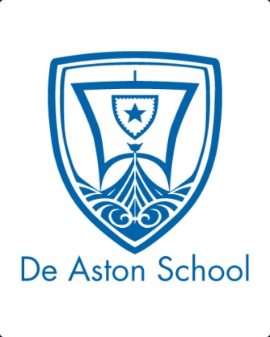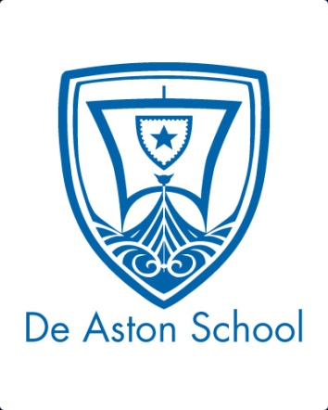**De Aston**

**English Department**

**Year 8: Dystopian Class Reader**

**Challenge Tasks**

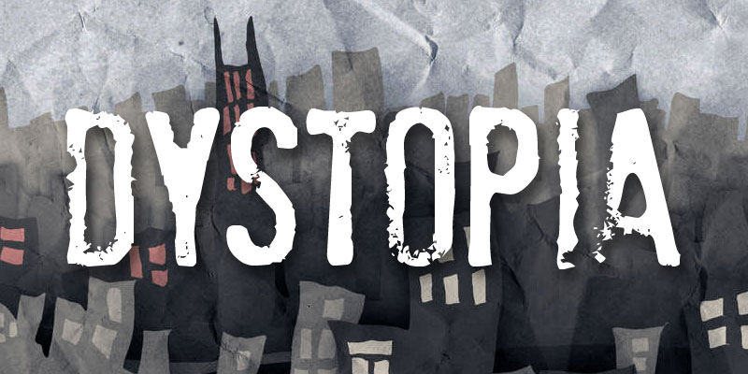

**Name:**

**Week One:**

This week is all about getting to know about dystopian conventions. Choose one of the tasks below to demonstrate your understanding of this week’s learning.

* Find 10 key words about the Dystopian genre and write their definition.
* Create a Dystopia ‘playlist’ of 10 songs and a commentary explaining how they relate to the genre
* Write a recipe for the perfect Dystopian novel or film. Be imaginative with your ingredients!

**Week Two:**

As you continue to read, you will be developing your understanding of the genre. Choose a creative task to show your understanding:

**Hard** – Imagine your own dystopian story. Write the blurb for the back of your book.

**Harder** – Create a villain to live in a dystopian world. This could be a monster, a machine or a person who abuses their position of power. Draw and label them and come up with a back story.

**Hardest –** Plan your own dystopian story. Make sure you include an introduction, a problem, a climax and a resolution.

**Week Three:**

This week is all about dystopian settings. Imagine your own dystopian world, then choose a task:

* Draw and label your own dystopian setting. Remember to include as many of the themes and conventions as you can!
* Imagine you have just woken up in a dystopian land. Write 200 words describing where you are. Try to use your other senses as well – not just what you can see.
* Write a poem about a Dystopian land!

**Week Four:**

As you continue to read, you are developing your knowledge and understanding of the main characters. Choose a task:

**Hard** – Create a timeline of important events for one of the major characters.

**Harder** – Create a Facebook page for a character, and a few of their friends: include personal information, remember to post conversations about their feelings, hopes and dreams on their walls;

**Hardest –** Imagine you are one of the characters. Write your diary, covering at least 2 days.

**Week Five:**

This week you are going to focus on key themes. Here are some themes that are explored in dystopian novels:

*choices dreams and plans fear freedom friendship*

*identity manipulation power rules and order*

Choose three themes that you think are particularly relevant to the novel you have been studying and make a note of all the ways this theme has been explored in the book. You could do this as a paragraph on each theme, a mind map or a poster. If you get stuck, look for your novel on www.shmoop.com

**Quotes to learn:**

You will be tested on these, plus you could use them in your assessment to help you refer to the rest of the play.

*You only need to learn the quotes for the text you’ve been studying!*

Animal Farm (old major’s speech – persuasive language)

* “You do not imagine, I hope, that we pigs are doing this in a spirit of selfishness and privilege?”
* “Milk and apples (this has been proved by Science, comrades) contain substances absolutely necessary to the well-being of a pig.”
* “We pigs are brainworkers. The whole management and organisation of this farm depend on us.”
* “It is for YOUR sake that we drink that milk and eat those apples.”
* “Do you know what would happen if we pigs failed in our duty? Jones would come back!”

Divergent

* “We are not the same. But we are, somehow, one.”
* “I scream as they surround me, feathers flapping in my ears, beaks pecking at my shoulders, talons clinging to my clothes.”
* “I am not pretty—my eyes are too big and my nose is too long.”
* “I don't know whether to be angry at the people laughing at me or flattered by the fact that he chose me first.”
* “I am selfish. I am brave. I am Divergent.”

Hunger Games

* “The crowd draws in a collective breath and then you can hear a pin drop, and I’m feeling nauseous and so desperately hoping that it’s not me, that it’s not me, that it’s not me.”
* “That's how I feel now, trying to remember how to breathe, unable to speak, totally stunned as the name bounces around the inside of my skull.”
* “You don’t forget the face of the person who was your last hope.”
* “For there to be betrayal, there would have to have been trust first.”
* “And while I was talking, the idea of actually losing Peeta hit me again and I realized how much I don't want him to die.”

Maze Runner

* “Every lovin’ second of every lovin’ day we spend in honor of the Maze, tryin’ to solve somethin’ that’s not shown us it has a bloody solution, ya know?”
* “We live inside a place that seems to have no way out, surrounded by bloodthirsty monster-guards. Doesn’t that sound like a prison to you?”
* “Most importantly, never go beyond those walls.”
* “A thick silence followed the thunderous rumble of the Door closing, and a veil of darkness seemed to cover the sky, as if even the sun had been frightened away by what lurked in the Maze.”
* “And the idea of those walls closing and trapping him inside this place they called the Glade was downright terrifying.”

**Week Six:**

Now it’s time to show your knowledge and understanding of the whole novel. Aim to write 200 words. Choose a task:

* Write a review of the book. Look at some examples online if you are unsure.
* Write a summary of the novel. You might find it helpful to bullet point the key events first.
* Draw a cartoon strip of the story. Include at least 8 boxes and make sure you include detailed captions to show your knowledge of the plot.

**Additional challenge tasks:**

Make sure you understand what each of these words means and show your understanding by trying to use them in your classwork. Then learn how to spell them – be ready for a spelling test in the last week of term.

**Hard:**

1. Dystopia 2. Utopia 3. Society 4. Government 5. Dictator

**Harder:**

1. Faction 2. Dysfunctional 3. Oppressive 4. Inequality 5. Evolution

**Hardest:**

1. Avarice 2. Compliant 3. Nadir 4. Insular 5. Maverick

**Final challenge:**

Finally, challenge yourself to read more dystopian fiction. Try to read at least one more of the following (not just the one you read in class!): Hunger Games, Divergent, Nought & Crosses, Uglies, Gone, Maze Runner, Ender’s Game, The 5th Wave, The Giver.

**Bonus week:**

Read the extract below and complete the ‘all’ question and one more of the questions below:

**All:** Underline the interesting adjectives and verbs in this passage.

**Hard:** What is the effect of the similes and personification? Answer using SQUAD paragraphs

**Harder:** How does the writer use language to create a dystopian setting? 



For more resources, including literacy support, visit www.deastonenglish.com