**De Aston**

**English Department**

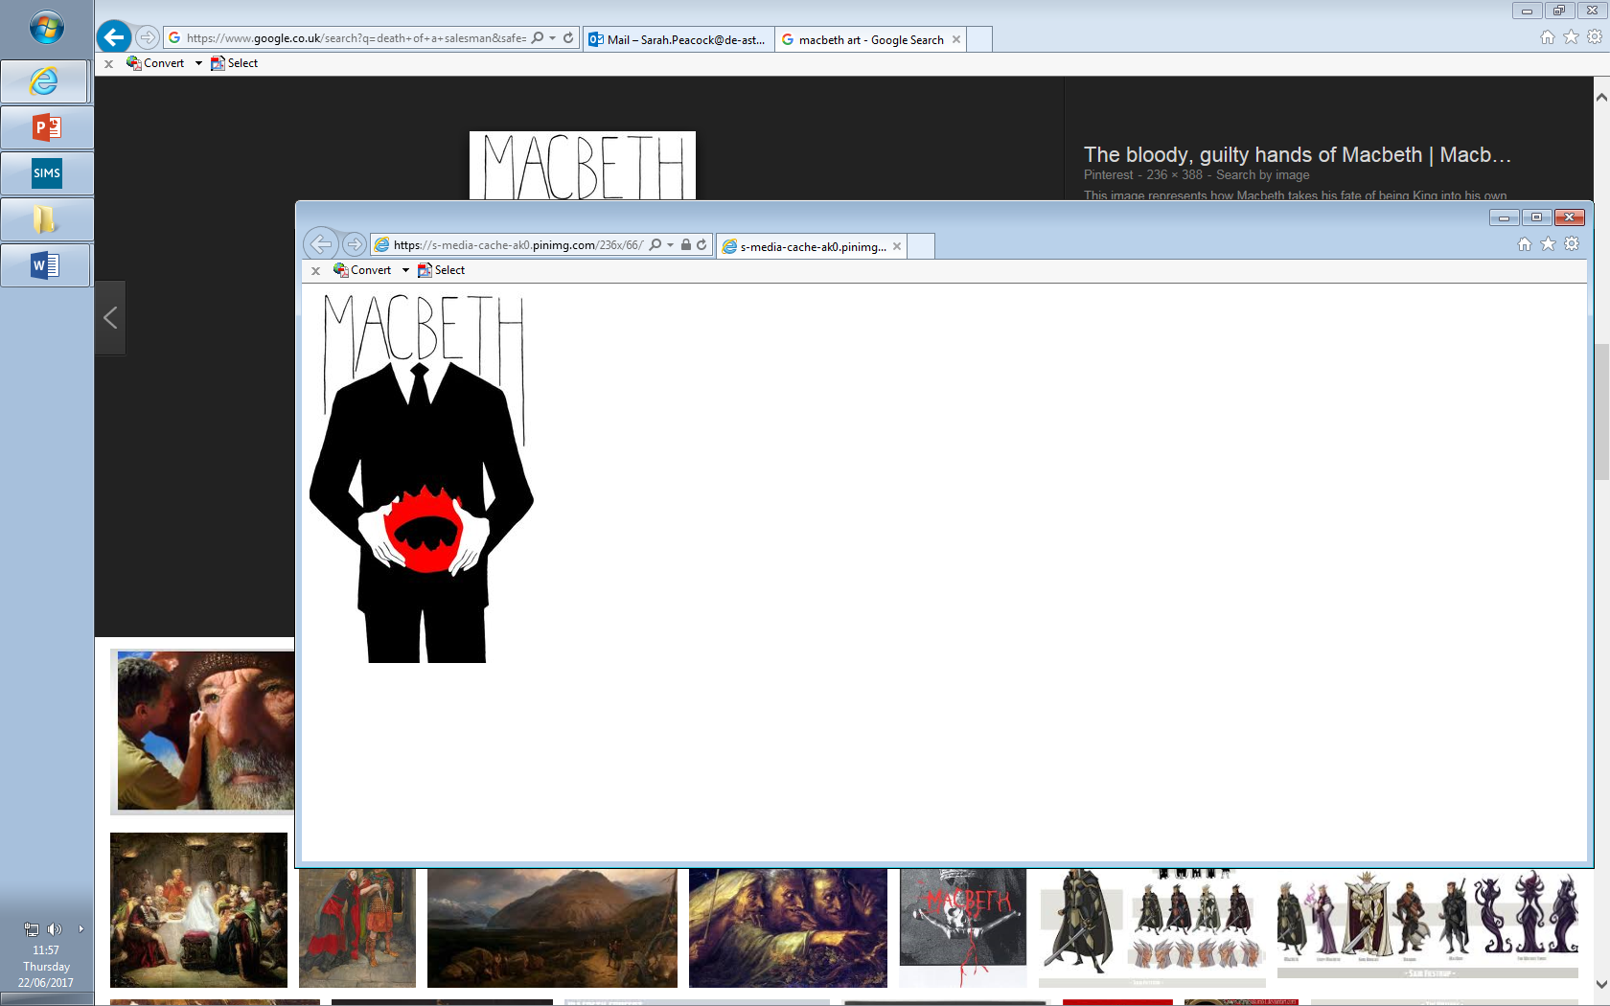

**Year 11: Macbeth**

**Challenge Tasks**

**Name:**

**Week Three:**

Finally, choose an essay task and write your response in 40 minutes.

**Hard** – How is Lady Macbeth presented in the play?

**Harder** – How does Macbeth reflect the power of ambition?

**Hardest** – How responsible are the witches for the events in Macbeth?

**Remember, when planning include the following:**

Intro – clear argument

Main body – 3 or 4 SQUAD paragraphs – remember, use quotations, analyse language and refer to context.

Conclusion – most significant aspect of your answer.

**Week Two:**

This week, revise the key themes in ‘Macbeth’. Choose a task:

**Hard** – Track each theme in the text – what key events can you link to each theme? (appearance vs. reality, gender, ambition, supernatural).

**Harder** – which theme do you think is the most important? Write a paragraph explaining your view.

**Hardest** – create a mini-lesson to deliver to the class on key themes. Feel free to work in small groups.

**Week One:**

This week, revise the key characters in ‘Macbeth. Choose a task:

**Hard** – create character profiles for Macbeth, Lady Macbeth, The Witches and Banquo. Include in each: key events, key themes they link to, key quotations said about them or by them.

**Harder** – Find two key quotations for each character – annotate them for language devices and themes.

**Hardest** – Create artistic presentations of each character, labelling them with annotated key quotations and themes.

**Extending your vocabulary**

*You should be trying to expand your vocabulary throughout your studies of English, for example by using a thesaurus when completing extended writing tasks. In addition to this, find out what the following words mean, learn how to spell them and try to use them in your class work:*

1. Multitudinous 2. Solicit 3. Prophetic 4. Harbinger 5. Regicide

**Additional challenge:**

Challenge yourself to read some criticism of Macbeth– note down key ideas critics have on the text. You can use these in your exam.

**Bonus week:**

Read the extract below and complete the ‘all’ question and one more of the questions below:

**All:** what is the context of this passage? (What is happening and what has just happened?)

**Hard:** How does Lady Macbeth change later in the play?

**Harder:** What is the audience’s impression of Lady Macbeth here? Remember, your audience are Jacobean.

**Hardest:** How does Shakespeare present Lady Macbeth in this extract? Pay close attention to language.

LADY MACBETH

Was the hope drunk  
Wherein you dressed yourself? Hath it slept since?  
And wakes it now to look so green and pale  
At what it did so freely? From this time,  
Such I account thy love. Art thou afeard  
To be the same in thine own act and valour  
As thou art in desire? Wouldst thou have that  
Which thou esteem'st the ornament of life,  
And live a coward in thine own esteem,  
Letting I dare not wait upon I would,  
Like the poor cat i'th'adage?



**Key terms: Linguistic study**

*The following terms are from the field of linguistics – the scientific study of language. You may find them useful at any point in your English studies. Make sure you understand what each term means and can identify examples in the texts you read.*

|  |  |  |
| --- | --- | --- |
| **Hard**  accent  colloquialism  dialect  homophone  monosyllabic  polysyllabic  prefix  root/stem word  Standard English  suffix  synonym | **Harder**  antonym  archaic  etymology  idiolect  Latinate  morpheme  neologism  phoneme  phonetics  phonology  pragmatics  semantics  sociolect | **Hardest**  deictic  diction  discourse  fricative  glide  graphology  lexeme  orthography  plosive  signifier |

For more resources, including literacy support, visit www.deastonenglish.com